Section 3: Advanced Data Management

Advancement only comes with habitually doing more than you are asked.

Gary Ryan Blair.[1]

The wiring of the world has given us ubiquitous networks and broadened the scope of issues that data management must now embrace. In everyday life, you might use a variety of networks (e.g., the Internet, 4G, WiFi, and bluetooth) to gain access to information wherever you might be and whatever time it is. As a result, data managers need to be concerned with both the spatial and temporal dimensions of data. In a highly connected world, massive amounts of data are exchanged every minute between computers to enable a high level of global integration in economic and social activity. XML has emerged as the foundation for data exchange across many industries. It is a core technology for global economic development. On the social side, every day people generate millions of messages, photos, and videos that fuel services such as Twitter, Flickr, and YouTube. Many organizations are interested in analyzing these data streams to learn about social trends, customers’ opinions, and entrepreneurial opportunities. Organizations need skills in collecting, processing, and interpreting the myriad data flows that intersect with their everyday business. Organizational or business intelligence is the general term for describing an enterprise’s efforts to collect, store, process, and interpret data from internal and external sources. It is the first stage of data-driven decision making. Once data have been captured and stored in an organizational repository, there are several techniques that can be applied.

In a world awash with data, visualization has become increasingly important for enabling executives to make sense of the business environment, to identify problems, and highlight potential new directions. Text mining is a popular tool for trying to make sense of data streams emanating from tweets and blogs. The many new sources of data and their high growth rate have made it more difficult to support real time analysis of the torrents of data that might contain valuable insights for an organization’s managers. Fortunately, Hadoop distributed file system (HDFS) and cluster computing methods are a breakthrough in storing and processing data that enable faster processing at lower cost. Dashboards are widely used for presenting key information. Furthermore, the open source statistics and graphical package, R, provides a common foundation for handling text mining, data visualization, HDFS, and cluster computing. It has become another component of the data manager’s toolkit.

The section covers the following topics.

* Spatial and temporal data management
* XML
* Organizational intelligence
* Introduction to R
* Data visualization
* Text mining
* Cluster Computing
* Dashboards

11. Spatial and Temporal Data Management

Nothing puzzles me more than time and space; and yet nothing troubles me less, as I never think about them.

Charles Lamb, 1810.

## Learning objectives

Students completing this chapter will

* be able to define and use a spatial database;
* be familiar with the issues surrounding the management of temporal data.

# Introduction

The introduction of ubiquitous networks and smartphones has led to the advent of location-based services. Customers expect information delivered based on, among other things, where they are. For example, a person touring the historic German city of Regensburg could receive information about its buildings and parks via her mobile phone in the language of her choice. Her smartphone will determine her location and then select from a database details of her immediate environment. Data managers need to know how to manage the spatial data necessary to support location-based services.

Some aspect of time is an important fact to remember for many applications. Banks, for example, want to remember what dates customers made payments on their loans. Airlines need to recall for the current and future days who will occupy seats on each flight. Thus, the management of time-varying, or temporal, data would be assisted if a database management system had built-in temporal support. As a result, there has been extensive research on temporal data models and DBMSs for more than a decade. The management of temporal data is another skill required of today’s data management specialist.

The Open Geospatial Consortium, Inc. (OGC) is a nonprofit international organization developing standards for geospatial and location-based services. Its goal is to create open and extensible software application programming interfaces for geographic information systems (GIS) and other geospatial technologies. DBMS vendors (e.g., MySQL) have implemented some of OGC’s recommendations for adding spatial features to SQL. MySQL is gradually adding further GIS features as it develops its DBMS.

# Managing spatial data

A spatial database is a data management system for the collection, storage, manipulation, and output of spatially referenced information. Also known as a geographic information system (GIS), it is an extended form of DBMS. Geospatial modeling is based on three key concepts: theme, geographic object, and map.

A theme refers to data describing a particular topic (e.g., scenic lookouts, rivers, cities) and is the spatial counterpart of an entity. When a theme is presented on a screen or paper, it is commonly seen in conjunction with a map. Color may be used to indicate different themes (e.g., blue for rivers and black for roads). A map will usually have a scale, legend, and possibly some explanatory text.

A geographic **object** is an instance of a theme (e.g., a river). Like an instance of an entity, it has a set of attributes. In addition, it has spatial components that can describe both geometry and topology. Geometry refers to the location-based data, such as shape and length, and topology refers to spatial relationships among objects, such as adjacency. Management of spatial data requires some additional data types to represent a point, line, and region.

Generic spatial data types

| Data type | Dimensions | Example |
| --- | --- | --- |
| Point | 0 | Scenic lookout |
| Line | 1 | River |
| Region | 2 | County |

Consider the case where we want to create a database to store some details of political units. A political unit can have many boundaries. The United States, for example, has a boundary for the continental portion, one for Alaska, one for Hawaii, and many more to include places such as American Samoa. In its computer form, a boundary is represented by an ordered set of line segments (a path).

Data model for political units

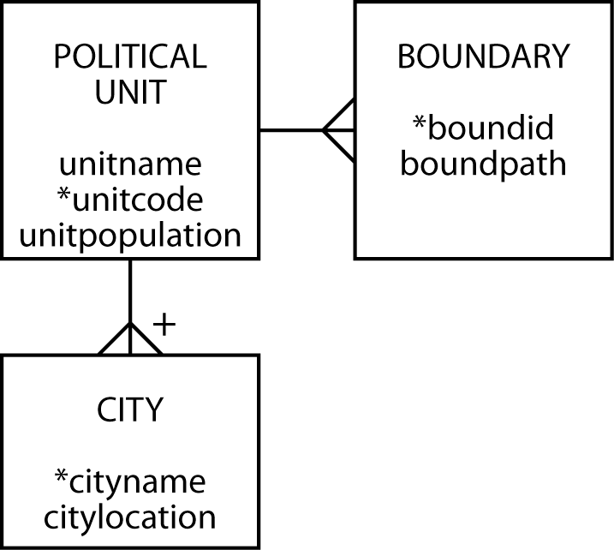

## SQL/MM Spatial

SQL/MM, also known as ISO 13249, is an extension of SQL to handle spatial data. It uses the prefix ST_ for tables, views, data types, and function names. Originally, this prefix meant *Spatial* and *Temporal*, because the intention was to develop a standard that combined spatial and temporal extensions to SQL. However, it was realized that temporal required a broader perspective and should be separate standard. Thus, think of ST_ as meaning *Spatial Type*.

MySQL has data types for storing geometric data, which are:

| Type | Representation | Description |
| --- | --- | --- |
| Point | POINT(x y) | A point in space (e.g., a city’s center) |
| LineString | LINESTRING(x1 y1,x2 y2,…) | A sequence of points with linear interpolation between points (e.g., a road) |
| Polygon | POLYGON((x1 y1,x2 y2,…), (x1 y1,x2 y2,…)) | A polygon (e.g., a boundary) which has a single exterior boundary and zero or more interior boundaries ( i.e., holes) |

## Spatial Reference Support System (SRS)

A spatial reference system (SRS) is facilitates the location of geometric objects using coordinates. A specific SRS is identified by an SRID, which is an integer

There are three types of reference systems:

### Projected

A projected SRS is a projection of a globe on a flat surface. Map makers have developed a variety of approaches, such as Mecator, to represent a portion of the earth on a page or screen. Each point on the flat surface is a place on the globe. A projected SRS typically shows a length legend, such as the distance in miles or kilometers.

### Geographic

For a geographic SRS, the coordinates are latitude and longitude. The SRID is 4326.[2]

### Cartesian

A Cartesian SRS, is an infinite flat plane with no specified units. The SRID is O, and this is the default if you don’t specify an SRS.

## Data model mapping

The data model in the preceding figure is mapped to MySQL. By specifying a SRID of 0, Ireland is represented using a Cartesian SRS. Since Ireland is small relative the size of the earth, this is a reasonable approximation.

In the following definition of the database’s tables, note two things. The boundpath column of boundary is defined with a data type of POLYGON and SRID of 0. The cityloc column of city is defined as a POINT. Otherwise, there is little new in the set of statements to create the tables.

Political unit database definition

CREATE TABLE political_unit (

Unitname VARCHAR(30) NOT NULL,

Unitcode CHAR(2),

Unitpop DECIMAL(6,2),

PRIMARY KEY(unitcode));

CREATE TABLE boundary (

Boundid INTEGER,

Boundpath POLYGON NOT NULL SRID 0,

Unitcode CHAR(2),

PRIMARY KEY(boundid),

CONSTRAINT fk_boundary_polunit FOREIGN KEY(unitcode)

REFERENCES political_unit(unitcode));

CREATE TABLE city (

Cityname VARCHAR(30),

Cityloc POINT NOT NULL SRID 0,

Unitcode CHAR(2),

PRIMARY KEY(unitcode,cityname),

CONSTRAINT fk_city_polunit FOREIGN KEY(unitcode)

REFERENCES political_unit(unitcode));

We now use the geographic entity of Ireland to demonstrate the application of spatial concepts. The island has two political units. The Republic of Ireland (Eire) governs the south, while Northern Ireland, a part of the United Kingdom, is in the north.

Map of Ireland

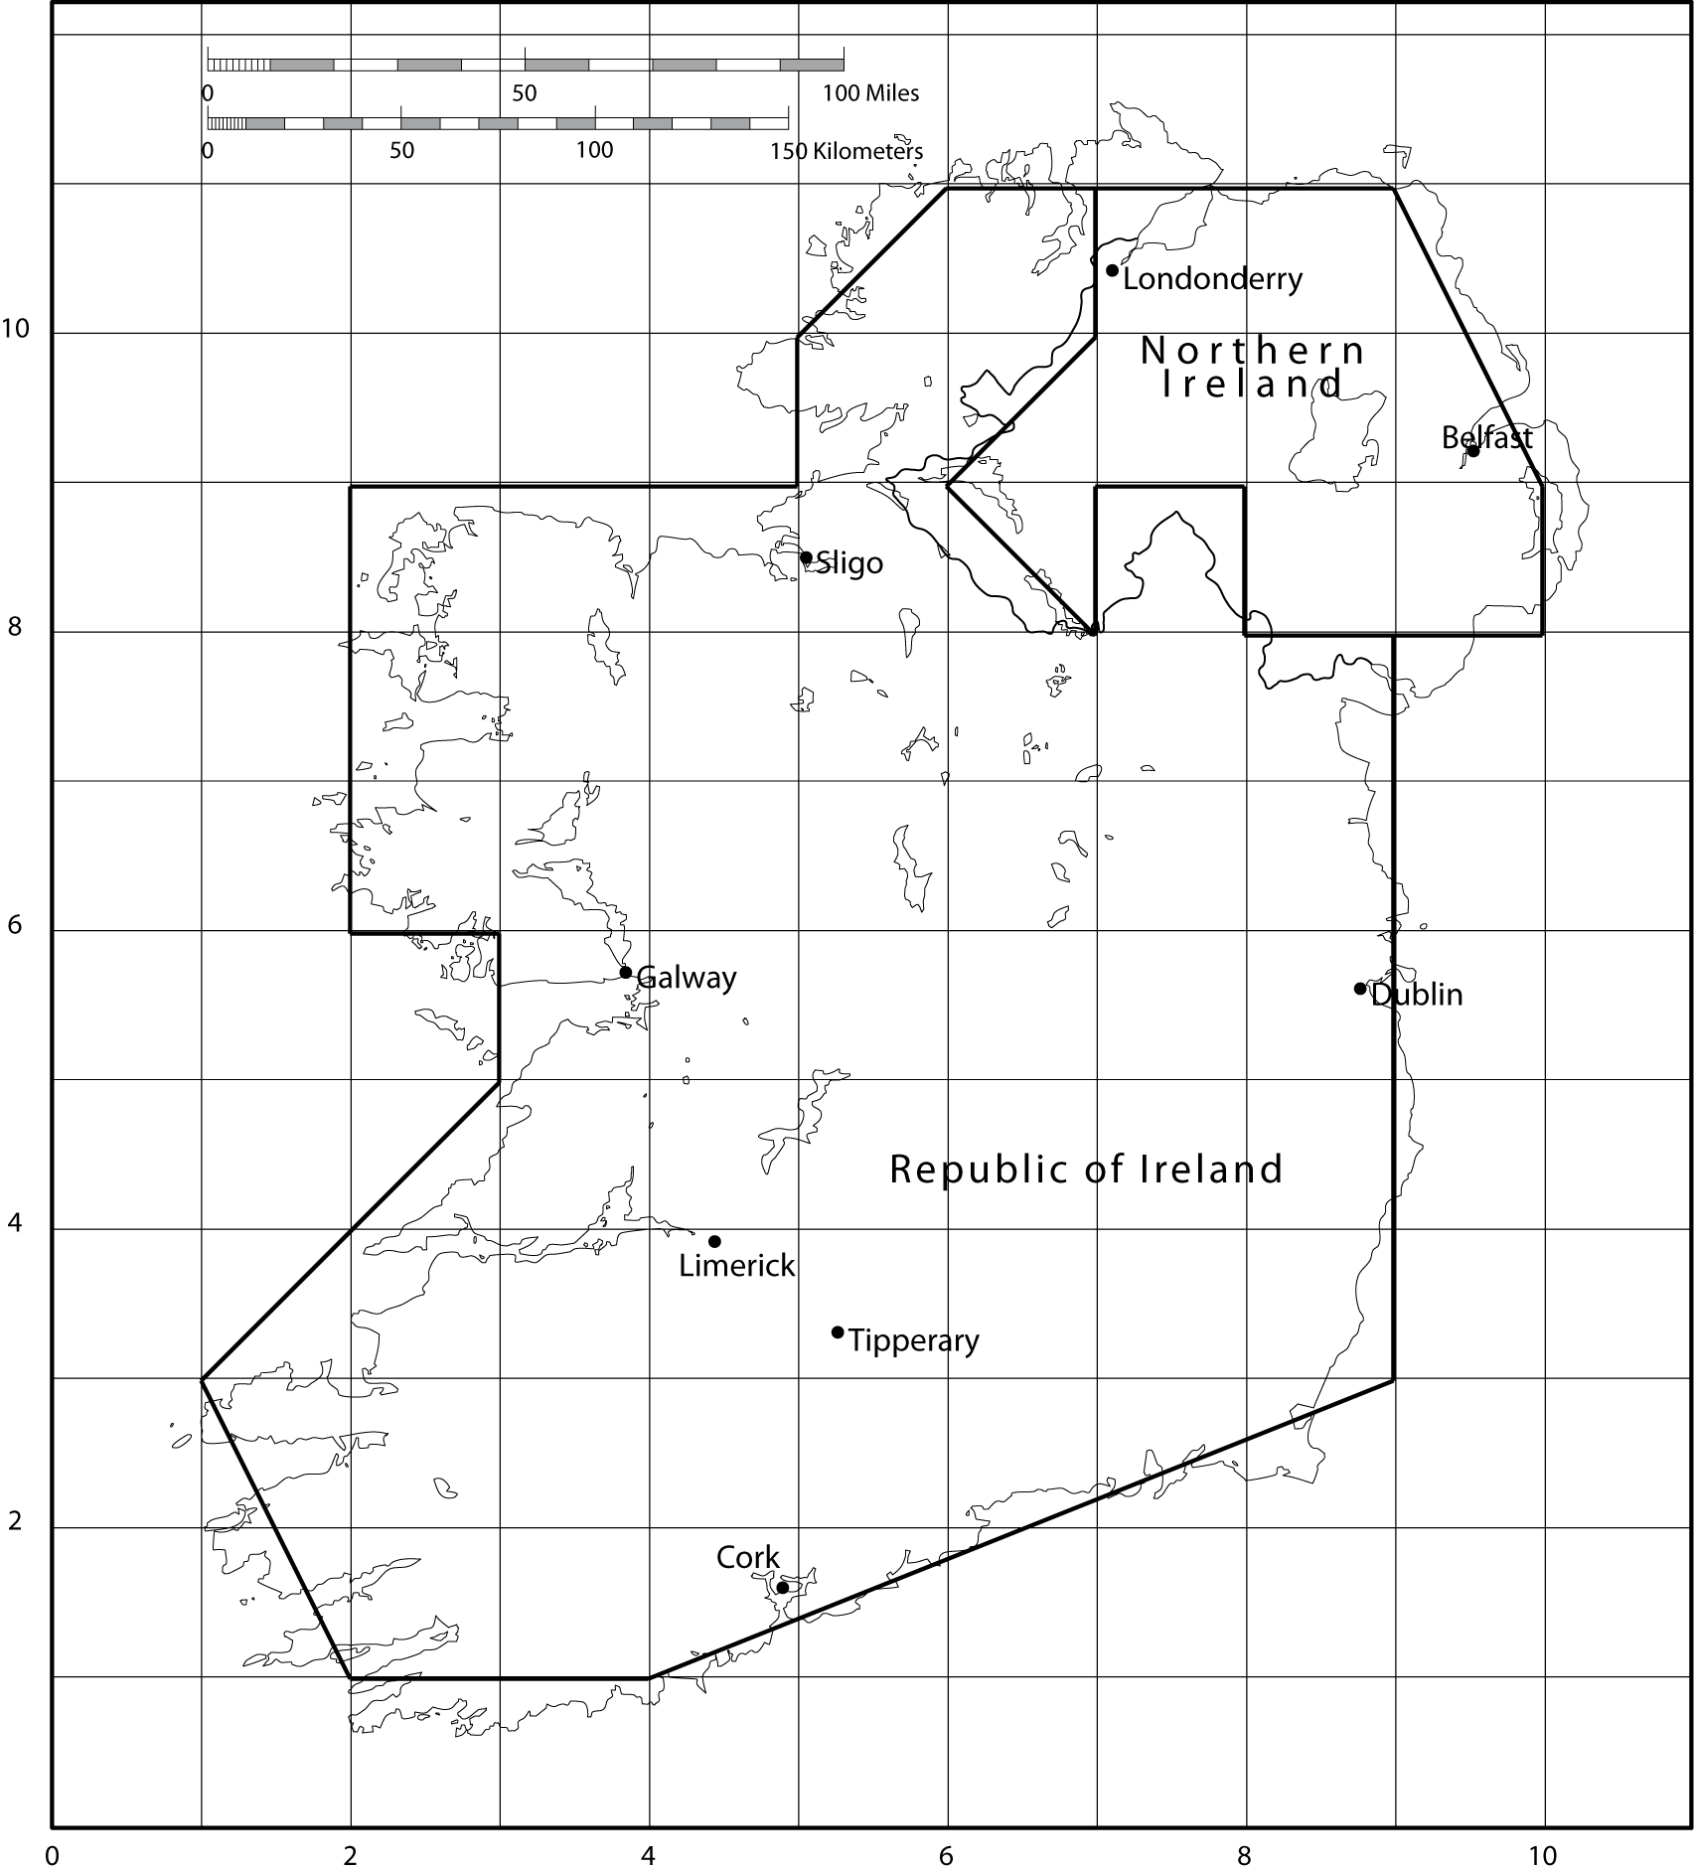

To represent these two political units within a spatial database, we need to define their boundaries. Typically, this is done by approximating the boundary by a single exterior polygon. In the preceding figure, you see a very coarse representation based on connecting intersection points of the overlay grid. The SRID needs to be specified for each geometric object, as for example where it is set to 0 when specifying Dublin’s coordinates, ST_GeomFROMText('POINT(9 6)', 0).

Insert statements for populating database

INSERT INTO political_unit VALUES ('Republic of Ireland','ie', 3.9);

INSERT INTO political_unit VALUES ('Northern Ireland','ni', 1.7);

INSERT INTO boundary VALUES

(1,ST_GeomFROMText('POLYGON((9 8, 9 3, 4 1, 2 2, 1 3, 3 5, 3 6, 2 6,

2 9, 5 9, 5 10, 6 11, 7 11, 7 10, 6 9, 7 8, 7 9, 8 9, 8 8, 9 8))', 0),'ie');

INSERT INTO boundary VALUES

(2,ST_GeomFROMText('POLYGON((7 11, 9 11, 10 9, 10 8, 8 8, 8 9, 7 9,

7 8, 6 9, 7 10, 7 11))', 0),'ni');

INSERT INTO city VALUES ('Dublin',ST_GeomFROMText('POINT(9 6)', 0),'ie');

INSERT INTO city VALUES ('Cork',ST_GeomFROMText('POINT(5 2)', 0),'ie');

INSERT INTO city VALUES ('Limerick',ST_GeomFROMText('POINT(4 4)', 0),'ie');

INSERT INTO city VALUES ('Galway',ST_GeomFROMText('POINT(4 6)', 0),'ie');

INSERT INTO city VALUES ('Sligo',ST_GeomFROMText('POINT(5 8)', 0),'ie');

INSERT INTO city VALUES ('Tipperary',ST_GeomFROMText('POINT(5 3)', 0),'ie');

INSERT INTO city VALUES ('Belfast',ST_GeomFROMText('POINT(9 9)', 0),'ni');

INSERT INTO city VALUES ('Londonderry',ST_GeomFROMText('POINT(7 10)', 0),'ni');

The two sets of values for the column boundary define the boundaries of the Republic of Ireland and Northern Ireland. Because of the coarseness of this sample mapping, the Republic of Ireland has only one boundary. A finer-grained mapping would have multiple boundaries, such as one to include the Arran Islands off the west coast near Galway. Each city’s location is defined by a point or pair of coordinates. ST_GeomFromText is an MySQL function to convert text into a geometry data form.

Workbench can show you the boundaries for you spatial database. See the following screenshot.

Boundary path as displayed by Workbench



Skill builder

Create the three tables for the example and insert the rows listed in the preceding SQL code.

MySQL includes a number of geometry functions and operators for processing spatial data that simplify the writing of queries. A column’s SRID value determines the method of calculating area or distance. Euclidean geometry is use for a flat plane (SRID = 0), and spherical geometry for latitude and longitude measures (SRID = 4326). For illustrative purposes, just a few of the geometric functions are described.

Some MySQL geometric functions

| Function | Description |
| --- | --- |
| ST_X(Point) | The x-coordinate of a point |
| ST_Y(Point) | The y-coordinate of a point |
| ST_Distance(Point, Point) | The distance between two points |
| ST_NumPoints(LineString) | The number of points in a linestring |
| ST_Area(Polygon) | The area of a polygon |

Once the database is established, we can do some queries to gain an understanding of the additional capability provided by the spatial additions. Before starting, examine the scale on the map and note that one grid unit is about 37.5 kilometers (23 miles). This also means that the area of one grid unit is 1406 km2 (526 square miles).

* What is the area of the Republic of Ireland?

Because we approximate the border by a polygon, we use the area function and multiply the result by 1406 to convert to square kilometers.

SELECT ST_AREA(boundpath)*1406

AS 'Area (km^2)' FROM political_unit JOIN boundary

ON political_unit.unitcode = boundary.unitcode

WHERE unitname = 'Republic of Ireland';

| Area(km^2) |
| --- |
| 71706 |

* How far, as the crow flies, is it from Sligo to Dublin?

You can measure the distance between two points using ST_Distance. You will need to multiply the result by 37.5 or 23 to convert to kilometers or miles, respectively.

SELECT ST_Distance(orig.cityloc,dest.cityloc)*37.5

AS 'Distance (kms)'

FROM city orig, city dest

WHERE orig.cityname = 'Sligo'

AND dest.cityname = 'Dublin';

| Distance (kms) |
| --- |
| 167.71 |

* What is the closest city to Limerick?

This query has a familiar structure. The inner query determines the minimum distance between Limerick and other cities. Notice that there is a need to exclude comparing the distance from Limerick to itself, which is zero.

SELECT dest.cityname FROM city orig, city dest

WHERE orig.cityname = 'Limerick'

AND ST_Distance(orig.cityloc,dest.cityloc)=

(SELECT MIN(ST_Distance(orig.cityloc,dest.cityloc))

FROM city orig, city dest

WHERE orig.cityname = 'Limerick' AND dest.cityname <> 'Limerick');

| cityname |
| --- |
| Tipperary |

* What is the westernmost city in Ireland?

The first thing to recognize is that by convention the west is shown on the left side of the map, which means the westernmost city will have the smallest x-coordinate.

SELECT west.cityname FROM city west

WHERE NOT EXISTS

(SELECT * FROM city other WHERE ST_X(other.cityloc) < ST_X(west.cityloc));

| cityname |
| --- |
| Limerick |
| Galway |

Skill builder

1. What is the area of Northern Ireland? Because Northern Ireland is part of the United Kingdom and miles are still often used to measure distances, report the area in square miles.
2. What is the direct distance from Belfast to Londonderry in miles?
3. What is the northernmost city of the Republic of Ireland?

## Geometry collections

A geometry collection is a data type for describing one or more geometries. It covers multiple points, strings, polygons, as well as their possible combinations.

### MultiPoint

The multipoint data type records information about a set of points, such as the bus stops on campus. For example:

MULTIPOINT(9.0 6.1, 8.9 6.0)

### MultiLineString

The MultiLineString data type records information about a set of line strings, such as the bus routes on campus. For example:

MULTILINESTRING((9 6, 4 6), (9 6, 5 2))

### MULTIPOLYGON

The MultiPOLYGOn data type records information about a set of polygons, such as the shapes of the buildings on campus. For example:

MULTIPOLYGON(((0 0,10 0,10 10,0 10,0 0)),((5 5,7 5,7 7,5 7, 5 5)))

### GEOMETRYCOLLECTION

The GEOMETRYCOLLECTION data type records information about a collection of geometries, such as the bus routes and stops on campus. For example:

GEOMETRYCOLLECTION(LINESTRING(15 15, 20 20), POINT(10 10), POINT(30 30))

You can insert data using ST_GeomCollFromText, as the following example illustrates:

INSERT INTO table VALUES ST_GeomCollFromText('GEOMETRYCOLLECTION(POINT(1 1),LINESTRING(0 0,1 1,2 2,3 3,4 4))’);

Skill builder

Modify the example database design to include:

1. Historic buildings in a city
2. Walking paths in a city
3. Use of the MULTIPOLYGON data type to indicate a political region’s boundary

## Geocoding using Google Maps

To get the latitude and longitude of a location, you can use Google Maps by following this procedure.

1. Go to maps.google.com.
2. Enter your address, zip code, airport code, or whatever you wish to geocode.
3. Click on the link that says ‘link to this page.’ It is on the right side, just above the upper right corner of the map.
4. The address bar (URL) will change. Copy the full link. For example: <http://maps.google.com/maps?f=q&source=s_q&hl=en&geocode=&q=ahn&aq=&sll=37.0625,-95.677068&sspn=48.822589,67.763672&ie=UTF8&hq=&hnear=Athens+Ben+Epps+Airport-Ahn,+1010+Ben+Epps+Dr,+Athens,+Georgia+30605&ll=33.953791,-83.323746&spn=0.025168,0.033088&z=15&iwloc=A>.
5. The latitude and longitude are contained in the URL following &ll. In this case, latitude is: 33.953791 and longitude: -83.323746.

## R-tree

Conventional DBMSs were developed to handle one-dimensional data (numbers and text strings). In a spatial database, points, lines, and rectangles may be used to represent the location of retail outlets, roads, utilities, and land parcels. Such data objects are represented by sets of x, y orx, y, z coordinates. Other applications requiring the storage of spatial data include computer-aided design (CAD), robotics, and computer vision.

The B-tree, often used to store data in one-dimensional databases, can be extended to n dimensions, where n ≥ 2. This extension of the B-tree is called an R-tree. As well as storing pointers to records in the sequence set, an R-tree also stores boundary data for each object. For a two-dimensional application, the boundary data are the x and y coordinates of the lower left and upper-right corners of the minimum bounding rectangle, the smallest possible rectangle enclosing the object. The index set, which contains pointers to lower-level nodes as in a B-tree, also contains data for the minimum bounding rectangle enclosing the objects referenced in the node. The data in an R-tree permit answers to such problems as Find all pizza stores within 5 miles of the dorm.

How an R-tree stores data is illustrated in the following figure, which depicts five two-dimensional objects labeled A, B, C, D, and E. Each object is represented by its minimum bounding rectangle (the objects could be some other form, such as a circle). Data about these objects are stored in the sequence set. The index set contains details of two intermediate rectangles: X and Y. X fully encloses A, B, and C. Y fully encloses D and E.

An R-tree with sample spatial data

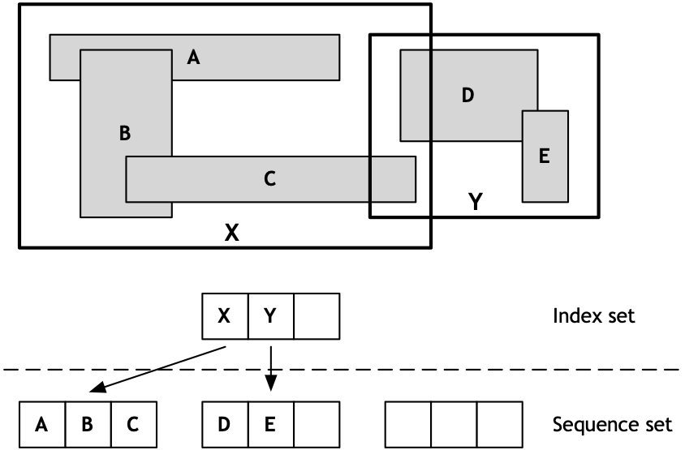

An example demonstrates how these data are used to accelerate searching. Using a mouse, a person could outline a region on a map displayed on a screen. The minimum bounding rectangle for this region would then be determined and the coordinates used to locate geographic objects falling within the minimum boundary. Because an R-tree is an index, geographic objects falling within a region can be found rapidly. In the following figure, the drawn region (it has a bold border) completely covers object E. The R-tree software would determine that the required object falls within intermediate region Y, and thus takes the middle node at the next level of the R-tree. Then, by examining coordinates in this node, it would determine that E is the required object.

Searching an R-tree

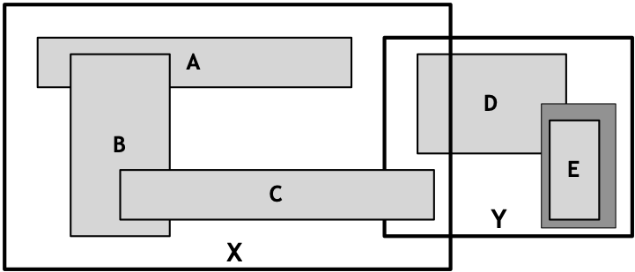

As the preceding example illustrates, an R-tree has the same index structure as a B-tree. An R-tree stores data about n-dimensional objects in each node, whereas a B-tree stores data about a one-dimensional data type in each node. Both also store pointers to the next node in the tree (the index set) or the record (the sequence set).

This short introduction to spatial data has given you some idea of how the relational model can be extended to support geometric information. Most of the major DBMS vendors support management of spatial data.

# Managing temporal data

With a temporal database, stored data have an associated time period indicating when the item was valid or stored in the database. By attaching a timestamp to data, it becomes possible to store and identify different database states and support queries comparing these states. Thus, you might be able to determine the number of seats booked on a flight by 3 p.m. on January 21, 2011, and compare that to the number booked by 3 p.m. on January 22, 2011.

To appreciate the value of a temporal database, you need to know the difference between transaction and valid time and that bitemporal data combines both valid and transaction time.

* Transaction time is the timestamp applied by the system when data are entered and cannot be changed by an application. It can be applied to a particular item or row. For example, when changing the price of a product, the usual approach would be to update the existing product row with the new price. The old price would be lost unless it was stored explicitly. In contrast, with a temporal database, the old and new prices would automatically have separate timestamps. In effect, an additional row is inserted to store the new price and the time when the insert occurred.
* Valid time is the actual time at which an item was or will be a valid or true value. Consider the case where a firm plans to increase its prices on a specified date. It might post new prices some time before their effective date. Valid time can be changed by an application.
* Bitemporal data records both the [valid time](http://en.wikipedia.org/wiki/Valid_time) and [transaction time](http://en.wikipedia.org/wiki/Transaction_time) for a fact. It usually requires four extra columns to record the upper and lower bounds for valid time and transaction time.

Valid time records when the change takes effect, and transaction time records when the change was entered. Storing transaction time is essential for database recovery because the DMBS can roll back the database to a previous state. Valid time provides a historical record of the state of the database. Both forms of time are necessary for a temporal database.

As you might expect, a temporal database will be somewhat larger than a traditional database because data are never discarded and new timestamped values are inserted so that there is a complete history of the values of an instance (e.g., the price of a product since it was first entered in the database). Thus, you can think of most of the databases we have dealt with previously as snapshots of a particular state of the database, whereas a temporal database is a record of all states of the database. As disk storage becomes increasingly cheaper and firms recognize the value of business intelligence, we are likely to see more attention paid to temporal database technology.

## Times remembered

SQL supports several different data types for storing numeric values (e.g., integer and float), and a temporal database also needs a variety of data types for storing time values. The first level of distinction is to determine whether the time value is anchored or unanchored. Anchored tim**e** has a defined starting point (e.g., October 15, 1582), and unanchored time is a block of time with no specified start (e.g., 45 minutes).

Types of temporal data[3]

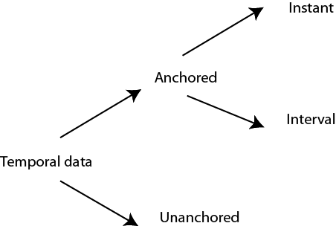

Anchored time is further split into an instant or interval. An instant is a moment in time (e.g., a date and time). In SQL, an instant can be represented by a date, time, or timestamp data type. An interval is the time between two specified instants, and can be defined as a value or a range with an upper and lower bound instant. For example, [2011-01-01, 2011-01-23] defines an interval in 2011 beginning January 1 and ending January 23.

### Interval

SQL-99 introduced the INTERVAL data type, which has not yet been implemented in MySQL. INTERVAL is a single value expressed in some unit or units of time (e.g., 6 years, 5 days, 7 hours). A small example illustrates the use of INTERVAL for time values. Consider the rotational and orbital periods of the planets . The CREATE statement for this table is

CREATE TABLE planet (

pltname VARCHAR(7),

pltday INTERVAL,

pltyear INTERVAL,

PRIMARY KEY(pltname));

Planetary data

| Planet | Rotational period (hours) | Orbital period (years) |
| --- | --- | --- |
| Mercury | 1407.51 | 0.24 |
| Venus | –5832.44a | 0.62 |
| Earth | 23.93 | 1 |
| Mars | 24.62 | 1.88 |
| Jupiter | 9.92 | 11.86 |
| Saturn | 10.66 | 29.45 |
| Uranus | 17.24 | 84.02 |
| Neptune | 16.11 | 164.79 |
| Pluto | 153.28 | 247.92 |

a. Rotates in the opposite direction to the other planets

To insert the values for Mercury, you would use

INSERT INTO planet VALUES ('Mercury','1407.51 hours','0.24 years');

### Modeling temporal data

You already have the tools for modeling temporal values. For example, the project management data model discussed in Chapter 7 and reproduced in the following figure contains temporal data.

A project management data model

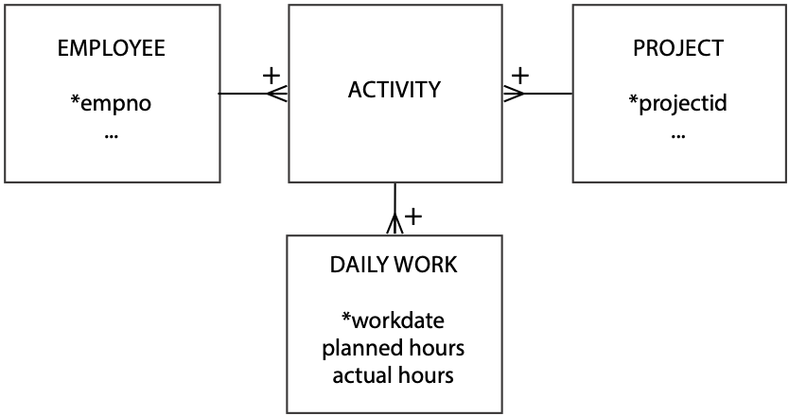

If we take the SHARE entity introduced very early in your data modeling experience, we can add temporal information to record the history of all values that are time-varying (i.e., price, quantity, dividend, and earnings). The data model to record temporal data is displayed . Firms pay dividends and report earnings only a few times per year, so we can associate a date with each value of dividend and earnings. Recording the history of trading transactions requires a timestamp, because a person can make multiple trades in a day. Every time a share is bought or sold, a new row is inserted containing both the transaction quantity and price. The number owned can be derived by using SUM.

A temporal model of SHARE

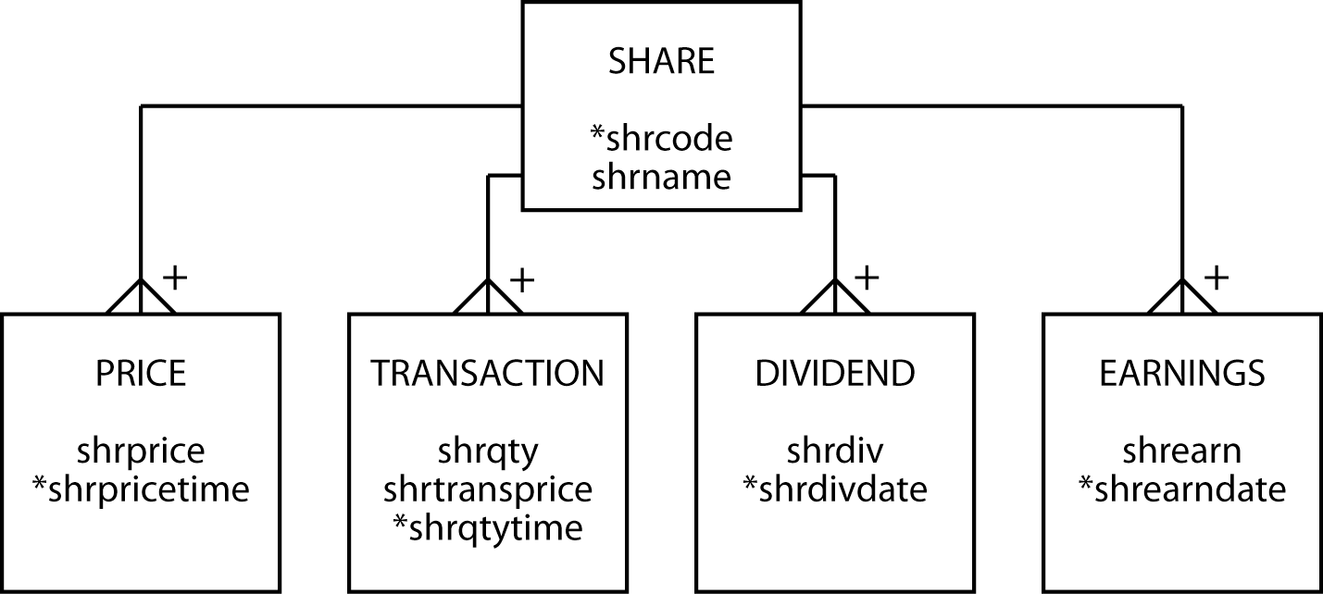

Recording the share’s price requires further consideration. If the intention is to record every change in price, then a time stamp is required as there will be multiple price changes in a day, and even in an hour, in busy trading. If there is less interest in the volatility of the stock and only the closing price for each day is of interest, then a date would be recorded.

You can add additional attributes to tables in a relational database to handle temporal data, but doing so does not make it a temporal database. The problem is that current relational implementations do not have built-in functions for querying time-varying data. Such queries can also be difficult to specify in SQL.

A temporal database has additional features for temporal data definition, constraint specification, data manipulation, and querying. A step in this direction is the development of TSQL (Temporal Structured Query Language). Based on SQL, TSQL supports querying of temporal databases without specifying time-varying criteria. SQL:2011, the seventh revision of the SQL standard, has improved support for temporal data.

## Summary

Spatial database technology stores details about items that have geometric features. It supports additional data types to describe these features, and has functions and operators to support querying. The new data types support point, line, and region values. Spatial technology is likely to develop over the next few years to support organizations offering localized information services.

Temporal database technology provides data types and functions for managing time-varying data. Transaction time and valid time are two characteristics of temporal data. Times can be anchored or unanchored and measured as an instant or as an interval.

## Key terms and concepts

Anchored time

Geographic object

Geographic information system (GIS)

Interval

Map

R-tree

Spatial data

Temporal data

Theme

Transaction time

Valid time

## References and additional readings

Gibson, Rich, and Schuyler Erle. 2006. *Google maps hacks*. Sebastopol, CA: O’Reilly.

Rigaux, P., M. O. Scholl, and A. Voisard. 2002. *Spatial databases: with application to GIS*, The Morgan Kaufmann series in data management systems. San Francisco: Morgan Kaufmann Publishers.

## Exercises

1. What circumstances will lead to increased use of spatial data?
2. A national tourist bureau has asked you to design a database to record details of items of interest along a scenic road. What are some of the entities you might include? How would you model a road? Draw the data model.
3. Using the map of the Iberian peninsula in the following figure, populate the spatial database with details of Andorra, Portugal, and Spain. Answer the following questions.
   1. What is the direct distance, or bee line, from Lisbon to Madrid?
   2. What is the farthest Spanish city from Barcelona?
   3. Imagine you get lost in Portugal and your geographic positioning system (GPS) indicates that your coordinates are (3,9). What is the nearest city?
   4. Are there any Spanish cities west of Braga?
   5. What is the area of Portugal?
   6. What is the southernmost city of Portugal?
4. Redesign the data model for political units assuming that your relational database does not support point and polygon data types.
5. For more precision and to meet universal standards, it would be better to use latitude and longitude to specify points and paths. You should also recognize that Earth is a globe and not flat. How would you enter latitude and longitude in MySQL?
6. When might you use transaction time and when might you use valid time?
7. Design a database to report basketball scores. How would you record time?
8. A supermarket chain has asked you to record what goods customers buy during each visit. In other words, you want details of each shopping basket. It also wants to know when each purchase was made. Design the database.
9. An online auction site wants to keep track of the bids for each item that a supplier sells. Design the database.
10. Complete the Google maps lab exercise listed on the book’s Web site.

Iberian Peninsula

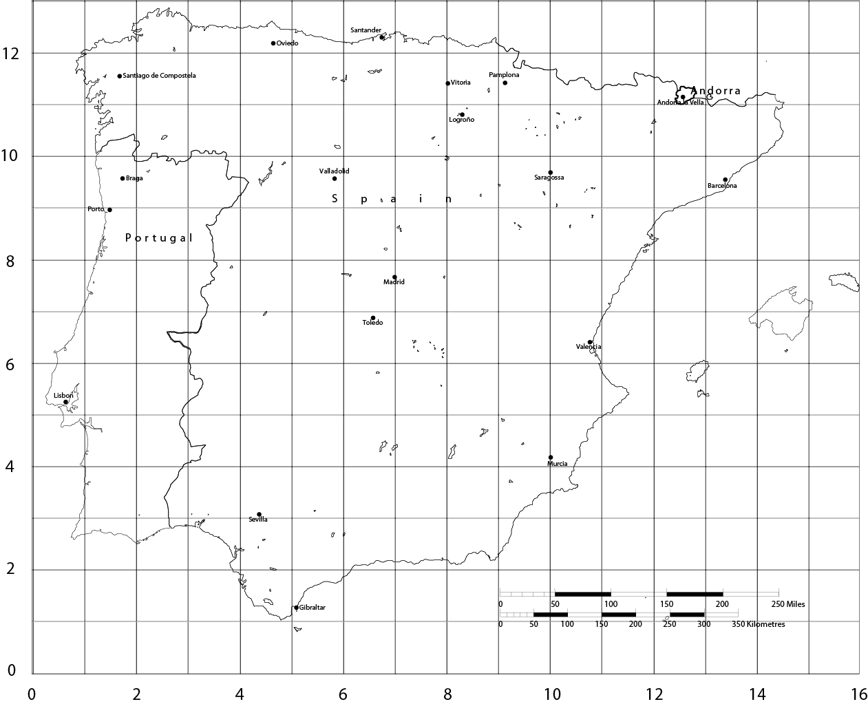

12. Graph Databases

When we use a network, the most important asset we get is access to one another.

Clay Shirky, Cognitive Surplus: Creativity and Generosity in a Connected Age, 2010

## Learning objectives

Students completing this chapter will be able to

* define the features of a labelled property graph database;
* use a graph description language (GDL) to define nodes and relationships;
* use a graph database query language (GQL) to query a graph database;
* identify applications of a graph database.

## Introduction

Relational database technology was developed to support the processing of business transactions and the querying of organizational data. As other applications, such social media developed, the labeled property database was introduced to support the processing of relationships between objects, such as people and organizations. Both are ways of modeling the world, and storing and retrieving data. Like a relational DBMS, a graph DBMS, supports Create, Read, Update, and Delete (CRUD) procedures. Both can be used for online transaction processing (OLTP) and online analytical processing (OLAP). The selection of one over the other is dependent on the purpose of the database and the nature of frequent queries. A graph database, for instance, is likely a better choice for supply chain analytics because of the network structure of a supply chain.

# A graph database

A graph is a set of nodes and relationships (edges in graph terminology). A node is similar to a relational row in that it stores data about an instance of an entity. In graph database terminology, a node has properties rather than attributes. Nodes can also have one or more labels, which are used to group nodes together and indicate their one or more roles in the domain of interest. Think of a group of nodes with a common label as an entity.

In a graph database, a relationship is explicitly defined to connect a pair of nodes, and can have properties, whereas, in a relational database, a relationship is represented by a pair of primary and foreign keys.

A graph description language (GDL) defines labels, nodes, and the properties of nodes and relationships. A GDL statement defines a specific entry in a graph database. It is like the INSERT statement of SQL. In a relational database you first define a table and then insert rows for specific instances, but in a graph database you start by defining nodes. There is no equivalent of the SQL CREATE TABLE command.

The properties of a node or relationship are specified as a key:value pair. A key is a unique identifier for some item of data (e.g., the NYSE code for a listed stock), and a value is data associated with the key (e.g., AAPL for Apple). When specifying properties of nodes or relationships, a key remains fixed and its values change for different instances. The following piece of code has two key-value pairs, and for the first, the key is StockCode and its value is “AR”. Similarly, Price is a key with the value 31.82.

StockCode: "AR", Price: 31.82

## Property data types

For the value component of a property’s key:value pair, the possible data types are:

* Numeric: Integer or Float
* String
* Boolean
* Spatial: Point
* Temporal: Date, Time, LocalTime, DateTime, LocalDateTime or Duration

A graph database is quite flexible because you can readily add nodes, relationships, and properties, while a relational database limits inserts of new data elements to the data type of columns previously defined for a table. Because there is no equivalent to defining a table in a graph database, you start by inserting nodes, relationships, and properties. Relationships are pliant, and a relationship could change from 1:m to m:m simply by adding a relationship that results in an m:m between two nodes. New additions can be made without the need to rewrite existing queries or recode applications.

Flexibility, like rigidity, has its pros and cons. Flexibility allows for new features of the environment to be quickly incorporated into a database, but at the same time it can lead to inconsistencies if nodes or properties of the same type have different keys. For example, the property for representing an employee’s first name sometimes has a key of firstName and other times a key of firstname. Rather than rushing into database creation, some initial modeling of the domain and the construction of a data dictionary is likely to be fruitful in the long run.

In summary, the key features of a labelled property graph database are:

* It consists of nodes and relationships;
* Nodes and relationships can have properties in the form of key:value pairs;
* A node can have one more labels;
* Relationships are between a pair of nodes;
* Relationships must be named.

Cypher is a combined graph description language (GDL) and graph query languages (GQL) for graph databases. Originally designed for the Neo4j graph database, it is now, in the form of Cypher 9, governed by the openCypher Implementation Group.[4] Cypher is used in open source projects (e.g., Apache Spark) and commercial products (e.g., SAP HANA). These actions indicate that Cypher will likely emerge as the industry standard language for labelled property graphs. In parallel, ISO has launched a project to create a new query language for graph databases based on openCypher and other GQLs.[5]

# Neo4j – a graph database implementation

Neo4j is a popular labeled property graph database that supports Cypher and has a free community version. These features make it suitable for learning how to create and use a graph database. To get started:

* Watch the video titled *Neo4j in Two Minutes;*[6]
* Download Neo4j Desktop[7] and follow the installation and launch guide to create a project and open your browser.

# A single node

We’ll start, as we did with the relational model, with a simple example of a set of nodes with the same label of Stock. There is no relationship between nodes. The following is a visualization of the data model. As the focus is on the graph structure, the properties of a node (a circle) are distributed around the edges of the model in rectangles.

A graph data model for a portfolio of stocks

**Stock**

StockCode

Name

Price

Qty

Div

PE

The Cypher code for creating a node for Stock is:

CREATE (:Stock {StockCode: "AR", Firm: "Abyssinian Ruby",

Price: 31.82, Qty: 22020, Div: 1.32, PE: 13});

## Inserting nodes

Usually, the data to populate a database exist in digital format, and if you can convert them to CSV format, such as an export of a spreadsheet, then you can use Cypher’s LOAD CSV command. The following code will create the nodes for each of the rows in a remote CSV file and return a count of how many nodes were created. You can load a local file by specifying a path rather than a url.

LOAD CSV WITH HEADERS FROM "https://www.richardtwatson.com/data/stock.csv" AS row

CREATE (s:Stock {StockCode: row.stkcode, Firm: row.stkfirm,

Price: toFloat(row.stkprice), Qty: toInteger(row.stkqty), Div: toFloat(row.stkdiv), PE: toInteger(row.stkpe)})

RETURN count(s);

The preceding code:

* Specifies the url of the external CSV file with the temporary name row;
* Creates a node with the label Stock and the temporary identifier s;
* Reads a row at a time and converts the format, as appropriate, since all data are read as character strings. For example, toFloat(row.stkprice) AS Price reads a cell in the stkprice column on the input file, converts it to float format and associates it with the key Price to create a key:value pair for the node identified by StockCode.

When the preceding code is executed, it creates 16 unconnected nodes, as shown in the following figure.

Visualization of unrelated nodes in graph database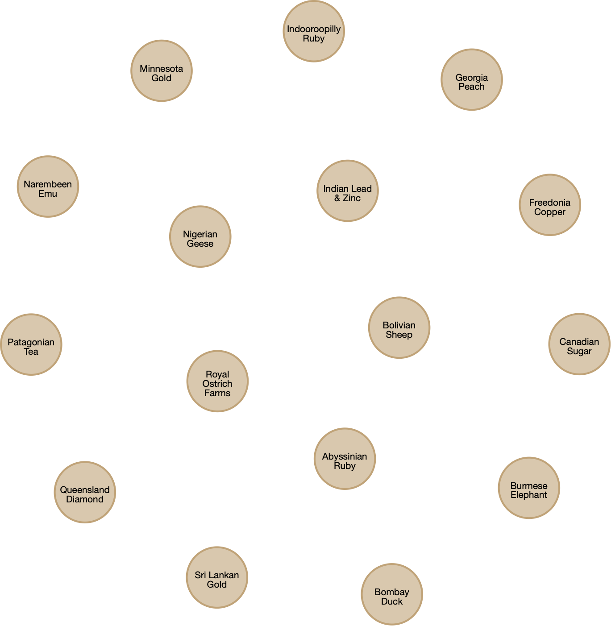

# Querying a node

This section mimics Chapter Three’s coverage of querying a single entity database. Many of the same queries are defined in Cypher code. As you should now have a clear idea of the results of a query, they are not shown in this chapter. You can alway run them in the Neo4j browser and look at the different forms of output it provides.

## Displaying data for nodes with the same label

MATCH is Cypher’s equivalent of SELECT. A MATCH statement can report the properties for a particular type of node. Each node has an associated temporary identifier which is usually short (e.g., s). In this case, RETURN s, lists all the properties of Stock.

* List all Stock data

MATCH (s:Stock)

RETURN s;

## Reporting properties

The Cypher code for the equivalent of a relational project defines the keys of the properties to be displayed. Notice how a key is prefixed with the temporary name for the node (i.e., s) to fully identify it (e.g., s.Firm) and the use of AS to rename it for reporting (e.g., s.Firm AS Firm)

* Report a firm’s name and price-earnings ratio.

MATCH (s:Stock)

RETURN s.Firm AS Firm, s.PE AS PE;

## Reporting nodes

The Cypher code for the equivalent of a relational restrict also uses a WHERE clause to specify which nodes are reported. Neo4j supports the same arithmetic, Boolean, and comparison operators as SQL for use with WHERE.

* Get all firms with a price-earnings ratio less than 12.

MATCH (s:Stock)

WHERE s.PE < 12

RETURN s;

## Reporting properties and nodes

A single Cypher MATCH statement can specify which properties of which nodes to report.

* List the name, price, quantity, and dividend of each firm where the share holding is at least 100,000.

MATCH (s:Stock)

WHERE s.Qty > 100000

RETURN s.Firm AS Firm, s.Price AS Price, s.Qty AS Quantity, s.Div AS Dividend;

## IN for a list of values

As with SQL, the keyword IN is used with a list to specify a set of values.

* Report data on firms with codes of FC, AR, or SLG.

MATCH (s:Stock)

WHERE s.StockCode IN ['FC','AR','SLG']

RETURN s;

Skill builder

List those shares where the value of the holding exceeds one million.

## Ordering rows

In Cypher, the ORDER BY clause sorts properties.

* List all firms where the PE is at least 10, and order the report in descending PE. Where PE ratios are identical, list firms in alphabetical order.

MATCH (s:Stock)

WHERE s.PE >= 10

RETURN s

ORDER BY s.PE DESC, s.Firm;

## Derived data

Calculations can be included in a query.

* Get firm name, price, quantity, and firm yield.

MATCH (s:Stock)

RETURN s.Firm AS Firm, s.Price AS Price, s.Qty AS Quantity,

s.Div/s.Price*100 AS Yield;

## Aggregate functions

Cypher has built-in functions similar to those of SQL, as the following two examples illustrate.

### COUNT

* How many firms are there in the portfolio?

MATCH (s:Stock)

RETURN count(s);

### AVG

* What is the average yield for the portfolio?

MATCH (s:Stock)

RETURN avg(s.Div/s.Price*100) As `Average yield`;

In the prior query, note how you use an angle quote (`), rather than a straight quote, to specify a column header that contains spaces.

## String handling

Cypher includes functions for string handling and supports regular expressions. The string functions are typical of those in other programming languages, such as toLower(), toUpper(), toString(), left(), right(), substring(), and replace(). For a complete list, see the Cypher manual.[8]

Cypher supports regular expression using the syntax of Java regular expressions.

* List the names of firms with a double ‘e’.

In the following code, the regular expression looks for any number of characters at the beginning or end of each string (.*) with two consecutive ‘e’s ([e]{2}) in between.

MATCH (s:Stock)

WHERE s.Firm =~ '.*[e]{2}.*'

RETURN s.Firm;

You can also express the query using the Cypher contains clause, as follows:

MATCH (s:Stock)

WHERE s.Firm CONTAINS 'ee'

RETURN s.Firm;

## Subqueries

A subquery requires you to determine the answer to another query before you can write the query of ultimate interest. The WITH clause chains subqueries by forwarding the results from one subquery to the next. For example, to list all shares with a PE ratio greater than the portfolio average, you first must find the average PE ratio for the portfolio, and then use the computed value in a second query.

* Report all firms with a PE ratio greater than the average for the portfolio.

MATCH (s:Stock)

WITH AVG(s.PE) AS AvgPE

MATCH (s:Stock)

WHERE s.PE > AvgPE

RETURN s.Firm AS FIRM, s.PE as PE;

# A relationship between nodes

We will use the data model in Chapter Four that records details of stocks listed in difference countries for illustrating a 1:m relationship between nodes. When developing a graph model, common nouns become labels (e.g., stock and country) and verbs become relationships. In the phrase "a nations lists many stocks,” we could extract the verb lists to use as a relationship name.

Lists

**Stock**

StockCode

Firm

Price

Qty

Div

PE

**Nation**

NatCode

Nation

ExchRate

**Lists**

ListingDate

A graphical data model for an international portfolio of stocks

In this case, a country can list many stocks. First, we need to add four nation nodes to the graph database, as follows:

LOAD CSV WITH HEADERS FROM "https://www.richardtwatson.com/data/nation.csv" AS row

CREATE (n:Nation {NationCode: row.natcode, Nation: row.natname, ExchRate: toFloat(row.exchrate)})

RETURN count(n);

## Specifying relationships in Cypher

Relationships are represented in Cypher using an arrow, either -> or <-, between two nodes. A node can have relationships to itself (i.e., recursive). In Neo4j, all relationships are directed (i.e., they are -> or <-).

The nature of the relationship is defined within square brackets, such as [:LISTS] in the case where a nation lists a stock on its exchange:

(n:Nation)-[:LISTS]->(s:Stock);

If you want to refer to a relationship later in a query, you can define a temporary name. In the follow code sample, r is the temporary name for referring to the relationship LISTS.

MATCH (n:Nation)-[r:LISTS]->(s:Stock)

Relationships can also have properties. The Cypher code for stating that Bombay Duck was listed in India on 2019-11-10 is:

MATCH (s:Stock), (n:Nation)

WHERE s.ShareCode = "BD" AND c.NationCode = "IND"

CREATE (n)-[r:LISTS {Listed: date(‘2019-11-10')}]->(s)

RETURN r;

The WHERE clause specifies that nodes Bombay Duck and India are related. The third line of code creates the relationship by stating one nation, abbreviated as n, can list many stocks, abbreviated as s. The name of the relationship, LISTS, has the temporary name of r, which is is used in the RETURN r statement.

Rather than have to match each country and its listed shares as separate code chunks as with Bombay Duck, we can reread the stock file, stock.csv, because it has a column containing the nation code of the listing country. We match this code with a Nation node having the same value for nation code to create the relationship. In other words, the Cypher code creates the relationship by reading each row of stock.csv and matching its value for row.natcode with a Nation node that has the same value for the key NatCode. This is the same logic as matching a primary and foreign key to join two tables.

LOAD CSV WITH HEADERS FROM "https://www.richardtwatson.com/data/stock.csv" AS row

MATCH (n:Nation {NatCode: row.natcode})

MATCH (s:Stock {StockCode: row.stkcode})

CREATE (n)-[r:LISTS]->(s)

RETURN r;

## Querying relationships

When defining relationship in a graph database, a coder is effectively pre-specifying how two tables are joined. As a result, querying is slightly different from the relational style. Consider the following request:

* Report the value of each stockholding in UK pounds. Sort the report by nation and firm.

The first step is define the relationship between the two nodes that contains the required properties to compute the value of the stockholding and then define the properties to be reported, the computation, and finally the sorting of the report.

MATCH (n:Nation)-[:LISTS]->(s:Stock)

RETURN n.Nation AS Nation, s.Firm AS Firm, s.Price AS Price, s.Qty as Quantity,

round(s.Price*s.Qty*n.ExchRate) AS Value

ORDER BY Nation, Firm

### WITH—reporting by groups

The WITH clause permits grouping nodes and it produces one row for each different value of the grouping node. The following example computes the value of the shareholding in UK pounds for each nation.

* Report by nation the total value of stockholdings.

MATCH (n:Nation)-[:LISTS]->(s:Stock)

WITH n, round(sum(s.Price*s.Qty*n.ExchRate)) as Value

RETURN n.Nation AS Nation, Value;

Cypher’s built-in functions (COUNT, SUM, AVERAGE, MIN, and MAX) can be used similarly to their SQL partners. They are applied to a group of rows having the same value for a specified column.

* Report the number of stocks and their total value by nation.

MATCH (n:Nation)-[:LISTS]->(s:Stock)

WITH n, count(s.StockCode) as Stocks, round(sum(s.Price*s.Qty*n.ExchRate)) as Value

RETURN n.Nation AS Nation, Stocks, Value;

Skill Builder

Report by nation the total value of dividends.

# Querying an m:m relationship

In a graph database, a relationship replaces the associative entity used in a relationship model for representing an m:m. In the following graph model we could have indicated that an item can appear in many sales and a sale can have many items. For bidirectional relationships, ignore the direction when querying rather than create two relations.

A graph data model for sales

The sales example discussed in Chapter Five illustrates how to handle a many-to-many situation. We first load these data and then define the relationship. Notice that SET is used to establish the values of price and quantity properties of the relationship, which in a relational model are attributes of the associative entity. In practice, as each transaction occurs, an entry would be generated for each item sold.

**Item**

ItemNo

ItemName

ItemType

ItemColor

**Sale**

SaleNo

SaleDate

SaleText

Contains

**Contains**

Price

Qty

LOAD CSV WITH HEADERS FROM "https://www.richardtwatson.com/data/item.csv" AS row

CREATE (i:Item {ItemNo: toInteger(row.itemno), ItemName: row.itemname, ItemType: row.itemtype, ItemColor: row.itemcolor})

RETURN count(i);

LOAD CSV WITH HEADERS FROM "https://www.richardtwatson.com/data/sale.csv" AS row

CREATE (s:Sale {SaleNo: toInteger(row.saleno), SaleDate: date(row.saledate), SaleText: row.saletext})

RETURN count(s);

LOAD CSV WITH HEADERS FROM "https://www.richardtwatson.com/data/receipt.csv" AS row

MATCH (s:Sale {SaleNo: toInteger(row.saleno)})

MATCH (i:Item {ItemNo: toInteger(row.itemno)})

CREATE (s)-[r:CONTAINS]->(i)

SET r.Price = toFloat(row.receiptprice), r.Qty = toInteger(row.receiptqty);

Once you have created the database, click on the CONTAINS relationship to get a visual of the database, as shown in the following figure. The nodes with numbers, SaleNo, are sales.

A view of the relationships between sales and items.

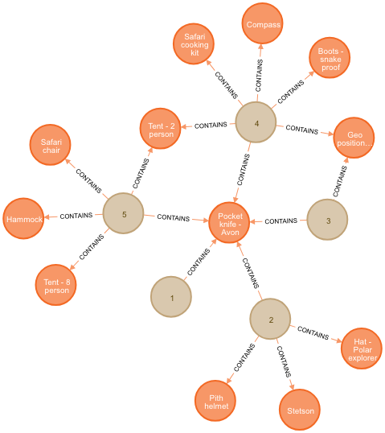

Here is an example of Cypher code for querying the graph for items and sales.

* List the name, quantity, price, and value of items sold on January 16, 2011.

MATCH (s: Sale)-[r:CONTAINS]->(i: Item)

WHERE S.SaleDate = date(‘2011-01-16')

RETURN i.ItemName AS Item, r.Qty as Quantity, r.Price as Price, r.Qty*r.Price AS Total;

The preceding query could also be written as:

MATCH (s: Sale {SaleDate: date('2011-01-16')})-[r:CONTAINS]->(i: Item)

RETURN i.ItemName AS Item, r.Qty as Quantity, r.Price as Price, r.Qty*r.Price AS Total;

## Does a relationship exist?

MATCH can be used to determine whether a particular relationship exists between two nodes by specifying the pattern of the sought relationship. The first query reports details of nodes satisfying a relationship.

* Report all clothing items (type “C”) for which a sale is recorded.

MATCH (s: Sale)-[:CONTAINS]->(i:Item {ItemType: 'C'})

RETURN DISTINCT i.ItemName AS Item, i.ItemColor AS Color;

The second query reports details of nodes not satisfying a relationship.

* Report all clothing items that have not been sold.

The query has a two stage process. First, identify all the items that have been sold and save their item numbers in SoldItems. Then, subtract this list from the the list of all items of type C to find the items not sold. This is similar to using a minus in SQL.

MATCH (s: Sale)-[:CONTAINS]->(i:Item {ItemType: 'C'})

WITH COLLECT (DISTINCT i.ItemNo) AS SoldItems

MATCH (i: Item)

WHERE i.ItemType = 'C' AND NOT (i.ItemNo IN SoldItems)

RETURN DISTINCT i.ItemName AS Item, i.ItemColor AS Color;

Skill builder

Report all red items that have not been sold.

# Recursive relationships

As you will recall, in data modeling a recursive relationship relates an entity to itself. It maps one instance in the entity to another instance of that entity. In graph terms, recursion relates nodes with the same label. The following diagram represents the previously discussed 1:1 monarch succession as graph.

A graph model for monarch

**Monarch**

Type

Name

Number

**Succeeded**

Date

Succeeded

To assist with understanding the monarch model, we repeat the prior data.

Recent British monarchs

| Type | Name | Number | Reign begin |
| --- | --- | --- | --- |
| King | William | IV | 1830-06-26 |
| Queen | Victoria | I | 1837-06-20 |
| King | Edward | VII | 1901-01-22 |
| King | George | V | 1910-05-06 |
| King | Edward | VIII | 1936-01-20 |
| King | George | VI | 1936-12-11 |
| Queen | Elizabeth | II | 1952-02-06 |

In the following Cypher code, observe the use of MATCH to connect each predecessor and successor monarch pair and the use of SET to define the succession date as a property of the succession relationship.

LOAD CSV WITH HEADERS FROM "https://www.richardtwatson.com/data/monarch.csv" AS row

CREATE (m: Monarch {Type: row.montype, Name: row.monname, Number: row.monnum})

RETURN count(m);

MATCH (p:Monarch), (s:Monarch) // p for predecessor and s for successor

WHERE p.Name = 'William' AND p.Number = 'IV' AND s.Name = 'Victoria' AND s.Number = 'I'

CREATE (s)-[r:SUCCEEDED]->(p)

SET r.Date = date('1837-06-20')

RETURN(r);

MATCH (p:Monarch), (s:Monarch)

WHERE p.Name = 'Victoria' AND p.Number = 'I' AND s.Name = 'Edward' AND s.Number = 'VII'

CREATE (s)-[r:SUCCEEDED]->(p)

SET r.Date = date('1901-01-22')

RETURN(r);

MATCH (p:Monarch), (s:Monarch)

WHERE p.Name = 'Edward' AND p.Number = 'VII' AND s.Name = 'George' AND s.Number = 'V'

CREATE (s)-[r:SUCCEEDED]->(p)

SET r.Date = date('1910-05-06')

RETURN(r);

MATCH (p:Monarch), (s:Monarch)

WHERE p.Name = 'George' AND p.Number = 'V' AND s.Name = 'Edward' AND s.Number = 'VIII'

CREATE (s)-[r:SUCCEEDED]->(p)

SET r.Date = date('1936-01-20')

RETURN(r);

MATCH (p:Monarch), (s:Monarch)

WHERE p.Name = 'Edward' AND p.Number = 'VIII' AND s.Name = 'George' AND s.Number = 'VI'

CREATE (s)-[r:SUCCEEDED]->(p)

SET r.Date = date('1936-12-11')

RETURN(r);

MATCH (p:Monarch), (s:Monarch)

WHERE p.Name = 'George' AND p.Number = 'VI' AND s.Name = 'Elizabeth' AND s.Number = 'II'

CREATE (s)-[r:SUCCEEDED]->(p)

SET r.Date = date('1952-02-06')

RETURN r;

The following figure shows the graph produced by Neo4j.

Monarch succession graph

## Querying a recursive relationship

Some queries on the monarch graph database demonstrate the ease of querying a recursive relationship. Observe how to concatenate strings by using a plus (+) sign.

* Who preceded Victoria I?

MATCH (s)-[r:SUCCEEDED]->(p)

WHERE s.Name = 'Victoria'

RETURN (p.Type + ' ' + p.Name + ' ' + p.Number);

* Who succeeded Victoria I?

MATCH (s)-[r:SUCCEEDED]->(p)

WHERE p.Name = 'Victoria'

RETURN (s.Type + ' ' + s.Name + ' ' + s.Number);

* List the kings and queens of England in ascending chronological order.

MATCH (s)-[r:SUCCEEDED]->(p)

RETURN (s.Type + ' ' + s.Name + ' ' + s.Number)

ORDER BY r.Date;

We see the power of a Cypher for querying a recursive relationship with the following query that uses *2 in the relationship pattern to select the second node in a chain of relationships.

* Who was Elizabeth II’s predecessor’s predecessor?

MATCH (s)-[r:SUCCEEDED*2]->(p)

WHERE s.Name = 'Elizabeth' and s.Number = 'II'

RETURN (p.Type + ' ' + p.Name + ' ' + p.Number);

We can also select a series of nodes in a chain, and in the following example the first to third are selected by specifying *1..3 in the relationship pattern.

* Who were Elizabeth II’s three immediate predecessors?

MATCH (s)-[r:SUCCEEDED*1..3]->(p)

WHERE s.Name = 'Elizabeth' and s.Number = 'II'

RETURN (p.Type + ' ' + p.Name + ' ' + p.Number);

The modeling and querying of 1:m and m:m recursive relationships are almost identical. Consider the case where an employee is the boss of other employees, then this could be expressed as:

MATCH (b:Employee), (e:Employee) // b for boss and e for employee

WHERE b.EmpCode = 1 AND e.EmpCode IN [2, 15, 23]

CREATE (b)-[r:IS_BOSS_OF]->(e);

and a query might start with:

MATCH (b)-[r:IS_BOSS_OF]->(e)

For a recursive m:m, such as a bill of materials, we might write:

MATCH (a:Part), (p:Part) // a for assembly and p for part

WHERE a.PartCode = 1 AND p.PartCode IN [2,35,4,19,121]

CREATE (a)-[r:CONTAINS]->p;

## Indexes and constraints

To speed up processing, indexes can be created on labels and property combinations. For example, the following code indexes the Stock label on the values of StockCode.

CREATE INDEX ON :Stock(StockCode);

If you wanted to ensure all nation codes are unique, you would code:

CREATE CONSTRAINT ON (n:Nation) ASSERT n.NatCode IS UNIQUE;

## Remove duplicates

As with SQL, DISTINCT will remove duplicates from the results of a query.

MATCH (s:Stock)

RETURN DISTINCT s.PE AS PE;

## Delete all nodes and relationships

To start afresh, use the following code to delete all nodes and relationships:

MATCH (a)

OPTIONAL MATCH (a)-[r]-()

DELETE a, r

## Conclusion

Graph databases are suitable for a wide range of common business problems. Graph analytics, in general, is useful for addressing three types of questions: How do things spread? What are the capacities, costs, and control points? How do things interact, and will that change?[9]

## Summary

A labeled property graph database consists of nodes and relationships. Both nodes and relationships can have properties. A relationship is explicitly defined to connect a pair of nodes, and can have properties. Nodes and relationships can have properties in the form of key:value pairs. Nodes can be given one or more labels to group them. A graph description language (GDL) defines nodes and relationships. A graph query language (GQL) enables querying. Cypher is a GDL and GQL. A graph database is a good choice when many queries are about the network of relationships between nodes.

## Key terms and concepts

Edge

Graph

Label

Node

Property

Relationship

## References and additional resources

Francis, N., Green, A., Guagliardo, P., Libkin, L., Lindaaker, T., Marsault, V., . . . Taylor, A. (2018). Cypher: An evolving query language for property graphs. Paper presented at the Proceedings of the 2018 International Conference on Management of Data. doi:10.1145/3183713.3190657

Robinson, I., Webber, J., & Eifrem, E. (2013). Graph databases: O'Reilly Media, Inc. ISBN: 1449356249

Problem showcases: [gist.neo4j.org/](http://gist.neo4j.org/) and [neo4j.com/use-cases/](http://neo4j.com/use-cases/)

## Exercises

The following exercises are based on the NorthWinds graph database, which you can create on your desktop by running the supplied code.[10] The graph model for NorthWinds follows the questions.

1. Write Cypher code for the following queries.
   1. How many employees are there in the company?
   2. Prepare a list of employees by last name, first name, and job title. Sort by last name.
   3. List the products that contain ‘sauce’ in their product description.
   4. In what category are sauces?
   5. List in alphabetical order those customers have placed an order.
   6. List in alphabetical order those customers who have not placed an order.
   7. Which customers have purchased ‘Chai’?
   8. List the amount ordered by each customer by the value of the order.
   9. List the products in each category.
   10. How many products in each category?
   11. What is the minimum value of a received order?
   12. Who is the customer who placed the minimum value order?
   13. Report total value of orders for Blauer See Delikatessen.
   14. Who reports to Andrew Fuller? Report by last name alphabetically and concatenate first and last names for each person.
   15. Report those employees who have sold to Blauer See Delikatessen.
   16. Report the total value of orders by year.
   17. Basket of goods analysis: A common retail analytics task is to analyze each basket or order to learn what products are often purchased together. Report the names of products that appear in the same order three or more times.

Sold

Part of

Supplies

Purchased

Contains

Reports to

* 1. ABC reporting: Compute the revenue generated by each customer based on their orders. Also, show each customer's revenue as a percentage of total revenue. Sort by customer name.
  2. Same as Last Year (SALY) analysis: Compute the ratio for each product of sales for 1997 versus 1996.

Graph model for NorthWinds

13. XML: Managing Data Exchange

Words can have no single fixed meaning. Like wayward electrons, they can spin away from their initial orbit and enter a wider magnetic field. No one owns them or has a proprietary right to dictate how they will be used.

David Lehman, End of the Word, 1991

## Learning objectives

Students completing this chapter will be able to

* define the purpose of XML;
* create an XML schema;
* code data in XML format;
* create an XML stylesheet;
* discuss data management options for XML documents.

## Introduction

There are four central problems in data management: capture, storage, retrieval, and exchange. The focus for most of this book has been on storage (i.e., data modeling) and retrieval (i.e., SQL). Now it is time to consider capture and exchange. Capture has always been an important issue, and the guiding principle is to capture data once in the cheapest possible manner.

# SGML

The Standard Generalized Markup Language (SGML) was designed to reduce the cost and increase the efficiency of document management. Its child, XML, has essentially replaced SGML. For example, the second edition of the *Oxford English Dictionary* was specified in SGML, and the third edition is stored in XML format.[11]

A markup language embeds information about a document in the text. In the following table, the markup tags indicate that the text contains CD liner notes. Note also that the titles and identifiers of the mentioned CDs are explicitly identified.

Markup language

<cdliner>This uniquely creative collaboration between Miles Davis and Gil Evans has already resulted in two extraordinary albums—<cdtitle>Miles Ahead</cdtitle><cdid>CL 1041</cdid> and <cdtitle>Porgy and Bess</cdtitle><cdid>CL 1274</cdid>.</cdliner>

SGML is an International Standard (ISO 8879) that defines the structure of documents. It is a vendor-independent language that supports cross-system portability and publication for all media. Developed in 1986 to manage software documentation, SGML was widely accepted as the markup language for a number of information-intensive industries. As a metalanguage, SGML is the mother of both HTML and XML.

SGML illustrates four major advantages a markup language provides for data management:

* Reuse: Information can be created once and reused over and over. By storing critical documents in markup format, firms do not need to duplicate efforts when there are changes to documents. For example, a firm might store all its legal contracts in SGML.
* Flexibility: SGML documents can be published in any medium for a wide variety of audiences. Because SGML is content-oriented, presentation decisions are delayed until the output format is known. Thus, the same content could be printed, presented on the Web in HTML, or written to a DVD as a PDF.
* Revision: SGML enhances control over revision and enables version control. When stored in an SGML database, original data are archived alongside any changes. That means you know exactly what the original document contained and what changes were made.
* Format independence: SGML files are stored as text and can be read by many programs on all operating systems. Thus, it preserves textual information independent of how and when it is presented. SGML protects a firm’s investment in documentation for the long term. Because it is now possible to display documentation using multiple media (e.g., Web and iPad), firms have become sensitized to the need to store documents in a single, independent manner that can then be converted for display by a particular medium.

SGML’s power is derived from its recording of both text and the meaning of that text. A short section of SGML demonstrates clearly the features and strength of SGML. The tags surrounding a chunk of text describe its meaning and thus support presentation and retrieval. For example, the pair of tags <title> and </title> surrounding “XML: Managing Data Exchange” indicates that it is the chapter title.

SGML code

<chapter>

<no>18</no>

<title>XML: Managing Data Exchange</title>

<section>

<quote><emph type = '2'>Words can have no single fixed meaning. Like wayward electrons, they can spin away from their initial orbit and enter a wider magnetic field. No one owns them or has a proprietary right to dictate how they will be used.</emph>

</quote>

</section>

</chapter>

Taking this piece of SGML, it is possible, using an appropriate stylesheet, to create a print version where the title of the chapter is displayed in Times, 16 point, bold, or a HTML version where the title is displayed in red, Georgia, 14 point, italics. Furthermore, the database in which this text is stored can be searched for any chapters that contain “Exchange” in their title.

Now, consider the case where the text is stored as HTML. How do you, with complete certainty, identify the chapter title? Do you extract all text contained by <h1> and </h1> tags? You will then retrieve “18” as a possible chapter title. What happens if there is other text displayed using <h1> and </h1> tags? The problem with HTML is that it defines presentation and has very little meaning. A similar problem exists for documents prepared with a word processor.

HTML code

<html>

<body>

<h1><b>18 </b></h1>

<h1><b>XML: Managing Data Exchange</b></h1>

<p><i>Words can have no single fixed meaning. Like wayward electrons, they can spin away from their initial orbit and enter a wider magnetic field. No one owns them or has a proprietary right to dictate how they will be used.</i>

</body>

</html>

By using embedded tags to record meaning, SGML makes a document platform-independent and greatly improves the effectiveness of searching. Despite its many advantages, there are some features of SGML that make implementation difficult and also limit the ability to create tools for information management and exchange. As a result, XML, a derivative of SGML, was developed.

# XML

Extensible Markup Language (XML), a language designed to make information self-describing, retains the core ideas of SGML. You can think of XML as SGML for electronic and mobile commerce. Since the definition of XML was completed in early 1998 by the World Wide Web Consortium (W3C), the standard has spread rapidly because it solves a critical data management problem. XML is a metalanguage—a language to generate languages.

Despite having the same parent, there are major differences between XML and HTML.

XML vs. HTML

| XML | HTML |
| --- | --- |
| Structured text | Formatted text |
| User-definable structure (extensible) | Predefined formats (not extensible) |
| Context-sensitive retrieval | Limited retrieval |
| Greater hypertext linking | Limited hypertext linking |

HTML, an electronic-publishing language, describes how a Web browser should display text and images on a computer screen. It tells the browser nothing about the meaning of the data. For example, the browser does not know whether a piece of text represents a price, a product code, or a delivery date. Humans infer meaning from the context (e.g., August 8, 2012, is recognized as a date). Given the explosive growth of the Web, HTML clearly works well enough for exchanging data between computers and humans. It does not, however, work for exchanging data between computers, because computers are not smart enough to deduce meaning from context.

Successful data exchange requires that the meaning of the exchanged data be readily determined by a computer. The XML solution is to embed tags in a file to describe the data (e.g., insert tags into an order to indicate attributes such as price, size, quantity, and color). A browser, or program for that matter, can then recognize this document as a customer order. Consequently, it can do far more than just display the price. For example, it can convert all prices to another currency. More importantly, the data can be exchanged between computers and understood by the receiving system.

XML consists of rules (that anyone can follow to create a markup language (e.g., a markup language for financial data such as XBRL). Hence, the “eXtensible” in the XML name, indicating that the language can be easily extended to include new tags. In contrast, HTML is not extensible and its set of tags is fixed, which is one of the major reasons why HTML is easy to learn. The XML rules ensure that a type of computer program known as a parser can process any extension or addition of new tags.

XML rules

* Elements must have both an opening and a closing tag.
* Elements must follow a strict hierarchy with only one root element.
* Elements must not overlap other elements.
* Element names must obey XML naming conventions.
* XML is case sensitive.

Consider the credit card company that wants to send you your latest statement via the Internet so that you can load it into your financial management program. Since this is a common problem for credit card companies and financial software authors, these industry groups have combined to create Open Financial Exchange (OFX),[12] a language for the exchange of financial data across the Internet.

XML has a small number of rules. Tags always come in pairs, as in HTML. A pair of tags surrounds each piece of data (e.g., <price>89.12</price>) to indicate its meaning, whereas in HTML ,they indicate how the data are presented. Tag pairs can be nested inside one another to multiple levels, which effectively creates a tree or hierarchical structure. Because XML uses Unicode (see the discussion in Chapter 11), it enables the exchange of information not only between different computer systems, but also across language boundaries.

The differences between HTML and XML are captured in the following examples for each markup language. Note that in the following table, HTML incorporates formatting instructions (i.e., the course code is bold), whereas XML describes the meaning of the data.

Comparison of HTML and XML coding

| HTML | XML |
| --- | --- |
| <p><b>MIST7600</b>  Data Management<br>  3 credit hours</p>  </course> | <course>  <code>MIST7600</code>  <title>Data Management</title>  <credit>3</credit> |

XML enables a shift of processing from the server to the browser. At present, most processing has to be done by the server because that is where knowledge about the data is stored. The browser knows nothing about the data and therefore can only present but not process. However, when XML is implemented, the browser can take on processing that previously had to be handled by the server.

Imagine that you are selecting a shirt from a mail-order catalog. The merchant’s Web server sends you data on 20 shirts (100 Kbytes of text and images) with prices in U.S. dollars. If you want to see the prices in euros, the calculation will be done by the server, and the full details for the 20 shirts retransmitted (i.e., another 100 Kbytes are sent from the server to the browser). However, once XML is in place, all that needs to be sent from the server to the browser is the conversion rate of U.S. dollars to euros and a program to compute the conversion at the browser end. In most cases, less data will be transmitted between a server and browser when XML is in place. Consequently, widespread adoption of XML will reduce network traffic.

Execution of HTML and XML code

| HTML | XML |
| --- | --- |
| Retrieve shirt data with prices in USD.  Retrieve shirt data with prices in EUR. | Retrieve shirt data with prices in USD.  Retrieve conversion rate of USD to EUR.  Retrieve Java program to convert currencies.  Compute prices in EUR. |

XML can also make searching more efficient and effective. At present, search engines look for matching text strings, and consequently return many links that are completely irrelevant. For instance, if you are searching for details on the Nomad speaker system, and specify “nomad” as the sought text string, you will get links to many items that are of no interest (e.g., The Fabulous Nomads Surf Band). Searching will be more precise when you can specify that you are looking for a product name that includes the text “nomad.” The search engine can then confine its attention to text contained with the tags <productname> and </productname>, assuming these tags are the XML standard for representing product names.

The major expected gains from the introduction of XML are

* Store once and format many ways—Data stored in XML format can be extracted and reformatted for multiple presentation styles (e.g., printed report, DVD).
* Hardware and software independence—One format is valid for all systems. Capture once and exchange many times—Data are captured as close to the source as possible and never again (i.e., no rekeying).
* Accelerated targeted searching—Searches are more precise and faster because they use XML tags.
* Less network congestion—The processing load shifts from the server to the browser.

## XML language design

XML lets developers design application-specific vocabularies. To create a new language, designers must agree on three things:

* The allowable tags
* The rules for nesting tagged elements
* Which tagged elements can be processed

The first two, the language’s vocabulary and structure, are typically defined in an XML schema. Developers use the XML schema to understand the meaning of tags so they can write software to process an XML file.

XML tags describe meaning, independent of the display medium. An XML stylesheet, another set of rules, defines how an XML file is automatically formatted for various devices. This set of rules is called an Extensible Stylesheet Language (XSL). Stylesheets allow data to be rendered in a variety of ways, such as Braille or audio for visually impaired people.

## XML schema

An XML schema (or just schema for brevity) is an XML file associated with an XML document that informs an application how to interpret markup tags and valid formats for tags. The advantage of a schema is that it leads to standardization. Consistently named and defined tags create conformity and support organizational efficiency. They avoid the confusion and loss of time when the meaning of data is not clear. Also, when validation information is built into a schema, some errors are detected before data are exchanged.

XML does not require the creation of a schema. If a document is well formed, XML will interpret it correctly. A well-formed document follows XML syntax and has tags that are correctly nested.

A schema is a very strict specification, and any errors will be detected when parsing. A schema defines:

* The names and contents of all elements that are permissible in a certain document
* The structure of the document
* How often an element may appear
* The order in which the elements must appear
* The type of data the element can contain

### DOM

The Document Object Model (DOM) is the model underlying XML. It is based on a tree (i.e., it directly supports one-to-one and one-to-many, but not many-to-many relationships). A document is modeled as a hierarchical collection of nodes that have parent/child relationships. The node is the primary object and can be of different types (such as document, element, attribute, text). Each document has a single document node, which has no parent, and zero or more children that are element nodes. It is a good practice to create a visual model of the XML document and then convert this to a schema, which is XML’s formal representation of the DOM.

At this point, an example is the best way to demonstrate XML, schema, and DOM concepts. We will use the familiar CD problem that was introduced in Chapter 3. In keeping with the style of this text, we define a minimal amount of XML to get you started, and then more features are added once you have mastered the basics.

## CD library case

The CD library case gradually develops, over several chapters, a data model for recording details of a CD collection, culminating in the model at the end of Chapter 6. Unfortunately, we cannot quickly convert this final model to an XML document model, because a DOM is based on a tree model. Thus, we must start afresh.

The model , in this case, is based on the observation that a CD library has many CDs, and a CD has many tracks.

CD library tree data model

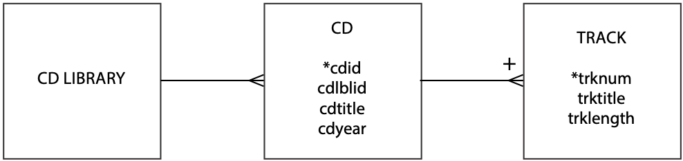

A model is then mapped into a schema using the following procedure.

* Each entity becomes a complex element type.
* Each data model attribute becomes a simple element type.
* The one-to-many (1:m) relationship is recorded as a sequence.

The schema for the CD library follows. For convenience of exposition, the source code lines have been numbered, but these numbers are not part of a schema.[13]

Schema for CD library (cdlib.xsd)

|  |  |
| --- | --- |
| 1  2  3  4  5  6  7  8  9  10  11  12  13  14  15  16  17  18  19  20  21  22  23  24  25  26  27  28  29  30  31 | <?xml version="1.0" encoding="UTF-8"?>  <xsd:schema xmlns:xsd='http://www.w3.org/2001/XMLSchema'>  <!--CD library-->  <xsd:element name="cdlibrary">  <xsd:complexType>  <xsd:sequence>  <xsd:element name="cd" type="cdType" minOccurs="1"  maxOccurs="unbounded"/>  </xsd:sequence>  </xsd:complexType>  </xsd:element>  <!--CD-->  <xsd:complexType name="cdType">  <xsd:sequence>  <xsd:element name="cdid" type="xsd:string"/>  <xsd:element name="cdlabel" type="xsd:string"/>  <xsd:element name="cdtitle" type="xsd:string"/>  <xsd:element name="cdyear" type="xsd:integer"/>  <xsd:element name="track" type="trackType" minOccurs="1"  maxOccurs="unbounded"/>  </xsd:sequence>  </xsd:complexType>  <!--Track-->  <xsd:complexType name="trackType">  <xsd:sequence>  <xsd:element name="trknum" type="xsd:integer"/>  <xsd:element name="trktitle" type="xsd:string"/>  <xsd:element name="trklen" type="xsd:time"/>  </xsd:sequence>  </xsd:complexType>  </xsd:schema> |

There are several things to observe about the schema.

* All XML documents begin with an XML declaration {1}.[14] The encoding attribute (i.e., encoding="UTF-8") specifies what form of Unicode is used (in this case the 8-bit form).
* The XSD Schema namespace[15] is declared {2}.
* Comments are placed inside the tag pair <!-- and --> {3}.
* The CD library is defined {4–10} as a complex element type, which essentially means that it can have embedded elements, which are a sequence of CDs in this case.
* A sequence is a series of child elements embedded in a parent, as illustrated by a CD library containing a sequence of CDs {7}, and a CD containing elements of CD identifier, label, and so forth {15–20}. The order of a sequence must be maintained by any XML document based on the schema.
* A sequence can have a specified range of elements. In this case, there must be at least one CD (minOccurs="1") but there is no upper limit (maxOccurs= "unbounded") on how many CDs there can be in the library {7}.
* An element that has a child (e.g., cdlibrary, which is at the 1 end of a 1:m) or possesses attributes (e.g., track) is termed a complex element type.
* A CD is represented by a complex element type {13–20}, and has the name cdType {13}.
* The element cd is defined by specifying the name of the complex type (i.e., cdType) containing its specification {7}.
* A track is represented by a complex type because it contains elements of track number, title, and length {24–30}. The name of this complex type is trackType {24}.
* Notice the reference within the definition of cd to the complex type trackType, used to specify the element track {19}.
* Simple types (e.g., cdid and cdyear) do not contain any elements, and thus the type of data they store must be defined. Thus, cdid is a text string and cdyear is an integer.

The purpose of a schema is to define the contents and structure of an XML file. It is also used to verify that an XML file has a valid structure and that all elements in the XML file are defined in the schema.

If you use an editor, you can possibly create a visual view of the schema.

A visual depiction of a schema as created by Oxygen

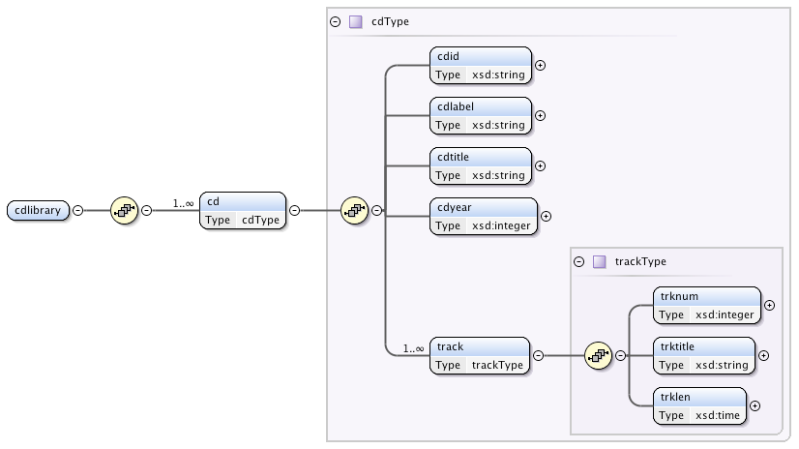Some common data types are shown in the following table. The meaning is obvious in most cases for those familiar with SQL, except for uriReference. A Uniform Resource Identifier (URI) is a generalization of the URL concept.

Some common data types

| Data type |
| --- |
| string |
| boolean |
| anyURI |
| decimal |
| float |
| integer |
| time |
| date |

We can now use the recently defined CDlibrary schema to describe a small CD library containing the CD information given in the following table.

Data for a small CD library

|  |  |  |  |  |
| --- | --- | --- | --- | --- |
| Id A2 1325  Label Atlantic  Title Pyramid  Year 1960 | | | D136705  Verve  Ella Fitzgerald  2000 | |
| Track | Title | Length | Title | Length |
| 1 | Vendome | 2:30 | A tisket, a tasket | 2:37 |
| 2 | Pyramid | 10:46 | Vote for Mr. Rhythm | 2:25 |
| 3 |  |  | Betcha nickel | 2:52 |

The XML for describing the CD library follows. There are several things to observe:

* All XML documents begin with an XML declaration.
* The declaration immediately following the XML declaration identifies the root element of the document (i.e., cdlibrary) and the schema (i.e., cdlib.xsd).
* Details of a CD are enclosed by the tags <cd> and </cd>.
* Details of a track are enclosed by the tags <track> and </track>.

XML for describing a CD (cdlib.xml)

<?xml version="1.0" encoding="UTF-8"?>

<cdlibrary xmlns:xsi="<http://www.w3.org/2001/XMLSchema-instance>"

xsi:noNamespaceSchemaLocation="cdlib.xsd">

<cd>

<cdid>A2 1325</cdid>

<cdlabel>Atlantic</cdlabel>

<cdtitle>Pyramid</cdtitle>

<cdyear>1960</cdyear>

<track>

<trknum>1</trknum>

<trktitle>Vendome</trktitle>

<trklen>00:02:30</trklen>

</track>

<track>

<trknum>2</trknum>

<trktitle>Pyramid</trktitle>

<trklen>00:10:46</trklen>

</track>

</cd>

<cd>

<cdid>D136705</cdid>

<cdlabel>Verve</cdlabel>

<cdtitle>Ella Fitzgerald</cdtitle>

<cdyear>2000</cdyear>

<track>

<trknum>1</trknum>

<trktitle>A tisket, a tasket</trktitle>

<trklen>00:02:37</trklen>

</track>

<track>

<trknum>2</trknum>

<trktitle>Vote for Mr. Rhythm</trktitle>

<trklen>00:02:25</trklen>

</track>

<track>

<trknum>3</trknum>

<trktitle>Betcha nickel</trktitle>

<trklen>00:02:52</trklen>

</track>

</cd>

</cdlibrary>

As you now realize, the definition of an XML document is relatively straightforward. It is a bit tedious with all the typing of tags to surround each data element. Fortunately, there are XML editors that relieve this tedium.

Skill builder

1. Use the Firefox browser[16] to access this book’s Web site, link to the Support > XML section, and click on customerpayments.xml. You will see how this browser displays XML. Investigate what happens when you click on the '-' and '+' signs next to some entries.
2. Again, using Firefox, save the displayed XML code (Save Page As …) as customerpayments.xml, and open it in a text editor.
3. Now, add details of the customer and payment data displayed in the following table to the beginning of the XML file. Open the saved file with Firefox, and verify your work.

Customer and payment data

|  |  |  |
| --- | --- | --- |
| AA Souvenirs  Yallingup  Australia | | |
| Check | Amount | Date |
| QP45901 | 9387.45 | 2005-03-16 |
| AG9984 | 3718.67 | 2005-07-24 |

### XSL

As you now know from the prior exercise, the browser display of XML is not particularly useful. What is missing is a stylesheet that tells the browser how to display an XML file. The eXtensible Stylesheet Language (XSL) is used for defining the rendering of an XML file. An XSL document defines the rules for presenting an XML document’s data. XSL is an application of XML, and an XSL file is also an XML file.

The power of XSL is demonstrated by applying the stylesheet that follows to the preceding XML.

Result of applying a stylesheet to CD library data

|  |
| --- |
| Complete List of Songs  Pyramid, Atlantic, 1960.5 [A2 1325]  1 Vendome 00:02:30  2 Pyramid 00:10:46  Ella Fitzgerald, Verve, 2000 [D136705]  1 A tisket, a tasket 00:02:37  2 Vote for Mr. Rhythm 00:02:25  3 Betcha nickel 00:02:52 |

Stylesheet for displaying an XML file of CD data (cdlib.xsl)

|  |  |
| --- | --- |
| 1  2  3  4  5  6  7  8  9  10  11  12  13  14  15  16  17  18  19  20  21  22  23  24  25  26  27  28  29  30 | <?xml version="1.0" encoding="UTF-8"?>  <xsl:stylesheet version="1.0"  xmlns:xsl="<http://www.w3.org/1999/XSL/Transform>">  <xsl:output encoding="UTF-8" indent="yes" method=“html" />  <xsl:template match="/">  <html>  <head>  <title> Complete List of Songs </title>  </head>  <body>  <h1> Complete List of Songs </h1>  <xsl:apply-templates select="cdlibrary" />  </body>  </html>  </xsl:template>  <xsl:template match="cdlibrary">  <xsl:for-each select="cd">  <br/>  <font color="maroon">  <xsl:value-of select="cdtitle" />  ,  <xsl:value-of select="cdlabel" />  ,  <xsl:value-of select="cdyear" />  [  <xsl:value-of select="cdid" />  ] </font>  <br/>  <table>  <xsl:for-each select="track">  <tr>  <td align="left">  <xsl:value-of select="trknum" />  </td>  <td>  <xsl:value-of select="trktitle" />  </td>  <td align="center">  <xsl:value-of select="trklen" />  </td>  </tr>  </xsl:for-each>  </table>  <br/>  </xsl:for-each>  </xsl:template>  </xsl:stylesheet> |

To use a stylesheet with an XML file, you must add a line of code to point to the stylesheet file. In this case, you add the following:

<?xml-stylesheet type=”text/xsl” href=”cdlib.xsl” media=”screen”?>

as the second line of cdlib.xml (i.e., it appears before <cdlibrary … >). The added line of code points to cdlib.xsl as the stylesheet. This means that when the browser loads cdlib.xml, it uses the contents of cdlib.xsl to determine how to render the contents of cdlib.xml.

We now need to examine the contents of cdlib.xsl so that you can learn some basics of creating XSL commands. You will soon notice that all XSL commands are preceded by xsl:.

* Tell the browser it is processing an XML file {1}
* Specify that the file is a stylesheet {2}
* Specify a template, which identifies which elements should be processed and how they are processed. The match attribute {4} indicates the template applies to the source node. Process the template {11} defined in the file {15–45}. A stylesheet can specify multiple templates to produce different reports from the same XML input.
* Specify a template to be applied when the XSL processor encounters the <cdlibrary> node {15}.
* Create an outer loop for processing each CD {16–44}.
* Define the values to be reported for each CD (i.e., title, label, year, and id) {19, 21, 23, 25}. The respective XSL commands select the values. For example, <xsl:value-of select=”cdtitle” /> specifies selection of cdtitle.
* Create an inner loop for processing the tracks on a particular CD {29–41}.
* Present the track data in tabular form using HTML table commands interspersed with XSL {28–42}.

Skill builder

1. Use the Firefox browser to access this book’s Web site, navigate to the XML page, and download cdlib.xml and cdlib.xsl to a directory or folder on your machine. Use Save Page As … for downloading.
2. Using a text editor, change the saved copy of cdlib.xml by inserting the following as the second line:  
   <?xml-stylesheet type="text/xsl" href="cdlib.xsl" media="screen"?>
3. Save the edited file in the same directory or folder as cdlib.xsl. Open the saved XML file with Firefox.

## Converting XML

There are occasions when there is a need to convert an XML file:

* Transformation: conversion from one XML vocabulary to another (e.g., between financial languages FPML and finML)
* Manipulation: reordering, filtering, or sorting parts of a document
* Rendering in another language: rendering the XML file using another format

You have already seen how XSL can be used to transform XML for rendering as HTML. The original XSL has been split into three languages:

* XSLT for transformation and manipulation
* XSLT for rendition
* XPath for accessing the structure of an XML file

For a data management course, this is as far as you need to go with learning about XSL. Just remember that you have only touched the surface. To become proficient in XML, you will need an entire course on the topic.

# XPath for navigating an XML document

XPath is a navigation language for an XML document. It defines how to select nodes or sets of nodes in a document. The first step to understanding XPath is to know about the different types of nodes. In the following XML document, the document node is <cdlibrary> {1}, <trktitle>Vendome</trktitle> {9} is an example of an element node, and <track length="00:02:30"> {7} is an instance of an attribute node.

An XML document

|  |  |
| --- | --- |
| 1  2  3  4  5  6  7  8  9  10  11  12  13  14  15  16 | <cdlibrary>  <cd>  <cdid>A2 1325</cdid>  <cdlabel>Atlantic</cdlabel>  <cdtitle>Pyramid</cdtitle>  <cdyear>1960</cdyear>  <track length="00:02:30">  <trknum>1</trknum>  <trktitle>Vendome</trktitle>  </track>  <track length="00:10:46">  <trknum>2</trknum>  <trktitle>Pyramid</trktitle>  </track>  </cd>  </cdlibrary> |

## A family of nodes

Each element and attribute has one parent node. In the preceding XML document, cd is the parent of cdid, cdlabel, cdyear, and track. Element nodes may have zero or more children nodes. Thus cdid, cdlabel, cdyear, and track are the children of cd. Ancestor nodes are the parent, parent’s parent, and so forth of a node. For example, cd and cdlibrary are ancestors of cdtitle. Similarly, we have descendant nodes, which are the children, children’s children, and so on of a node. The descendants of cd include cdid, cdtitle, track, trknum, and trktitle. Finally, we have sibling nodes, which are nodes that share a parent. In the sample document, cdid, cdlabel, cdyear, and track are siblings.

## Navigation examples

The examples in the following table give you an idea of how you can use XPath to extract data from an XML document. Our preference is to answer such queries using SQL, but if your data are in XML format, then XPath provides a means of interrogating the file.

XPath examples

| Example | Result |
| --- | --- |
| /cdlibrary/cd[1] | Selects the first CD |
| //trktitle | Selects all the titles of all tracks |
| /cdlibrary/cd[last() -1] | Selects the second last CD |
| /cdlibrary/cd[last()]/track[last()]/trklen | The length of the last track on the last CD |
| /cdlibrary/cd[cdyear=1960] | Selects all CDs released in 1960 |
| /cdlibrary/cd[cdyear>1950]/cdtitle | Titles of CDs released after 1950 |

# XQuery for querying an XML document

XQuery is a query language for XML, and thus it plays a similar role that SQL plays for a relational database. It is used for finding and extracting elements and attributes of an XML document. It builds on XPath's method for specifying navigation through the elements of an XML document. As well as being used for querying, XQuery can also be used for transforming XML to XHTML.

The first step is to specify the location of the XML file. In this case, we will use the cdlib.xml file, which is stored on the web site for this book. Using XPath notation it is relatively straightforward to list some values in an XML file

* List the titles of CDs.

doc("[http://www.richardtwatson.com/xml/cdlib.xml](http://richardtwatson.com/xml/cdlib.xml)")/cdlibrary/cd/cdtitle

<?xml version="1.0" encoding="UTF-8"?>  
<cdtitle>Pyramid</cdtitle>  
<cdtitle>Ella Fitzgerald</cdtitle>

You can also use an XPath expression to select particular information.

* List the titles of CDs released under the Verve label

doc("[http://www.richardtwatson.com/xml/cdlib.xml](http://richardtwatson.com/xml/cdlib.xml)")/cdlibrary/cd[cdlabel='Verve']/cdtitle

<?xml version="1.0" encoding="UTF-8"?>

<cdtitle>Ella Fitzgerald</cdtitle>

XQuery commands can also be written using an SQL like structure, which is called FLWOR, an easy way to remember 'For, Let, Where, Order by, Return.' Here is an example.

* List the titles of tracks longer than 5 minutes

for $x in doc("[http://www.richardtwatson.com/xml/cdlib.xml](http://richardtwatson.com/xml/cdlib.xml)")/cdlibrary/cd/track  
where $x/'track length' > "00:05:00"  
order by $x/'trktitle'  
return $x

<?xml version="1.0" encoding="UTF-8"?>  
<track>  
 <trknum>2</trknum>  
 <trktitle>Pyramid</trktitle>  
 <trklen>00:10:46</trklen>  
</track>

If you want to just report the data without the tags, use return data($x).

# XML and databases

XML is more than a document-processing technology. It is also a powerful tool for data management. For database developers, XML can be used to facilitate middle-tier data integration and schemas. Most of the major DBMS producers have XML-centric extensions for their product lines.

Many XML documents are stored for the long term, because they are an important repository of organizational memory. A data exchange language, XML is a means of moving data between databases, which means a need for tools for exporting and importing XML.

XML documents can be stored in the same format as you would store a word processing or HTML file: You just place them in an appropriately named folder. File systems, however, have limitations that become particularly apparent when a large number of files need to be stored, as in the corporate setting.

What is needed is a DBMS for storing, retrieving, and manipulating XML documents. Such a DBMS should:

* Be

Two possible solutions for XML document management are a relational database management system (RDBMS) or an XML database.

## RDBMS

An XML document can stored within an RDBMS. Storing an intact XML document as a CLOB is a sensible strategy if the XML document contains static content that will only be updated by replacing the entire document. Examples include written text such as articles, advertisements, books, or legal contracts. These document-centric files (e.g., articles and legal contracts) are retrieved and updated in their entirety.

For more dynamic data-centric XML files (e.g., orders, price lists, airline schedules), the RDBMS must be extended to support the structure of the data so that portions of the document (e.g., an element such as the price for a product) can be retrieved and updated.

## XML database

A second approach is to build a special-purpose XML database. Tamino[17] is an example of such an approach.

# MySQL and XML

MySQL has functions for storing, searching, and maintaining XML documents. Any XML file can be stored as a document, and each XML fragment is stored as a character string. Creation of a table is straightforward:

CREATE TABLE cdlib (

docid INT AUTO_INCREMENT,

doc VARCHAR(10000),

PRIMARY KEY(docid));

Insertion of an XML fragment follows the familiar pattern:

INSERT INTO cdlib (doc) VALUES

('<cd>

<cdid>A2 1325</cdid>

<cdlabel>Atlantic</cdlabel>

<cdtitle>Pyramid</cdtitle>

<cdyear>1960</cdyear>

<track length="00:02:30">

<trknum>1</trknum>

<trktitle>Vendome</trktitle>

</track>

<track length="00:10:46">

<trknum>2</trknum>

<trktitle>Pyramid</trktitle>

</track>

</cd>');

## Querying XML

ExtractValue is the MySQL function for retrieving data from a node. It requires specification of the XML fragment to be retrieved and the XPath expression to locate the required node.

* Report the title of the first CD in the library

SELECT ExtractValue(doc,'/cd/cdtitle[1]') FROM cdlib;

| ExtractValue |
| --- |
| Pyramid |

* Report the title of the first track on the first CD.

SELECT ExtractValue(doc,'//cd[1]/track[1]/trktitle') FROM cdlib;

| ExtractValue |
| --- |
| Vendome |

## Updating XML

UpdateXML replaces a single fragment of XML with another fragment. It requires specification of the XML fragment to be replaced and the XPath expression to locate the required node.

* Change the title for the CD with identifier A2 1325 to Stonehenge

UPDATE cdlib SET doc = UpdateXML(doc,'//cd[cdid="A2 1325"]/cdtitle', '<cdtitle>Stonehenge</cdtitle>');

You can repeat the previous query to find the title of the first CD to verify the update.

## Generating XML

A set of user defined functions (UDF)[18] has been developed to convert the results of an SQL query into XML. The xql_element function is used to define the name and value of the XML element to be reported. Here is an example.

* List in XML format the name of all stocks with a PE ratio greater than 14.

SELECT xql_element ('firm',shrfirm) FROM share WHERE shrpe > 14

Query output

<firm>Canadian Sugar</firm>

<firm>Freedonia Copper</firm>

<firm>Sri Lankan Gold</firm>

The preceding is just a brief example of what can be done. Read the documentation on UDF to learn how to handle more elaborate transformations.

## Conclusion

XML has two main roles. The first is to facilitate the exchange of data between organizations and within those organizations that do not have integrated systems. Its second purpose is to support exchange between servers.

Mastery of XML is well beyond the scope of a single chapter. Indeed, it is a book-length topic, and hundreds of books have been written on XML. It is important to remember that the prime goal of XML is to support data interchange. If you would like to continue learning about XML, then consider the open content textbook (en.wikibooks.org/wiki/XML), which was created by students and is under continual revision. You might want to contribute to this book.

## Summary

Electronic data exchange became more important with the introduction of the Internet. SGML, a precursor of XML, defines the structure of documents. SGML’s value derives from its reusability, flexibility, support for revision, and format independence. XML, a derivative of SGML, is designed to support electronic commerce and overcome some of the shortcomings of SGML. XML supports data exchange by making information self-describing. It is a metalanguage because it is a language for generating other languages (e.g., finML). It provides substantial gains for the management and distribution of data. The XML language consists of an XML schema, document object model (DOM), and XSL. A schema defines the structure of a document and how an application should interpret XML markup tags. The DOM is a tree-based data model of an XML document. XSL is used to specify a stylesheet for displaying an XML document. XML documents can be stored in either a RDBMS or XML database.

## Key terms and concepts

Document object model (DOM)

Document type definition (DTD)

Electronic data interchange (EDI)

Extensible markup language (XML)

Extensible stylesheet language (XSL)

Hypertext markup language (HTML)

Markup language

Occurrence indicators

Standard generalized markup language (SGML)

XML database

XML schema

## References and additional readings

Watson, R. T., and others. 2004. *XML: managing data exchange*:   
<http://en.wikibooks.org/wiki/XML_-_Managing_Data_Exchange>.

## Exercises

1. A business has a telephone directory that records the first and last name, telephone number, and e-mail address of everyone working in the firm. Departments are the main organizing unit of the firm, so the telephone directory is typically displayed in department order, and shows for each department the contact phone and fax numbers and e-mail address.
   1. Create a hierarchical data model for this problem.
   2. Define the schema.
   3. Create an XML file containing some directory data.
   4. Create an XSL file for a stylesheet and apply the transformation to the XML file.
2. Create a schema for your university or college’s course bulletin.
3. Create a schema for a credit card statement.
4. Create a schema for a bus timetable.
5. Using the portion of ClassicModels that has been converted to XML,[19] answer the following questions using XPath.
   1. List all customers.
   2. Who is the last customer in the file?
   3. Select all customers in Sweden.
   4. List the payments of more than USD 100,000.
   5. Select the first payments by Toys4GrownUps.com.
   6. What was the payment date for check DP677013?
   7. Who paid with check DP677013?
   8. What payments were received on 2003-12-04?
   9. Who made payments on 2003-12-04?
   10. List the numbers of all checks from customers in Denmark.
6. Using the portion of ClassicModels that has been converted to XML, answer the following questions using XQuery.
   1. List all customers.
   2. Who is the last customer in the file?
   3. Select all customers in Sweden sorted by customer name.
   4. List the payments of more than USD 100,000.
   5. Select the first payments by Toys4GrownUps.com.
   6. What was the payment date for check DP677013?
   7. Who paid with check DP677013?
   8. What payments were received on 2003-12-04?
   9. Who made payments on 2003-12-04?
   10. List the numbers of all checks from customers in Denmark.

14. Organizational Intelligence

There are three kinds of intelligence: One kind understands things for itself, the other appreciates what others can understand, the third understands neither for itself nor through others. This first kind is excellent, the second good, and the third kind useless.

Machiavelli, The Prince, 1513

## Learning objectives

Students completing this chapter will be able to

* understand the principles of organizational intelligence;
* decide whether to use verification or discovery for a given problem;
* select the appropriate data analysis technique(s) for a given situation;

## Introduction

Too many companies are data rich but information poor. They collect vast amounts of data with their transaction processing systems, but they fail to turn these data into the necessary information to support managerial decision making. Many organizations make limited use of their data because they are scattered across many systems rather than centralized in one readily accessible, integrated data store. Technologies exist to enable organizations to create vast repositories of data that can be then analyzed to inform decision making and enhance operational performance.

Organizationalintelligence is the outcome of an organization’s efforts to collect, store, process, and interpret data from internal and external sources. The conclusions or clues gleaned from an organization’s data stores enable it to identify problems or opportunities, which is the first stage of decision making.

Organizational intelligence technology is in transition. In this chapter, we deal with the the older version, which is still in place in many organizations. In the latter chapter on cluster computing, we cover the newer approach that some firms have already adopted. It is likely that a mix of the two sets of technologies will exist in parallel for some time.

## An organizational intelligence system

Transaction processing systems (TPSs) are a core component of organizational memory and thus an important source of data. Along with relevant external information, the various TPSs are the bedrock of an organizational intelligence system. They provide the raw facts that an organization can use to learn about itself, its competitors, and the environment. A TPS can generate huge volumes of data. In the United States, a telephone company may generate millions of records per day detailing the telephone calls it has handled. The hundreds of million credit cards on issue in the world generate billions of transactions per year. A popular Web site can have a hundred million hits per day. TPSs are creating a massive torrent of data that potentially reveals to an organization a great deal about its business and its customers.

Unfortunately, many organizations are unable to exploit, either effectively or efficiently, the massive amount of data generated by TPSs. Data are typically scattered across a variety of systems, in different database technologies, in different operating systems, and in different locations. The fundamental problem is that organizational memory is highly fragmented. Consequently, organizations need a technology that can accumulate a considerable proportion of organizational memory into one readily accessible system. Making these data available to decision makers is crucial to improving organizational performance, providing first-class customer service, increasing revenues, cutting costs, and preparing for the future. For many organizations, their memory is a major untapped resource—an underused intelligence system containing undetected key facts about customers. To take advantage of the mass of available raw data, an organization first needs to organize these data into one logical collection and then use software to sift through this collection to extract meaning.

The data warehouse, a subject-oriented, integrated, time-variant, and nonvolatile set of data that supports decision making, has emerged as the key device for harnessing organizational memory. Subject databases are designed around the essential entities of a business (e.g., customer) rather than applications (e.g., auto insurance). Integrated implies consistency in naming conventions, keys, relationships, encoding, and translation (e.g., gender is always coded as m or f  in all relevant fields). Time-variant means that data are organized by various time periods (e.g., by months). Because a data warehouse is updated with a bulk upload, rather than as transactions occur, it contains nonvolatile data.

Data warehouses are enormous collections of data, often measured in terabytes, compiled by mass marketers, retailers, and service companies from the transactions of their millions of customers. Associated with a data warehouse are data management aids (e.g., data extraction), analysis tools (e.g., OLAP), and applications (e.g., executive information system).

The data warehouse environment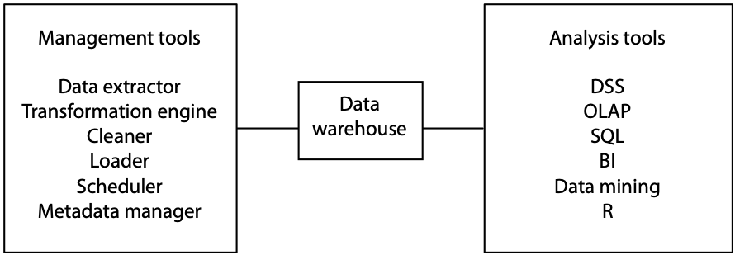

# The data warehouse

## Creating and maintaining the data warehouse

A data warehouse is a snapshot of an organization at a particular time. In order to create this snapshot, data must be extracted from existing systems, transformed, cleaned, and loaded into the data warehouse. In addition, regular snapshots must be taken to maintain the usefulness of the warehouse.

### Extraction

Data from the operational systems, stored in operational data stores (ODS), are the raw material of a data warehouse. Unfortunately, it is not simply a case of pulling data out of ODSs and loading them into the warehouse. Operational systems were often written many years ago at different times. There was no plan to merge these data into a single system. Each application is independent or shares little data with others. The same data may exist in different systems with different names and in different formats. The extraction of data from many different systems is time-consuming and complex. Furthermore, extraction is not a one-time process. Data must be extracted from operational systems on an ongoing basis so that analysts can work with current data.

### Transformation

Transformation is part of the data extraction process. In the warehouse, data must be standardized and follow consistent coding systems. There are several types of transformation:

* **Encoding**: Non-numeric attributes must be converted to a common coding system. Gender may be coded, for instance, in a variety of ways (e.g., m/f, 1/0, or M/F) in different systems. The extraction program must transform data from each application to a single coding system (e.g., m/f).
* **Unit of measure**: Distance, volume, and weight can be recorded in varying units in different systems (e.g., centimeters or inches) and must be converted to a common system.
* **Field**: The same attribute may have different names in different applications (e.g., sales-date, sdate, or saledate), and a standard name must be defined.
* **Date**: Dates are stored in a variety of ways. In Europe the standard for date is dd/mm/yy, in the U.S. it is mm/dd/yy, whereas the ISO standard is yyyy-mm-dd.

### Cleaning

Unfortunately, some of the data collected from applications may be dirty***—***they contain errors, inconsistencies, or redundancies. There are a variety of reasons why data may need cleaning:

* The same record is stored by several departments. For instance, both Human Resources and Production have an employee record. Duplicate records must be deleted.
* Multiple records for a company exist because of an acquisition. For example, the record for Sun Microsystems should be removed because it was acquired by Oracle.
* Multiple entries for the same entity exist because there are no corporate data entry standards. For example, FedEx and Federal Express both appear in different records for the same company.
* Data entry fields are misused. For example, an address line field is used to record a second phone number.

Data cleaning starts with determining the dirtiness of the data. An analysis of a sample should indicate the extent of the problem and whether commercial data-cleaning tools are required. Data cleaning is unlikely to be a one-time process. All data added to the data warehouse should be validated in order to maintain the integrity of the warehouse. Cleaning can be performed using specialized software or custom-written code.

### Loading

Data that have been extracted, transformed, and cleaned can be loaded into the warehouse. There are three types of data loads:

* Archival**:** Historical data (e.g., sales for the period 2005–2012) that is loaded once. Many organizations may elect not to load these data because of their low value relative to the cost of loading.
* Current**:** Data from current operational systems.
* Ongoing**:** Continual revision of the warehouse as operational data are generated. Managing the ongoing loading of data is the largest challenge for warehouse management. This loading is done either by completely reloading the data warehouse or by just updating it with the changes.

### Scheduling

Refreshing the warehouse, which can take many hours, must be scheduled as part of a data center’s regular operations. Because a data warehouse supports medium- to long-term decision making, it is unlikely that it would need to be refreshed more frequently than daily. For shorter decisions, operational systems are available. Some firms may decide to schedule less frequently after comparing the cost of each load with the cost of using data that are a few days old.

### Metadata

A data dictionary is a reference repository containing metadata (i.e., data about data). It includes a description of each data type, its format, coding standards (e.g., volume in liters), and the meaning of the field. For the data warehouse setting, a data dictionary is likely to include details of which operational system created the data, transformations of the data, and the frequency of extracts. Analysts need access to metadata so that they can plan their analyses and learn about the contents of the data warehouse. If a data dictionary does not exist, it should be established and maintained as part of ensuring the integrity of the data warehouse.

## Data warehouse technology

Selecting an appropriate data warehouse system is critical to support significant data mining or online analytical processing. Data analysis often requires intensive processing of large volumes of data, and large main memories are necessary for good performance. In addition, the system should be scalable so that as the demand for data analysis grows, the system can be readily upgraded.

In recent years, there has been a shift to Hadoop, which is covered in the next chapter, as the foundation for a data warehouse. It offers speed and cost advantages over the technology that had predominated for some years.

# Exploiting data stores

Two approaches to analyzing a data store (i.e., a database or data warehouse) are data mining and online analytical processing (OLAP). Before discussing each of these approaches, it is helpful to recognize the fundamentally different approaches that can be taken to exploiting a data store.

## Verification and discovery

The verification approach to data analysis is driven by a hypothesis or conjecture about some relationship (e.g., customers with incomes in the range of $50,000–75,000 are more likely to buy minivans). The analyst then formulates a query to process the data to test the hypothesis. The resulting report will either support or disconfirm the theory. If the theory is disconfirmed, the analyst may continue to propose and test hypotheses until a target customer group of likely prospects for minivans is identified. Then, the minivan firm may market directly to this group because the likelihood of converting them to customers is higher than mass marketing to everyone. The verification approach is highly dependent on a persistent analyst eventually finding a useful relationship (i.e., who buys minivans?) by testing many hypotheses. OLAP, DSS, EIS, and SQL-based querying systems support the verification approach.

Data mining uses the discovery approach. It sifts through the data in search of frequently occurring patterns and trends to report generalizations about the data. Data mining tools operate with minimal guidance from the client. Data mining tools are designed to yield useful facts about business relationships efficiently from a large data store. The advantage of discovery is that it may uncover important relationships that no amount of conjecturing would have revealed and tested.

A useful analogy for thinking about the difference between verification and discovery is the difference between conventional and open-pit gold mining. A conventional mine is worked by digging shafts and tunnels with the intention of intersecting the richest gold vein. Verification is like conventional mining—some parts of the gold deposit may never be examined. The company drills where it believes there will be gold. In open-pit mining, everything is excavated and processed. Discovery is similar to open-pit mining—everything is examined. Both verification and discovery are useful; it is not a case of selecting one or the other. Indeed, analysts should use both methods to gain as many insights as possible from the data.

Comparison of verification and discovery

|  |  |
| --- | --- |
| Verification | Discovery |
| What is the average sale for in-store and catalog customers? | What is the best predictor of sales? |
| What is the average high school GPA of students who graduate from college compared to those who do not? | What are the best predictors of college graduation? |

# OLAP

Edgar F. Codd, the father of the relational model, and colleagues (including, notably, Sharon B. Codd, his wife) proclaimed in 1993 that RDBMSs were never intended to provide powerful functions for data synthesis, analysis, and consolidation. This was the role of spreadsheets and special-purpose applications. They argued that analysts need data analysis tools that complement RDBMS technology, and they put forward the concept of online analytical processing (OLAP)**:** the analysis of business operations with the intention of making timely and accurate analysis-based decisions.

Instead of rows and columns, OLAP tools provide multidimensional views of data, as well as some other differences. OLAP means fast and flexible access to large volumes of derived data whose underlying inputs may be changing continuously.

Comparison of TPS and OLAP applications

| *TPS* | *OLAP* |
| --- | --- |
| Optimized for transaction volume | Optimized for data analysis |
| Process a few records at a time | Process summarized data |
| Real-time update as transactions occur | Batch update (e.g., daily) |
| Based on tables | Based on hypercubes |
| Raw data | Aggregated data |
| SQL is widely used | MDX becoming a standard |

For instance, an OLAP tool enables an analyst to view how many widgets were shipped to each region by each quarter in 2012. If shipments to a particular region are below budget, the analyst can find out which customers in that region are ordering less than expected. The analyst may even go as far as examining the data for a particular quarter or shipment. As this example demonstrates, the idea of OLAP is to give analysts the power to view data in a variety of ways at different levels. In the process of investigating data anomalies, the analyst may discover new relationships. The operations supported by the typical OLAP tool include

* Calculations and modeling across dimensions, through hierarchies, or across members
* Trend analysis over sequential time periods
* Slicing subsets for on-screen viewing
* Drill-down to deeper levels of consolidation
* Drill-through to underlying detail data
* Rotation to new dimensional comparisons in the viewing area

An OLAP system should give fast, flexible, shared access to analytical information. Rapid access and calculation are required if analysts are to make ad hoc queries and follow a trail of analysis. Such quick-fire analysis requires computational speed and fast access to data. It also requires powerful analytic capabilities to aggregate and order data (e.g., summarizing sales by region, ordered from most to least profitable). Flexibility is another desired feature. Data should be viewable from a variety of dimensions, and a range of analyses should be supported.

## MDDB

OLAP is typically used with an MDDB, a data management system in which data are represented by a multidimensional structure. The MDDB approach is to mirror and extend some of the features found in spreadsheets by moving beyond two dimensions. These tools are built directly into the MDDB to increase the speed with which data can be retrieved and manipulated. These additional processing abilities, however, come at a cost. The dimensions of analysis must be identified prior to building the database. In addition, MDDBs have size limitations that RDBMSs do not have and, in general, are an order of magnitude smaller than a RDBMS.

MDDB technology is optimized for analysis, whereas relational technology is optimized for the high transaction volumes of a TPS. For example, SQL queries to create summaries of product sales by region, region sales by product, and so on, could involve retrieving many of the records in a marketing database and could take hours of processing. A MDDB could handle these queries in a few seconds. TPS applications tend to process a few records at a time (e.g., processing a customer order may entail one update to the customer record, two or three updates to inventory, and the creation of an order record). In contrast, OLAP applications usually deal with summarized data.

Fortunately, RDBMS vendors have standardized on SQL, and this provides a commonality that allows analysts to transfer considerable expertise from one relational system to another. Similarly, MDX, originally developed by Microsoft to support multidimensional querying of an SQL server, has been implemented by a number of vendors for interrogating an MDDB. More details are provided later in this chapter.

The current limit of MDDB technology is approximately 10 dimensions, which can be millions to trillions of data points.

### ROLAP

An alternative to a physical MDDB is a *relational OLAP* (or ROLAP), in which case a multidimensional model is imposed on a relational model. As we discussed earlier, this is also known as a logical MDDB. Not surprisingly, a system designed to support OLAP should be superior to trying to retrofit relational technology to a task for which it was not specifically designed.

The star schemais used by some MDDBs to represent multidimensional data within a relational structure. The center of the star is a table storing multidimensional ***facts*** derived from other tables. Linked to this central table are the ***dimensions*** (e.g., region) using the familiar primary-key/foreign-key approach of the relational model. The following figure depicts a star schema for an international automotive company. The advantage of the star model is that it makes use of a RDBMS, a mature technology capable of handling massive data stores and having extensive data management features (e.g., backup and recovery). However, if the fact table is very large, which is often the case, performance may be slow. A typical query is a join between the fact table and some of the dimensional tables.

A star schema

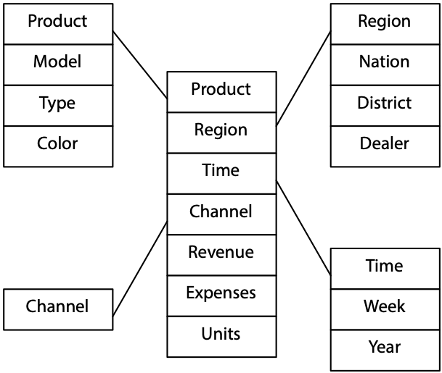

A snowflake schema, more complex than a star schema, resembles a snowflake. Dimensional data are grouped into multiple tables instead of one large table. Space is saved at the expense of query performance because more joins must be executed. Unless you have good reasons, you should opt for a star over a snowflake schema.

A snowflake schema

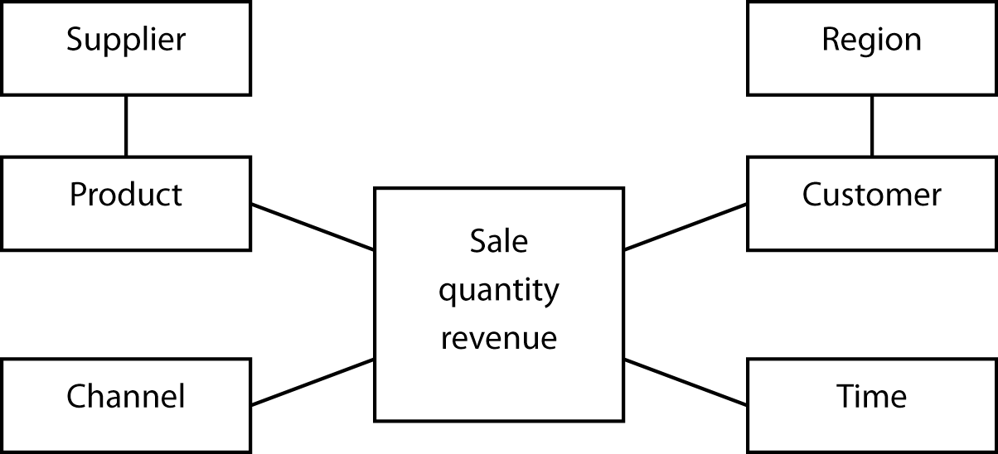

Rotation, drill-down, and drill-through

MDDB technology supports  **rotation** of data objects (e.g., changing the view of the data from “by year” to “by region” as shown in the following figure) and drill-down(e.g., reporting the details for each nation in a selected region as shown in the Drill Down figure), which is also possible with a relational system. Drill-down can slice through several layers of summary data to get to finer levels of detail. The Japanese data, for instance, could be dissected by region (e.g., Tokyo), and if the analyst wants to go further, Tokyo could be analyzed by store. In some systems, an analyst can drill through the summarized data to examine the source data within the organizational data store from which the MDDB summary data were extracted.

Rotation

|  |  |  |  |  |  |
| --- | --- | --- | --- | --- | --- |
|  |  | Region | | |  |
| Year | Data | Asia | Europe | North America | Grand total |
| 2010 | Sum of hardware | 97 | 23 | 198 | 318 |
|  | Sum of software | 83 | 41 | 425 | 549 |
| 2011 | Sum of hardware | 115 | 28 | 224 | 367 |
|  | Sum of software | 78 | 65 | 410 | 553 |
| 2012 | Sum of hardware | 102 | 25 | 259 | 386 |
|  | Sum of software | 55 | 73 | 497 | 625 |
| Total sum of hardware | | 314 | 76 | 681 | 1,071 |
| Total sum of software | | 216 | 179 | 1,322 | 1717 |

|  |  |  |  |  |  |
| --- | --- | --- | --- | --- | --- |
|  |  | Year | | |  |
| Region | Data | 2010 | 2011 | 2012 | Grand total |
| Asia | Sum of hardware | 97 | 115 | 102 | 314 |
|  | Sum of software | 83 | 78 | 55 | 216 |
| Europe | Sum of hardware | 23 | 28 | 25 | 76 |
|  | Sum of software | 41 | 65 | 73 | 179 |
| North America | Sum of hardware | 198 | 224 | 259 | 681 |
|  | Sum of software | 425 | 410 | 497 | 1,332 |
| Total sum of hardware | | 318 | 367 | 386 | 1,071 |
| Total sum of software | | 549 | 553 | 625 | 1,727 |

Drill-down

| Region | Sales variance |  |  |  |
| --- | --- | --- | --- | --- |
| Africa | 105% |  | Nation | Sales variance |
| Asia | 57% | ——> | China | 123% |
| Europe | 122% |  | Japan | 52% |
| North America | 97% |  | India | 87% |
| Pacific | 85% |  | Singapore | 95% |
| South America | 163% |  |  |  |

## The hypercube

From the analyst’s perspective, a fundamental difference between MDDB and RDBMS is the representation of data. As you know from data modeling, the relational model is based on tables, and analysts must think in terms of tables when they manipulate and view data. The relational world is two-dimensional. In contrast, the hypercube is the fundamental representational unit of a MDDB. Analysts can move beyond two dimensions. To envisage this change, consider the difference between the two-dimensional blueprints of a house and a three-dimensional model. The additional dimension provides greater insight into the final form of the building.

A hypercube

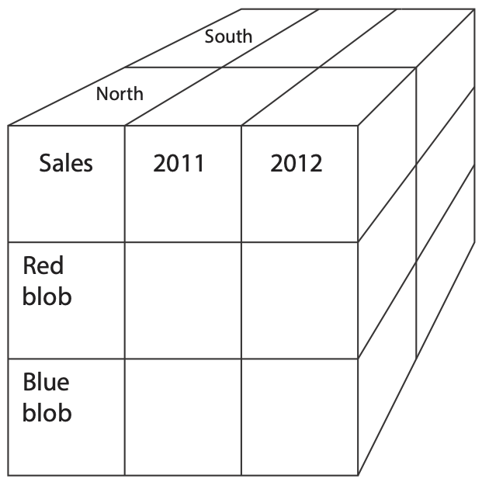

Of course, on a screen or paper only two dimensions can be shown. This problem is typically overcome by selecting an attribute of one dimension (e.g., North region) and showing the other two dimensions (i.e., product sales by year). You can think of the third dimension (i.e., region in this case) as the page dimension—each page of the screen shows one region or slice of the cube.

|  |  |  |  |  |
| --- | --- | --- | --- | --- |
| Page |  |  |  | Columns |
| Region: North |  |  |  | Sales |
|  |  | Red blob | Blue blob | Total |
|  | 2011 |  |  |  |
| Rows | 2012 |  |  |  |
| Year | Total |  |  |  |

A three-dimensional hypercube display

A hypercube can have many dimensions. Consider the case of a furniture retailer who wants to capture six dimensions of data. Although it is extremely difficult to visualize a six-dimensional hypercube, it helps to think of each cell of the cube as representing a fact (e.g., the Atlanta store sold five Mt. Airy desks to a business in January).

A six-dimensional hypercube

| Dimension | Example |
| --- | --- |
| Brand | Mt. Airy |
| Store | Atlanta |
| Customer segment | Business |
| Product group | Desks |
| Period | January |
| Variable | Units sold |

Similarly, a six-dimensional hypercube can be represented by combining dimensions (e.g., brand and store can be combined in the row dimension by showing stores within a brand).

A quick inspection of the table of the comparison of TPS and OLAP applications reveals that relational and multidimensional database technologies are designed for very different circumstances. Thus, the two technologies should be considered as complementary, not competing, technologies. Appropriate data can be periodically extracted from an RDBMS, aggregated, and loaded into an MDDB. Ideally, this process is automated so that the MDDB is continuously updated. Because analysts sometimes want to drill down to low-level aggregations and even drill through to raw data, there must be a connection from the MDDB to the RDBMS to facilitate access to data stored in the relational system.

The relationship between RDBMS and MDDB

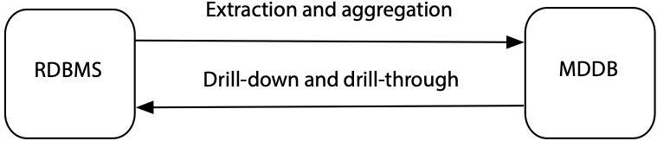

## Designing a multidimensional database

The multidimensional model, based on the hypercube, requires a different design methodology from the relational model. At this stage, there is no commonly used approach, such as the entity-relationship principle of the relational model. However, the method proposed by Thomsen (1997) deserves consideration.

The starting point is to identify what must be tracked (e.g., sales for a retailer or revenue per passenger mile for a transportation firm). A collection of tracking variables is called a variable dimension.

The next step is to consider what types of analyses will be performed on the variable dimension. In a sales system, these may include sales by store by month, comparison of this month’s sales with last month’s for each product, and sales by class of customer. These types of analyses cannot be conducted unless the instances of each variable have an identifying tag. In this case, each sale must be tagged with time, store, product, and customer type. Each set of identifying factors is anidentifier dimension. As a cross-check for identifying either type of dimension, use these six basic prompts.

Basic prompts for determining dimensions

| Prompt | Example | Source |
| --- | --- | --- |
| When? | June 5, 2013 10:27am | Transaction data |
| Where? | Paris |
| What? | Tent |
| How? | Catalog |
| Who? | Young adult woman | Face recognition or credit card issuer |
| Why? | Camping trip to Bolivia | Social media |
| Outcome? | Revenue of €624.00 | Transaction data |

Most of the data related to the prompts can be extracted from transactional data. Face recognition software could be used to estimate the age and gender of the buyer in a traditional retail establishment. If the buyer uses a credit card, then such data, with greater precision, could be obtained from the bank issuing the credit card. In the case of why, the motivation for the purchase, the retailer can mine social exchanges made by the customer. Of course, this requires the retailer to be able to uniquely identify the buyer, through a store account or credit card, and use this identification to mine social media.

Variables and identifiers are the key concepts of MDDB design. The difference between the two is illustrated in the following table. Observe that time, an identifier, follows a regular pattern, whereas sales do not. Identifiers are typically known in advance and remain constant (e.g., store name and customer type), while variables change. It is this difference that readily distinguishes between variables and identifiers. Unfortunately, when this is not the case, there is no objective method of discriminating between the two. As a result, some dimensions can be used as both identifiers and variables.

A sales table

| Identifier  time (hour) | Variable  sales (dollars) |
| --- | --- |
| 10:00 | 523 |
| 11:00 | 789 |
| 12:00 | 1,256 |
| 13:00 | 4,128 |
| 14:00 | 2,634 |

There can be a situation when your intuitive notion of an identifier and variable is not initially correct. Consider a Web site that is counting the number of hits on a particular page. In this case, the identifier is hit and time is the variable because the time of each hit is recorded.

A hit table

| Identifier  hit | Variable  time (hh:mm:ss) |
| --- | --- |
| 1 | 9:34:45 |
| 2 | 9:34:57 |
| 3 | 9:36:12 |
| 4 | 9:41:56 |

The next design step is to consider the form of the dimensions. You will recall from statistics that there are three types of variables (dimensions in MDDB language): nominal, ordinal, and continuous. A nominal variable is an unordered category (e.g., region), an ordinal variable is an ordered category (e.g., age group), and a continuous variable has a numeric value (e.g., passenger miles). A hypercube is typically a combination of several types of dimensions. For instance, the identifier dimensions could be product and store (both nominal), and the variable dimensions could be sales and customers. A dimension’s type comes into play when analyzing relationships between identifiers and variables, which are known as independent and dependent variables in statistics. The most powerful forms of analysis are available when both dimensions are continuous. Furthermore, it is always possible to recode a continuous variable into ordinal categories. As a result, wherever feasible, data should be collected as a continuous dimension.

Relationship of dimension type to possible analyses

|  |  |  |  |
| --- | --- | --- | --- |
|  |  | Identifier dimension | |
|  |  | Continuous | Nominal or ordinal |
| Variable dimension | Continuous | Regression and curve fitting  Sales over time | Analysis of variance  Sales by store |
| Nominal or ordinal | Logistic regression  Customer response (yes or no) to the level of advertising | Contingency table analysis  Number of sales by region |

This brief introduction to multidimensionality modeling has demonstrated the importance of distinguishing between types of dimensions and considering how the form of a dimension (e.g., nominal or continuous) will affect the choice of analysis tools. Because multidimensional modeling is a relatively new concept, you can expect design concepts to evolve. If you become involved in designing an MDDB, then be sure to review carefully current design concepts. In addition, it would be wise to build some prototype systems, preferably with different vendor implementations of the multidimensional concept, to enable analysts to test the usefulness of your design.

Skill builder

A national cinema chain has commissioned you to design a multidimensional database for its marketing department. What identifier and variable dimensions would you select?

# Data mining

Data mining is the search for relationships and global patterns that exist in large databases but are hidden in the vast amounts of data. In data mining, an analyst combines knowledge of the data with advanced machine learning technologies to discover nuggets of knowledge hidden in the data. Data mining software can find meaningful relationships that might take years to find with conventional techniques. The software is designed to sift through large collections of data and, by using statistical and artificial intelligence techniques, identify hidden relationships. The mined data typically include electronic point-of-sale records, inventory, customer transactions, and customer records with matching demographics, usually obtained from an external source. Data mining does not require the presence of a data warehouse. An organization can mine data from its operational files or independent databases. However, data mining independent files will not uncover relationships that exist between data in different files. Data mining will usually be easier and more effective when the organization accumulates as much data as possible in a single data store, such as a data warehouse. Recent advances in processing speeds and lower storage costs have made large-scale mining of corporate data a reality.

Database marketing, a common application of data mining, is also one of the best examples of the effective use of the technology. Database marketers use data mining to develop, test, implement, measure, and modify tailored marketing programs. The intention is to use data to maintain a lifelong relationship with a customer. The database marketer wants to anticipate and fulfill the customer’s needs as they emerge. For example, recognizing that a customer buys a new car every three or four years and with each purchase gets an increasingly more luxurious car, the car dealer contacts the customer during the third year of the life of the current car with a special offer on its latest luxury model.

## Data mining uses

There are many applications of data mining:

* Predicting the probability of default for consumer loan applications. Data mining can help lenders reduce loan losses substantially by improving their ability to predict bad loans.
* Reducing fabrication flaws in VLSI chips. Data mining systems can sift through vast quantities of data collected during the semiconductor fabrication process to identify conditions that cause yield problems.
* Predicting audience share for television programs. A market-share prediction system allows television programming executives to arrange show schedules to maximize market share and increase advertising revenues.
* Predicting the probability that a cancer patient will respond to radiation therapy. By more accurately predicting the effectiveness of expensive medical procedures, health care costs can be reduced without affecting quality of care.
* Predicting the probability that an offshore oil well is going to produce oil. An offshore oil well may cost $30 million. Data mining technology can increase the probability that this investment will be profitable.
* Identifying quasars from trillions of bytes of satellite data. This was one of the earliest applications of data mining systems, because the technology was first applied in the scientific community.

## Data mining functions

Based on the functions they perform, five types of data mining functions exist:

### Associations

An association function identifies affinities existing among the collection of items in a given set of records. These relationships can be expressed by rules such as “72 percent of all the records that contain items A, B, and C also contain items D and E.” Knowing that 85 percent of customers who buy a certain brand of wine also buy a certain type of pasta can help supermarkets improve use of shelf space and promotional offers. Discovering that fathers, on the way home on Friday, often grab a six-pack of beer after buying some diapers, enabled a supermarket to improve sales by placing beer specials next to diapers.

### Sequential patterns

Sequential pattern mining functions identify frequently occurring sequences from given records. For example, these functions can be used to detect the set of customers associated with certain frequent buying patterns. Data mining might discover, for example, that 32 percent of female customers within six months of ordering a red jacket also buy a gray skirt. A retailer with knowledge of this sequential pattern can then offer the red-jacket buyer a coupon or other enticement to attract the prospective gray-skirt buyer.

### Classifying

Classifying divides predefined classes (e.g., types of customers) into mutually exclusive groups, such that the members of each group are as close as possible to one another, and different groups are as far as possible from one another, where distance is measured with respect to specific predefined variables. The classification of groups is done before data analysis. Thus, based on sales, customers may be first categorized as infrequent***,*** occasional***,*** andfrequent***.*** A classifier could be used to identify those attributes, from a given set, that discriminate among the three types of customers. For example, a classifier might identify frequent customers as those with incomes above $50,000 and having two or more children. Classification functions have been used extensively in applications such as credit risk analysis, portfolio selection, health risk analysis, and image and speech recognition. Thus, when a new customer is recruited, the firm can use the classifying function to determine the customer’s sales potential and accordingly tailor its market to that person.

### Clustering

Whereas classifying starts with predefined categories, clustering starts with just the data and discovers the hidden categories. These categories are derived from the data. Clustering divides a dataset into mutually exclusive groups such that the members of each group are as close as possible to one another, and different groups are as far as possible from one another, where distance is measured with respect to all available variables. The goal of clustering is to identify categories. Clustering could be used, for instance, to identify natural groupings of customers by processing all the available data on them. Examples of applications that can use clustering functions are market segmentation, discovering affinity groups, and defect analysis.

### Prediction

Prediction calculates the future value of a variable. For example, it might be used to predict the revenue value of a new customer based on that person’s demographic variables.

These various data mining techniques can be used together. For example, a sequence pattern analysis could identify potential customers (e.g., red jacket leads to gray skirt), and then classifying could be used to distinguish between those prospects who are converted to customers and those who are not (i.e., did not follow the sequential pattern of buying a gray skirt). This additional analysis should enable the retailer to refine its marketing strategy further to increase the conversion rate of red-jacket customers to gray-skirt purchasers.

## Data mining technologies

Data miners use technologies that are based on statistical analysis and data visualization.

### Decision trees

Tree-shaped structures can be used to represent decisions and rules for the classification of a dataset. As well as being easy to understand, tree-based models are suited to selecting important variables and are best when many of the predictors are irrelevant. A decision tree, for example, can be used to assess the risk of a prospective renter of an apartment.

A decision tree

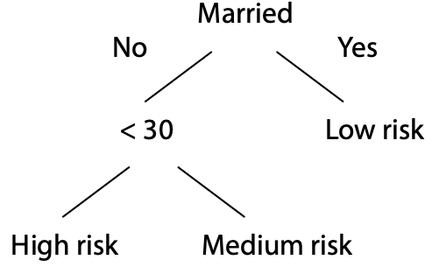

Genetic algorithms

Genetic algorithms are optimization techniques based on the concepts of biological evolution, and use processes such as genetic combination, mutation, and natural selection. Possible solutions for a problem compete with each other. In an evolutionary struggle of the survival of the fittest, the best solution survives the battle. Genetic algorithms are suited for optimization problems with many candidate variables (e.g., candidates for a loan).

### K-nearest-neighbor method

The nearest-neighbor method is used for clustering and classification. In the case of clustering, the method first plots each record in n-dimensional space, where n attributes are used in the analysis. Then, it adjusts the weights for each dimension to cluster together data points with similar goal features. For instance, if the goal is to identify customers who frequently switch phone companies, the k-nearest-neighbor method would adjust weights for relevant variables (such as monthly phone bill and percentage of non-U.S. calls) to cluster switching customers in the same neighborhood. Customers who did not switch would be clustered some distance apart.

### Neural networks

A neural network, mimicking the neurophysiology of the human brain, can learn from examples to find patterns in data and classify data. Although neural networks can be used for classification, they must first be trained to recognize patterns in a sample dataset. Once trained, a neural network can make predictions from new data. Neural networks are suited to combining information from many predictor variables; they work well when many of the predictors are partially redundant. One shortcoming of a neural network is that it can be viewed as a black box with no explanation of the results provided. Often managers are reluctant to apply models they do not understand, and this can limit the applicability of neural networks.

### Data visualization

Data visualization can make it possible for the analyst to gain a deeper, intuitive understanding of data. Because they present data in a visual format, visualization tools take advantage of our capability to discern visual patterns rapidly. Data mining can enable the analyst to focus attention on important patterns and trends and explore these in depth using visualization techniques. Data mining and data visualization work especially well together.

## SQL-99 and OLAP

SQL-99 includes extensions to the GROUP BY clause to support some of the data aggregation capabilities typically required for OLAP. Prior to SQL-99, the following questions required separate queries:

1. Find the total revenue.
2. Report revenue by location.
3. Report revenue by channel.
4. Report revenue by location and channel.

Skill builder

Write SQL to answer each of the four preceding queries using the exped table, which is a sample of 1,000 sales transactions from The Expeditioner.

Writing separate queries is time-consuming for the analyst and is inefficient because it requires multiple passes of the table. SQL-99 introduced GROUPING SETS, ROLLUP, and CUBE as a means of getting multiple answers from a single query and addressing some of the aggregation requirements necessary for OLAP.

### Grouping sets

The GROUPING SETS clause is used to specify multiple aggregations in a single query and can be used with all the SQL aggregate functions. In the following SQL statement, aggregations by location and channel are computed. In effect, it combines questions 2 and 3 of the preceding list.

SELECT location, channel, SUM(revenue)

FROM exped

GROUP BY GROUPING SETS (location, channel);

| location | channel | revenue |
| --- | --- | --- |
| null | Catalog | 108762 |
| null | Store | 347537 |
| null | Web | 27166 |
| London | null | 214334 |
| New York | null | 39123 |
| Paris | null | 143303 |
| Sydney | null | 29989 |
| Tokyo | null | 56716 |

The query sums revenue by channel or location. The null in a cell implies that there is no associated location or channel value. Thus, the total revenue for catalog sales is 108,762, and that for Tokyo sales is 56,716.

Although GROUPING SETS enables multiple aggregations to be written as a single query, the resulting output is hardly elegant. It is not a relational table, and thus a view based on GROUPING SETS should not be used as a basis for further SQL queries.

### Rollup

The ROLLUP option supports aggregation across multiple columns. It can be used, for example, to cross-tabulate revenue by channel and location.

SELECT location, channel, SUM(revenue)

FROM exped

GROUP BY ROLLUP (location, channel);

| location | channel | revenue |
| --- | --- | --- |
| null | null | 483465 |
| London | null | 214334 |
| New York | null | 39123 |
| Paris | null | 143303 |
| Sydney | null | 29989 |
| Tokyo | null | 56716 |
| London | Catalog | 50310 |
| London | Store | 151015 |
| London | Web | 13009 |
| New York | Catalog | 8712 |
| New York | Store | 28060 |
| New York | Web | 2351 |
| Paris | Catalog | 32166 |
| Paris | Store | 104083 |
| Paris | Web | 7054 |
| Sydney | Catalog | 5471 |
| Sydney | Store | 21769 |
| Sydney | Web | 2749 |
| Tokyo | Catalog | 12103 |
| Tokyo | Store | 42610 |
| Tokyo | Web | 2003 |

In the columns with null for location and channel, the preceding query reports a total revenue of 483,465. It also reports the total revenue for each location and revenue for each combination of location and channel. For example, Tokyo Web revenue totaled 2,003.

### Cube

CUBE reports all possible values for a set of reporting variables. If SUM is used as the aggregating function, it will report a grand total, a total for each variable, and totals for all combinations of the reporting variables.

SELECT location, channel, SUM(revenue)

FROM exped

GROUP BY cube (location, channel);

| location | channel | revenue |
| --- | --- | --- |
| null | Catalog | 108762 |
| null | Store | 347537 |
| null | Web | 27166 |
| null | null | 483465 |
| London | null | 214334 |
| New York | null | 39123 |
| Paris | null | 143303 |
| Sydney | null | 29989 |
| Tokyo | null | 56716 |
| London | Catalog | 50310 |
| London | Store | 151015 |
| London | Web | 13009 |
| New York | Catalog | 8712 |
| New York | Store | 28060 |
| New York | Web | 2351 |
| Paris | Catalog | 32166 |
| Paris | Store | 104083 |
| Paris | Web | 7054 |
| Sydney | Catalog | 5471 |
| Sydney | Store | 21769 |
| Sydney | Web | 2749 |
| Tokyo | Catalog | 12103 |
| Tokyo | Store | 42610 |
| Tokyo | Web | 2003 |

### MySQL

MySQL supports a variant of CUBE. The MySQL format for the preceding query is

SELECT location, channel, FORMAT(SUM(revenue),0) FROM exped

GROUP BY location, channel WITH ROLLUP;

Skill builder

Using MySQL’s ROLLUP capability, report the sales by location and channel for each item.

The SQL-99 extensions to GROUP BY are useful, but they certainly do not give SQL the power of a multidimensional database. It would seem that CUBE could be used as the default without worrying about the differences among the three options.

## Conclusion

Data management is a rapidly evolving discipline. Where once the spotlight was clearly on TPSs and the relational model, there are now multiple centers of attention. In an information economy, the knowledge to be gleaned from data collected by routine transactions can be an important source of competitive advantage. The more an organization can learn about its customers by studying their behavior, the more likely it can provide superior products and services to retain existing customers and lure prospective buyers. As a result, data managers now have the dual responsibility of administering databases that keep the organization in business today and tomorrow. They must now master the organizational intelligence technologies described in this chapter.

## Summary

Organizations recognize that data are a key resource necessary for the daily operations of the business and its future success. Recent developments in hardware and software have given organizations the capability to store and process vast collections of data. Data warehouse software supports the creation and management of huge data stores. The choice of architecture, hardware, and software is critical to establishing a data warehouse. The two approaches to exploiting data are verification and discovery. DSS and OLAP are mainly data verification methods. Data mining, a data discovery approach, uses statistical analysis techniques to discover hidden relationships. The relational model was not designed for OLAP, and MDDB is the appropriate data store to support OLAP. MDDB design is based on recognizing variable and identifier dimensions. SQL-99 includes extensions to GROUP BY to improve aggregation reporting.

## Key terms and concepts

Association

Classifying

Cleaning

Clustering

CUBE

Continuous variable

Database marketing

Data mining

Data visualization

Data warehouse

Decision support system (DSS)

Decision tree

Discovery

Drill-down

Drill-through

Extraction

Genetic algorithm

GROUPING SETS

Hypercube

Identifier dimension

Information systems cycle

K-nearest-neighbor method

Loading

Management information system (MIS)

Metadata

Multidimensional database (MDDB)

Neural network

Nominal variable

Object-relational

Online analytical processing (OLAP)

Operational data store (ODS)

Ordinal variable

Organizational intelligence

Prediction

Relational OLAP (ROLAP)

ROLLUP

Rotation

Scheduling

Sequential pattern

Star model

Transaction processing system (TPS)

Transformation

Variable dimension

Verification

## References and additional readings

Codd, E. F., S. B. Codd, and C. T. Salley. 1993. Beyond decision support. Computerworld, 87–89.

## Exercises

1. Identify data captured by a TPS at your university. Estimate how much data are generated in a year.
2. What data does your university need to support decision making? Does the data come from internal or external sources?
3. If your university were to implement a data warehouse, what examples of dirty data might you expect to find?
4. How frequently do you think a university should refresh its data warehouse?
5. Write five data verification questions for a university data warehouse.
6. Write five data discovery questions for a university data warehouse.
7. Imagine you work as an analyst for a major global auto manufacturer. What techniques would you use for the following questions?
   1. How do sports car buyers differ from other customers?
   2. How should the market for trucks be segmented?
   3. Where does our major competitor have its dealers?
   4. How much money is a dealer likely to make from servicing a customer who buys a luxury car?
   5. What do people who buy midsize sedans have in common?
   6. What products do customers buy within six months of buying a new car?
   7. Who are the most likely prospects to buy a luxury car?
   8. What were last year’s sales of compacts in Europe by country and quarter?
   9. We know a great deal about the sort of car a customer will buy based on demographic data (e.g., age, number of children, and type of job). What is a simple visual aid we can provide to sales personnel to help them show customers the car they are most likely to buy?
8. An international airline has commissioned you to design an MDDB for its marketing department. Choose identifier and variable dimensions. List some of the analyses that could be performed against this database and the statistical techniques that might be appropriate for them.
9. A telephone company needs your advice on the data it should include in its MDDB. It has an extensive relational database that captures details (e.g., calling and called phone numbers, time of day, cost, length of call) of every call. As well, it has access to extensive demographic data so that it can allocate customers to one of 50 lifestyle categories. What data would you load into the MDDB? What aggregations would you use? It might help to identify initially the identifier and variable dimensions.
10. What are the possible dangers of data mining? How might you avoid these?
11. Download the file exped.xls from the book’s web site and open it as a spreadsheet in LibreOffice. This file is a sample of 1,000 sales transactions for The Expeditioner. For each sale, there is a row recording when it was sold, where it was sold, what was sold, how it was sold, the quantity sold, and the sales revenue. Use the PivotTable Wizard (Data>PivotTable) to produce the following report:

|  |  |  |  |  |
| --- | --- | --- | --- | --- |
| Sum of REVENUE | HOW |  |  |  |
| WHERE | Catalog | Store | Web | Grand total |
| London | 50,310 | 151,015 | 13,009 | 214,334 |
| New York | 8,712 | 28,060 | 2,351 | 39,123 |
| Paris | 32,166 | 104,083 | 7,054 | 143,303 |
| Sydney | 5,471 | 21,769 | 2,749 | 29,989 |
| Tokyo | 12,103 | 42,610 | 2,003 | 56,716 |
| Grand Total | 108,762 | 347,537 | 27,166 | 483,465 |

Continue to use the PivotTable Wizard to answer the following questions:

* 1. What was the value of catalog sales for London in the first quarter?
  2. What percent of the total were Tokyo web sales in the fourth quarter?
  3. What percent of Sydney’s annual sales were catalog sales?
  4. What was the value of catalog sales for London in January? Give details of the transactions.
  5. What was the value of camel saddle sales for Paris in 2002 by quarter?
  6. How many elephant polo sticks were sold in New York in each month of 2002?

15. Introduction to R

Statistics are no substitute for judgment

Henry Clay, U.S. congressman and senator

## Learning objectives

Students completing this chapter will:

* Be able to use R for file handling and basic statistics;
* Be competent in the use of RStudio.

# The R project

The [R project](http://www.r-project.org) supports ongoing development of R, a free software environment for statistical computing, data visualization, and data analytics. It is a highly-extensible platform, the R programming language is object-oriented, and R runs on the common operating systems. There is evidence to indicate that adoption of R has grown in recent years, and is now the one of the most popular analytics platform.

[RStudio](http://www.rstudio.com) is a commonly used integrated development environment (IDE) for R. It contains four windows. The upper-left window contains scripts, one or more lines of R code that constitute a task. Scripts can be saved and reused. It is good practice to save scripts as you will find you can often edit an existing script to meet the needs of a new task. The upper-right window provides details of all datasets created. It also useful for importing datasets and reviewing the history of R commands executed. The lower-left window displays the results of executed scripts. If you want to clear this window, then press control-L. The lower-right window can be used to show files on your system, plots you have created by executing a script, packages installed and loaded, and help information.

## Creating a project

It usually makes sense to store all R scripts and data in the same folder or directory. Thus, when you first start RStudio, create a new project.

Project > Create Project…

RStudio remembers the state of each window, so when you quit and reopen, it will restore the windows to their prior state. You can also open an existing project, which sets the path to the folder for that project. As a result, all saved scripts and files during a session are stored in that folder.

RStudio interface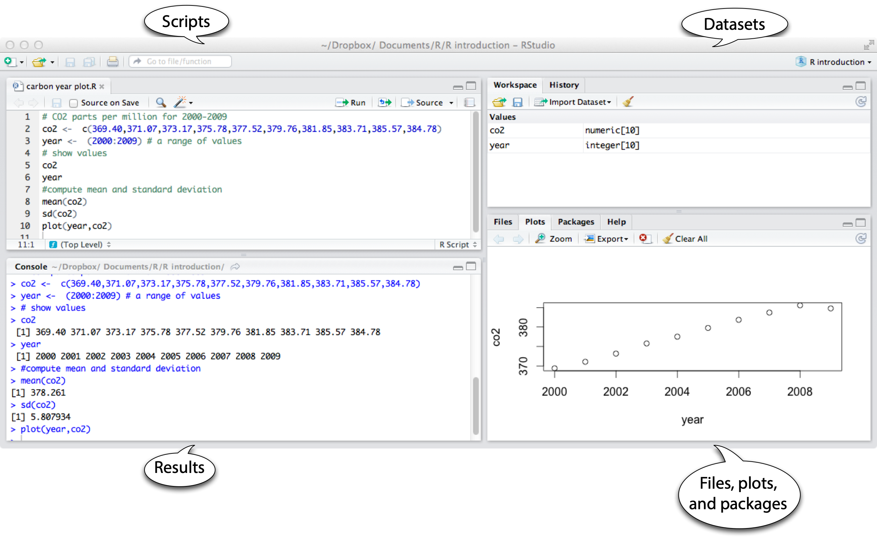

## Scripting

A script is a set of R commands. You can also think of it as a short program.

# CO2 parts per million (ppm) for 2000-2009

co2 <- c(369.40,371.07,373.17,375.78,377.52,379.76,381.85,383.71,385.57,384.78)

year <- (2000:2009) # a range of values

# show values

co2

year

# compute mean and standard deviation

mean(co2)

sd(co2)

plot(year,co2)

The previous script

* Creates an object co2 with the values 369.40, 371.07, … , 348.78.
* Creates an object year with values 2000 through 2009.
* Displays in the lower-left window the values stored in these two objects.
* Computes the mean for each variable.
* Creates an x-y plot of year and co2, which is shown in the lower-right window.

Note the use of <- for assigning values to an object and that c is short for combine in the expression:[20]

co2 <- c(369.40,371.07,373.17,375.78,377.52,379.76,381.85,383.71,385.57,384.78)

|  |
| --- |
| Smart editing It is not uncommon to find that a dataset you would like to use is in electronic format, but not in a format that matches your need. In most cases, you can use a word processor, spreadsheet, or text editor to reformat the data. In the case of the data in the previous table, here is a recipe for reformatting the data.   1. Copy each column to a word processor 2. Use the convert table to text command 3. Search and replace commas with nulls (i.e, “”) 4. Search and replace returns with commas 5. Edit to put R code around numbers   In some cases, you might find it quicker to copy a table to a spreadsheet, select each column within the spreadsheet, and then proceed as described above. This technique works well when the original table is in a pdf document. |

Skill builder

Plot kWh per square foot by year for the following University of Georgia data.

| year | square feet | kWh |
| --- | --- | --- |
| 2007 | 14,214,216 | 2,141,705 |
| 2008 | 14,359,041 | 2,108,088 |
| 2009 | 14,752,886 | 2,150,841 |
| 2010 | 15,341,886 | 2,211,414 |
| 2011 | 15,573,100 | 2,187,164 |
| 2012 | 15,740,742 | 2,057,364 |

# Data in R format

year <- (2007:2012)

sqft <- c(14214216, 14359041, 14752886, 15341886, 15573100, 15740742)

kwh <- c(2141705, 2108088, 2150841, 2211414, 2187164, 2057364)

## Datasets

An R dataset is the familiar table of the relational model. There is one row for each observation, and the columns contain the observed values or facts about each observation. R supports multiple data structures and data types.

#### Vector

A vector is a single row table where data are all of the same type (e.g., character, logical, numeric). In the following sample code, two numeric vectors are created.

co2 <- c(369.40,371.07,373.17,375.78,377.52,379.76,381.85,383.71,385.57,384.78)

year <- (2000:2009)

co2[2] # show the second value

#### Matrix

A matrix is a table where all data are of the same type. Because it is a table, a matrix has two dimensions, which need to be specified when defining the matrix. The sample code creates a matrix with 4 rows and 3 columns, as the results of the executed code illustrate.

m <- matrix(1:12, nrow=4,ncol=3)

m[4,3] # show the value in row 4, column 3

[,1] [,2] [,3]

[1,] 1 5 9

[2,] 2 6 10

[3,] 3 7 11

[4,] 4 8 12

Skill builder

Create a matrix with 6 rows and 3 columns containing the numbers 1 through 18.

#### Array

An array is a multidimensional table. It extends a matrix beyond two dimensions. Review the results of running the following code by displaying the array created.

a <- array(letters[seq(1:24)], c(4,3,2))

a[1,1,1] # show the first value in the array

#### Data frame

While vectors, matrices, and arrays are all forms of a table, they are restricted to data of the same type (e.g., numeric). A data frame, like a relational table, can have columns of different data types. The sample code creates a data frame with character and numeric data types.

gender <- c("m","f","f")

age <- c(5,8,3)

df <- data.frame(gender,age)

# show some data frame values

df[1,2] # a cell

df[1,] # a row

df[,2] # a column

#### List

The most general form of data storage is a list, which is an ordered collection of objects. It permits you to store a variety of objects together under a single name. In other words, a list is an object that contains other objects. Retrieve a list member with a *single square bracket* []. To reference a list member directly, use a *double square bracket* [[]].

l <- list(co2,m,df)

# show a list member

l[3] # retrieves list member

l[[3]] # reference a list member

l[[1]][2] # second element of list 1

## Logical operators

R supports the common logical operators, as shown in the following table.

| Logical operator | Symbol |
| --- | --- |
| EQUAL | ==' |
| AND | & |
| OR | | |
| NOT | ! |

#### Object

In R, an object is anything that can be assigned to a variable. It can be a constant, a function, a data structure, a graph, a times series, and so on. You find that the various packages in R support the creation of a wide range of objects and provide functions to work with these and other objects. A variable is a way of referring to an object. Thus, we might use the variable named l to refer to the list object defined in the preceding subsection.

## Types of data

R can handle the four types of data: nominal, ordinal, interval, and ratio. Nominal data, typically character strings, are used for classification (e.g., high, medium, or low). Ordinal data represent an ordering and thus can be sorted (e.g., the seeding or ranking of players for a tennis tournament). The intervals between ordinal data are not necessarily equal. Thus, the top seeded tennis play (ranked 1) might be far superior to the second seeded (ranked 2), who might be only marginally better than the third seed (ranked 3). Interval and ratio are forms of measurement data. The interval between the units of measure for interval data are equal. In other words, the distance between 50cm and 51cm is the same as the distance between 105cm and 106cm. Ratio data have equal intervals and a natural zero point. Time, distance, and mass are examples of ratio scales. Celsius and Fahrenheit are interval data types, but not ratio, because the zero point is arbitrary. As a result, 10º C is not twice as hot as 5º C. Whereas, Kelvin is a ratio data type because nothing can be colder than 0º K, a natural zero point.

In R, nominal and ordinal data types are also known as factors. Defining a column as a factor determines how its data are analyzed and presented. By default, factor levels for character vectors are created in alphabetical order, which is often not what is desired. To be precise, specify using the levels option.

rating <- c('high','medium','low')

rating <- factor(rating, order=T, levels = c('high','medium','low'))

Thus, the preceding code will result in changing the default reporting of factors from alphabetical order (i.e., high, low, and medium) to listing them in the specified order (i.e., high, medium, and low).

## Missing values

Missing values in R are represented as NA, meaning not available. Infeasible values, such as the result of dividing by zero, are indicated by NaN, meaning not a number. Any arithmetic expression or function operating on data containing missing values will return NA. Thus sum(c(1,NA,2)) will return NA.

To exclude missing values from calculations, use the option na.rm = T, which specifies the removal of missing values prior to calculations. Thus, sum(c(1,NA,2),na.rm=T) will return 3.

You can remove rows with missing data by using na.omit(), which will delete those rows containing missing values.

gender <- c("m","f","f","f")

age <- c(5,8,3,NA)

df <- data.frame(gender,age)

df2 <- na.omit(df)

## Packages

A major advantage of R is that the basic software can be easily extended by installing additional packages, of which more than 6,000 exist. You can consult the R package directory to help find a package that has the functions you need.[21] RStudio has an interface for finding and installing packages. See the Packages tab on RStudio’s lower-right window.

Before running a script, you need to indicate which packages it needs, beyond the default packages that are automatically loaded. The library statement specifies that a package is required for execution. The following example uses the measurements package to handle the conversion of Fahrenheit to Celsius. The package’s documentation provides details of how to use its various conversion options.

library(measurements) # previously installed

# convert F to C

conv_unit(100,'F','C')

Skill builder

Install the measurements package and run the preceding code.

## Reading a file

Files are the usual form of input for R scripts. Fortunately, R can handle a wide variety of input formats, including text (e.g., CSV), statistical package (e.g., SAS), and XML. A common approach is to use a spreadsheet to prepare a data file, export it as CSV, and then read it into R.

Files can be read from the local computer on which R is installed or the Internet, as the following sample code illustrates. We will use the readr library for handling files, so you will need to install it before running the following code.

library(readr)

# read a local file (this will not work on your computer)

t <- read_delim("Documents/R/Data/centralparktemps.txt", delim=“,")

You can also read a remote file using a URL.

library(readr)

# read using a URL

url <- 'http://www.richardtwatson.com/data/centralparktemps.txt'

t <- read_delim(url, delim=',')

You must define the separator for data fields with the delim keyword (e.g., for a tab use delim='\t').

### Learning about a file

After reading a file, you might want to learn about its contents. First, you can click on the file’s name in the top-right window. This will open the file in the top-left window. If it is a long file, only a portion, such as the first 1000 rows, will be displayed. Second, you can execute some R commands, as shown in the following code, to show the first few and last few rows. You can also report the dimensions of the file, its structure, and the type of object.

library(readr)

url <- 'http://www.richardtwatson.com/data/centralparktemps.txt'

t <- read_delim(url, delim=',')

head(t) # first few rows

tail(t) # last few rows

dim(t) # dimension

str(t) # structure of a dataset

class(t) #type of object

## Referencing columns

Columns within a table are referenced by using the format tablename$columname. This is similar to the qualification method used in SQL. The following code shows a few examples. It also illustrates how to add a new column to an existing table.

library(measurements)

library(readr)

url <- 'http://www.richardtwatson.com/data/centralparktemps.txt'

t <- read_delim(url, delim=',')

# qualify with table name to reference a column

mean(t$temperature)

max(t$year)

range(t$month)

# create a new column with the temperature in Celsius

t$Ctemp = round(conv_unit(t$temperature,'F','C'),1) # round to one decimal

## Recoding

Some analyses might be facilitated by the recoding of data. For instance, you might want to split a continuous measure into two categories. Imagine you decide to classify all temperatures greater than or equal to 25ºC as ‘hot’ and the rest as ‘other.’ Here are the R command to create a new column in table t called Category.

t$Category <- ifelse(t$Ctemp >= 30, 'Hot','Other')

## Deleting a column

You can delete a column by setting each of its values to NULL.

t$Category <- NULL

## Reshaping data

Data are not always in the shape that you want. For example, you might have a spreadsheet that, for each year, lists the quarterly observations (i.e., year and four quarterly values in one row). For analysis, you typically need to have a row for each distinct observation (e.g., year, quarter, value). Gathering converts a document from what is commonly called wide to narrow format. It is akin to normalization in that the new table has year and quarter as the identifier of each observation.

Once the file has been read, you create appropriate column names for the converted file using the colnames() function applied to the file t. Thus, the input file has column names of Q1, Q2, etc, but it makes sense for these to be integers in the new file in a new column called quarter.

The gather command specifies the file to be gathered, the column names of the new file, and the columns of the input file to be gathered (i.e., the four quarters in columns 2 through 5). Note that you also need convert the column quarter from character to integer.

Reshaping data with gathering and spreading

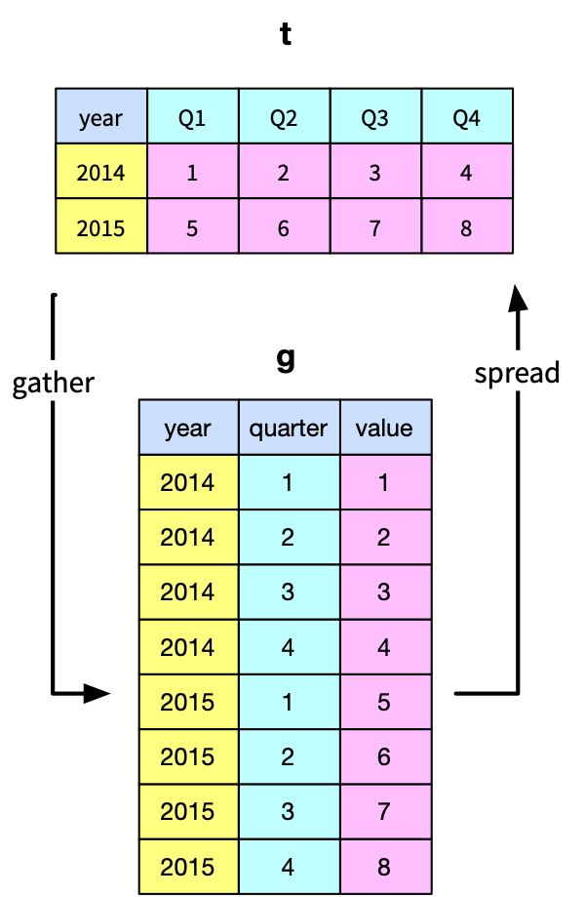

library(readr)

library(tidyr)

url <- 'http://www.richardtwatson.com/data/gatherExample.csv'

t <- read_csv(url)

t

colnames(t) <- c('year',1:4)

t

# gather with data in columns 2 through 5

g <- gather(t,'quarter','value',2:5)

g$quarter <- as.integer(g$quarter)

g

# spread

s <- spread(g,quarter,value)

s

colnames(s) <- c('year', 'Q1','Q2','Q3','Q4')

s

Spreading takes a narrow file and converts it to wide or spreadsheet format. This is the reverse of gathering.

s <- spread(g,quarter,value)

s

colnames(s) <- c('year', 'Q1','Q2','Q3','Q4')

s

## Writing files

R can write data in a few file formats. We just focus on text format in this brief introduction. The following code illustrates how to create a new column containing the temperature in C and renaming an existing column. The revised table is then written as a csv text file to the project’s folder.

library(measurements)

library(readr)

url <- 'http://www.richardtwatson.com/data/centralparktemps.txt'

t <- read_delim(url, delim=',')

# compute Celsius and round to one decimal place

t$Ctemp = round(conv_unit(t$temperature,'F','C'),1)

colnames(t)[3] <- 'Ftemp' # rename third column to indicate Fahrenheit

write_csv(t,"centralparktempsCF.txt")

## Data manipulation with dplyr

The dplyr package[22] provides functions for efficiently manipulating data sets. By providing a series of basic data handling functions and use of the pipe function ( %>% ),[23] dplyr implements a grammar for data manipulation. The pipe function is used to pass data from one operation to the next.

Some dplyr functions

| Function | Purpose |
| --- | --- |
| filter() | Select rows |
| select() | Select columns |
| arrange() | Sort rows |
| summarize() | Compute a single summary statistic |
| group_by() | Pair with summarize() to analyze groups within a dataset |
| inner_join() | Join two tables |
| mutate() | Create a new column |

Here are some examples using dplyr with data frame t.

library(dplyr)

library(readr)

url <- 'http://www.richardtwatson.com/data/centralparktemps.txt'

t <- read_delim(url, delim=',')

# a row subset

trow <- filter(t, year == 1999)

# a column subset

tcol <- select(t, year)

The following example illustrates application of the pipe function. The data frame t is piped to select(), and the results of select method passed onto filter(). The final output is stored in trowcol, which contains year, month, and Celsius temperature for the years 1990 through 1999.

# a combo subset and use of the pipe function

trowcol <- t %>% select(year, month, temperature) %>% filter(year > 1989 & year < 2000)

## Sorting

You can also use dplyr for sorting.

t <- arrange(t, desc(year),month)

Skill builder

* View the web page of yearly CO2 emissions (million metric tons) since the beginning of the industrial revolution.
* Create a new text file using R
* Clean up the file for use with R and save it as CO2.txt
* Import (Import Dataset) the file into R
* Plot year versus CO2 emissions

## Summarizing data

The dplyr function can be used for summarizing data in a specified way (e.g., mean, minimum, standard deviation). In the sample code, a file containing the mean temperature for each year is created. Notice the use of the pipe function to first group the data by year and then compute the mean for each group.

library(dplyr)

url <- 'http://www.richardtwatson.com/data/centralparktemps.txt'

t <- read_delim(url, delim=',')

w <- t %>% group_by(year) %>% summarize(averageF = mean(temperature))

## Adding a column

The following example shows how to add a column and compute its average.

# add column

t <- mutate(t, CTemp = (temperature-32)*5/9)

# summarize

summarize(t, mean(CTemp))

Skill builder

Create a file with the maximum temperature for each year.

## Merging files

If there is a common column in two files, then they can be merged using dplyr.::inner_join().[24] This is the same as joining two tables using a primary key and foreign key match. In the following code, a file is created with the mean temperature for each year, and it is merged with CO2 readings for the same set of years.

library(dplyr)

Library(readr)

url <- 'http://www.richardtwatson.com/data/centralparktemps.txt'

t <- read_delim(url, delim=',')

# average monthly temp for each year

a <- t %>% group_by(year) %>% summarize(mean = mean(temperature))

# read yearly carbon data (source: http://co2now.org/Current-CO2/CO2-Now/noaa-mauna-loa-co2-data.html)

url <- 'http://www.richardtwatson.com/data/carbon1959-2011.txt'

carbon <- read_delim(url, delim=',')

m <- inner_join(a,carbon)

head(m)

## Data manipulation with sqldf

The sqldf package enables use of the broad power of SQL to extract rows or columns from a data frame to meet the needs of a particular analysis. It provides essentially the same data manipulation capabilities as dplyr. The following example illustrates use of sqldf.

library(sqldf)

library(readr)

options(sqldf.driver = "SQLite") # to avoid a conflict with RMySQL

url <- 'http://www.richardtwatson.com/data/centralparktemps.txt'

t <- read_delim(url, delim=',')

# a row subset

trowcol <- sqldf("select year, month, temperature from t where year > 1989 and year < 2000")

However, sqldf does not enable you to embed R functions within an SQL command. For this reason, dplyr is the recommended approach for data manipulation. However, there might be occasions when you find it more efficient to first execute a complex query in SQL and then do further analysis with dplyr.

## Correlation coefficient

A correlation coefficient is a measure of the covariation between two sets of observations. In this case, we are interested in whether there is a statistically significant covariation between temperature and the level of atmospheric CO2.[25]

cor.test(m$mean, m$CO2)

The following results indicate that a correlation of .40 is a statistically significant as the p-value is less than 0.05, the common threshold for significance testing. Thus, we conclude that, because there is a small chance (p = .002997) of observing by chance such a value for the correlation coefficient, there is a relationship between mean temperature and the level of atmospheric CO2. Given that global warming theory predicts an increase in temperature with an increase in atmospheric CO2, we can also state that the observations support this theory. In other words, an increase in CO2 increases temperatures in Central Park.

Pearson's product-moment correlation

data: m$mean and m$CO2

t = 3.1173, df = 51, p-value = 0.002997

95 percent confidence interval:

0.1454994 0.6049393

sample estimates:

cor

0.4000598

When reporting correlation coefficients, you can you use the terms small, moderate, and large in accordance with the values specified in following table.

| Correlation coefficient | Effect size |
| --- | --- |
| .10 - .30 | Small |
| .30 - .50 | Moderate |
| > .50 | Large |

If we want to understand the nature of the relationship, we could fit a linear model.

lm(m$mean ~ m$CO2)

summary(mod)

The following results indicate a linear model is significant (p < .05), and it explains 14.36% (adjusted multiple R-squared) of the variation between temperature and atmospheric CO2. The linear equation is

temperature = 48.29 + 0.019208* CO2

As CO2 emissions are measured in parts per millions (ppm), an increase of 1.0 ppm predicts an annual mean temperature increase in Central Park of .01920 F°. Currently CO2 emissions are increasing at about 2.0 ppm per year.

As a linear model explains about 14% of the variation, this suggests that there might other variables that should be considered (e.g., level of volcanic activity) and that the relationship might not be linear.

Coefficients:

Estimate Std. Error t value Pr(>|t|)

(Intercept) 48.291319 2.149937 22.462 <2e-16 ***

m$CO2 0.019208 0.006162 3.117 0.003 **

---

Signif. codes: 0 ‘***’ 0.001 ‘**’ 0.01 ‘*’ 0.05 ‘.’ 0.1 ‘ ’ 1

Residual standard error: 1.016 on 51 degrees of freedom

Multiple R-squared: 0.16, Adjusted R-squared: 0.1436

F-statistic: 9.718 on 1 and 51 DF, p-value: 0.002997

# Database access

The DBI package provides a convenient way for a direct connection between R and a relational database, such as MySQL or PostgreSQL. Once the connection has been made, you can run an SQL query and load the results into a R data frame.

The dbConnect() function makes the connection. You specify the type of relational database, url, database name, userid, and password, as shown in the following code.[26]

library(DBI)

conn <- dbConnect(RMySQL::MySQL(), "www.richardtwatson.com", dbname="Weather", user="student", password="student")

# Query the database and create file t for use with R

t <- dbGetQuery(conn,"select * from record;")

head(t)

timestamp airTemp humidity precipitation

1 2010-01-01 03:00:00 44 93 0

2 2010-01-01 04:00:00 44 89 0

3 2010-01-01 05:00:00 43 89 0

4 2010-01-01 06:00:00 42 83 0

5 2010-01-01 07:00:00 41 86 0

6 2010-01-01 08:00:00 40 79 0

For security reasons, it is not a good idea to put database access details in your R code. They should be hidden in a file. I recommend that you create a csv file within your R code folder to containing database access parameters. First, create a new directory or folder (File > New Project > New Directory > Empty Project), called dbaccess for containing you database access files. Then, create a csvfile (Use File > New File > Text File) with the name weather_richardtwatson.csv in the newly created folder containing the following data:

url,dbname,user,password

richardtwatson.com,Weather,student,student

The R code will now be:

# Database access

library(readr)

library(DBI)

url <- 'dbaccess/weather_richardtwatson.csv'

d <- read_csv(url)

conn <- dbConnect(RMySQL::MySQL(), d$url, dbname=d$dbname, user=d$user, password=d$password)

t <- dbGetQuery(conn,"SELECT timestamp, airTemp from record;")

head(t)

Despite the prior example, I will continue to show database access parameters because you need them to run the sample code. However, in practice you should follow the security advice given.

# Timestamps

Many data sets include a timestamp to indicate when an observation was recorded. A timestamp will show the data and time to the second or microsecond. The format of a standard timestamp is yyyy-mm-dd hh:mm:ss (e.g., 2010-01-31 03:05:46).

Some R functions, including those in the lubridate package, can detect a standard format timestamp and support operations for extracting parts of it, such as the year, month, day, hour, and so forth. The following example shows how to use lubridate to extract the month and year from a character string in standard timestamp format.

library(lubridate)

library(DBI)

conn <- dbConnect(RMySQL::MySQL(), "www.richardtwatson.com", dbname="Weather", user="student", password="student")

# Query the database and create file t for use with R

t <- dbGetQuery(conn,"select * from record;")

t$year <- year(t$timestamp)

t$month <- month(t$timestamp)

head(t)

# Excel files

There are a number of packages with methods for reading an Excel file. Of these, readxl seems to be the simplest. However, it can handle only files stored locally, which is the case with most of the packages examined. If the required Excel spreadsheet is stored remotely, then download it and store lit ocally.

library(readxl)

library(httr)

# read remote file and store on disk

url <- 'http://www.richardtwatson.com/data/GDP.xlsx'

GET(url,write_disk('temp.xlsx',overwrite = TRUE))

e <- read_excel('temp.xlsx',sheet = 1,col_names = TRUE)

# R resources

The vast number of packages makes the learning of R a major challenge. The basics can be mastered quite quickly, but you will soon find that many problems require special features or the data need some manipulation. Once you learn how to solve a particular problem, make certain you save the script, with some embedded comments, so you can reuse the code for a future problem. There are books that you might find useful to have in electronic format on your computer or tablet, and one of these is listed at the end of the chapter. There are, however, many more books,[27] both of a general and specialized nature. The [R Reference Card](http://cran.r-project.org/doc/contrib/Short-refcard.pdf) is handy to keep nearby when you are writing scripts. I printed and laminated a copy, and it’s in the top drawer of my desk. A useful website is [Quick-R](http://www.statmethods.net), which is an online reference for common tasks, such as those covered in this chapter. For a quick tutorial, you can [Try R](http://tryr.codeschool.com).

# R and data analytics

R is a platform for a wide variety of data analytics, including

* Statistical analysis
* Data visualization
* HDFS and cluster computing
* Text mining
* Energy Informatics
* Dashboards

You have probably already completed an introductory statistical analysis course, and you can now use R for all your statistical needs. In subsequent chapters, we will discuss data visualization, HDFS and cluster computing, and text mining. [Energy Informatics](http://energyinformatics.info) is concerned with optimizing energy flows, and R is an appropriate tool for analysis and optimization of energy systems. R is being used extensively to analyze climate change data.[28]

R is also a programming language. You might find that in some situations, R provides a quick method for reshaping files and performing calculations.

## Summary

R is a free software environment for statistical computing, data visualization, and data analytics. RStudio is a commonly used integrated development environment (IDE) for R. A script is a set of R commands. Store all R scripts and data for a project in the same folder or directory. An R dataset is a table that can be stored as a vector, matrix, array, data frame, and list. In R, an object is anything that can be assigned to a variable. R can handle the four types of data: nominal, ordinal, interval, and ratio. Nominal and ordinal data types are also known as factors. Defining a column as a factor determines how its data are analyzed and presented. Missing values are indicated by NA. R can handle a wide variety of input formats, including text (e.g., CSV), statistical package (e.g., SAS), and XML. Data can be reshaped. Gathering converts a document from what is commonly called wide to narrow format. Spreading takes a narrow file and converts it to wide format. Columns within a table are referenced using the format tablename$columname. R can write data to a file. A major advantage of R is that the basic software can be easily extended by installing additional packages. The dplyr packages adds functionality for data management and reporting. Learning R is a major challenge because of the many packages available.

## Key terms and concepts

Aggregate

Array

Data frame

Data type

Factor

Gather

List

Matrix

Package

R

Reshape

Script

Spread

SQL

Tibble

Subset

Vector

## References

Wickham, H., & Grolemund, G. (2017). R for data science: O’Reilly.

## Exercises

1. Access [richardtwatson.com/data/manheim.txt](http://richardtwatson.com/data/manheim.txt) which contains details of the sales of three car models: X, Y, and Z.
   1. Use the table function to compute the number of sales for each type of model.
   2. Use the table function to compute the number of sales for each type of sale.
   3. Report the mean price for each model.
   4. Report the mean price for each type of sale.
2. Use the 'Import Dataset' feature of RStudio to read http://www.richardtwatson.com/data/electricityprices.csv, which contains details of electricity prices for a major city.[29]
   1. What is the maximum cost?
   2. What is the minimum cost?
   3. What is the mean cost?
   4. What is the median cost?
3. Read the table [richardtwatson.com/data/wealth.csv](http://richardtwatson.com/data/wealth.csv) containing details of the wealth of various countries and complete the following exercises.
   1. Sort the table by GDP per capita.
   2. What is the average GDP per capita?
   3. Compute the ratio of US GDP per capita to the average GDP per capita.
   4. What’s the correlation between GDP per capita and wealth per capita?
4. Merge the data for weather (database weather at richardtwatson.com discussed in the chapter) and electricity prices (Use RStudio's 'Import Dataset' to read http://www.richardtwatson.com/data/electricityprices.csv) and compute the correlation between temperature and electricity price. Hint: MySQL might return a timestamp with decimal seconds (e.g., 2010-01-01 01:00:00.0), and you can remove the rightmost two characters using substr(),[30] so that the two timestamp columns are of the same format and length. Also, you need to ensure that the timestamps from the two data frames are of the same data type (e.g., both character).
5. Get the list of failed US banks from <https://explore.data.gov/Banking-Finance-and-Insurance/FDIC-Failed-Bank-List/pwaj-zn2n>.
   1. Determine how many banks failed in each state.
   2. How many banks were not acquired (hint: nrow() will count rows in a table)?
   3. How many banks were closed each year (hint: use strptime() and the lubridate package)?
6. Use Table01 of U.S. broccoli data on farms and area harvested from <http://usda.mannlib.cornell.edu/MannUsda/viewDocumentInfo.do?documentID=1816>. Get rid of unwanted rows to create a spreadsheet for the area harvested with one header row and the 50 states. Change cells without integer values to 0 and save the file in CSV format for reading with R.
   1. Reshape the data so that each observation contains state name, year, and area harvested.
   2. Add hectares as a column in the table. Round the calculation to two decimal places.
   3. Compute total hectares harvested each year for which data are available.
   4. Save the reshaped file.

16. Data visualization

The commonality between science and art is in trying to see profoundly - to develop strategies of seeing and showing.

Edward Tufte, *The Visual Display of Quantitative Information*

## Learning objectives

Students completing this chapter will:

* Understand the principles of the grammar of graphics;
* Be able to use ggvis to create common business graphics;
* Be able to select data from a database for graphic creation;
* Be able to depict locations on a Google map.

# Visual processing

Humans are particularly skilled at processing visual information because it is an innate capability, compared to reading which is a learned skill. When we evolved on the Savannah of Africa, we had to be adept at processing visual information (e.g., recognizing danger) and deciding on the right course of action (fight or flight). Our ancestors were those who were efficient visual processors and quickly detected threats and used this information to make effective decisions. They selected actions that led to survival. Those who were inefficient visual information processors did not survive to reproduce. Even those with good visual skills failed to propagate if they made poor decisions relative to detected dangers. Consequently, we should seek opportunities to present information visually and play to our evolved strength. As people vary in their preference for visual and textual information, it often makes sense to support both types of reporting.

In order to learn how to visualize data, you need to become familiar with the grammar of graphics and ggvis (an R extension for graphics). In line with the learning of data modeling and SQL, we will take an intertwined spiral approach. First we will tackle the grammar of graphics (the abstract) and then move to ggvis (the concrete). You will also learn how to take the output of an SQL query and feed it directly into ggvis. The end result will be a comprehensive set of practical skills for data visualization.

# The grammar of graphics

A grammar is a system of rules for generating valid statements in a language. A grammar makes it possible for people to communicate accurately and concisely. English has a rather complex grammar, as do most languages. In contrast, computer-related languages, such as SQL, have a relatively simple grammar because they are carefully designed for expressive power, consistency, and ease of use. Each of the dialects of data modeling also has a grammar, and each of these grammars is quite similar in that they all have the same foundational elements: entities, attributes, identifiers, and relationships.

A grammar has been designed by Wilkinson[31] for creating graphics to enhance their expressiveness and comprehensiveness. From a mathematical perspective, a graph is a set of points. A graphic is a physical representation of a graph. Thus, a graph can have many physical representations, and one of the skills you need to gain is to be able to judge what is a meaningful graphic for your clients. A grammar for graphics provides you with many ways of creating a graphic, just as the grammar of English gives you many ways of writing a sentence. Of course, we differ in our ability to convey information in English. Similarly, we also differ in our skills in representing a graph in a visual format. The aesthetic attributes of a graph determine its ability to convey information. For a graphic, aesthetics are specified by elements such as size and color. One of the most applauded graphics is Minard’s drawing in 1861 of Napoleon’s advance on and retreat from Russia during 1812. The dominating aspect of the graphic is the dwindling size of the French army as it battled winter, disease, and the Russian army. The graph shows the size of the army, its location, and the direction of its movement. The temperature during the retreat is drawn at the bottom of graphic.

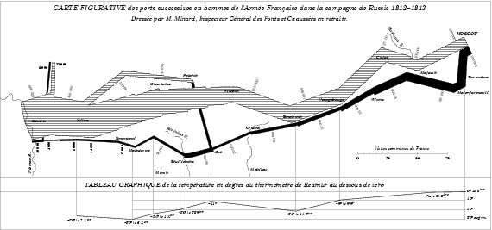

Charles Joseph Minard’s graphic of Napoleon’s Russian expedition in 1812

Wilkinson’s grammar is based on six elements:

1. Data: a set of data operations that creates variables from datasets;
2. Trans: variable transformations;
3. Scale: scale transformations;
4. Coord: a coordinate system;
5. Element: a graph and its aesthetic attributes;
6. Guide: one or more guides.

Interest in the grammar of data visualization has increased in recent years because of the growth in data. There is ongoing search to find ways to reveal clearly the information in large data sets. Vega[32] is a recent formulation building on Wilkinson’s work. In Vega, a visualization consists of basic properties of a graph (such as the width and height) and definitions of the data to visualize, scales for mapping to data to a visual form, axes for representing scales, and graphic marks (such as rectangles, circles, and arcs) for displaying the data.

# ggvis

ggvis is an implementation of Vega in R Because it is based on a grammar, ggvis is a very powerful graphics tool for creating both simple and complex graphs. It is well-suited for generating multi-layered graphs because of its grammatical foundation. As a result, using ggvis you specify a series of steps (think of them as sentences) to create a graphic (think of it as a paragraph) to visually convey your message. ggvis is a descendant of ggplot2 and adds new features to support interactive visualization using shiny, another R package, which we will cover later.

## Data

Most structured data, which is what we require for graphing, are typically stored in spreadsheets or databases. In the prior chapter introducing R, you learned how to read a spreadsheet exported as a CSV file and access a database. These are also the skills you need for reading a file containing data to be visualized.

## Transformation

A transformation converts data into a format suitable for the intended visualization. In this case, we want to depict the relative change in carbon levels since pre-industrial periods, when the value was 280 ppm. Here are sample R commands.

# compute a new column in carbon containing the relative change in CO2

carbon$relCO2 = (carbon$CO2-280)/280

There are many ways that you might want to transform data. The preceding example just illustrates the general nature of a transformation. You can also think of SQL as a transformation process as it can compute new values from existing columns.

## Coord

A coordinate system describes where things are located. A geopositioning system (GPS ) reading of latitude and longitude describes where you are on the surface of the globe. It is typically layered onto a map so you can see where you are relative to your current location. Most graphs are plotted on a two-dimensional (2D) grid with x (horizontal) and y (vertical) coordinates. ggvis currently supports six 2D coordinate systems, as shown in the following table. The default coordinate system for most packages is Cartesian.

Coordinate systems

| Name | Description |
| --- | --- |
| cartesian | Cartesian coordinates |
| equal | Equal scale Cartesian coordinates |
| flip | Flipped Cartesian coordinates |
| trans | Transformed Cartesian coordinates |
| map | Map projections |
| polar | Polar coordinates |

## Element

An element is a graph and its attributes. Let’s start with a simple scatterplot of year against CO2 emissions. We do this in two steps applying the ggvis approach of building a graphic by adding layers. ggvis uses the pipe function to specify a linear sequence of processing.

* The foundation is the ggvis function, which identifies the source of the data and what is to be plotted. In the following example, the file carbon is fed into the ggvis function, which selects year and CO2 as the x and y, respectively, dimensions of the graph
* A graph consists of a number of layers, and in the following example the points layer receives the x and y values from ggvis and plots each pair of points with a red dot.

library(ggvis)

library(readr)

library(dplyr)

url <- 'http://www.richardtwatson.com/data/carbon.txt'

carbon <- read_delim(url, delim=',')

# Select year(x) and CO2(y) to create a x-y point plot

# Specify red points, as you find that aesthetically pleasing

carbon %>%

ggvis(~year,~CO2) %>%

layer_points(fill:='red')

# Notice how ‘%>%’ is used for creating a pipeline of commands

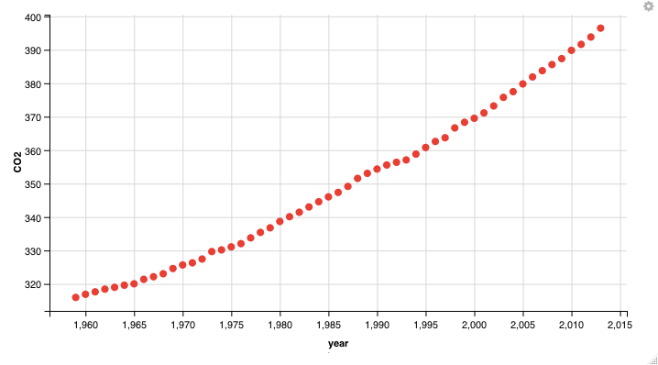

Graphics appear under the Plots tab of the bottom right window. You can select the Export tab to save a graphic to a file or the clipboard. Also, notice that you can use left and right arrows of the Plots tab to cycle through graphics created in a session.

## Scale

Scales control the visualization of data. It is usually a good idea to have a zero point for the y axis so you don’t distort the slope of the line. In the following example, the scale_numeric functionspecifies a zero point for the y axis with the command zero=T.

carbon %>%

ggvis(~year,~CO2) %>%

layer_points(fill:='red') %>%

scale_numeric('y',zero=T)

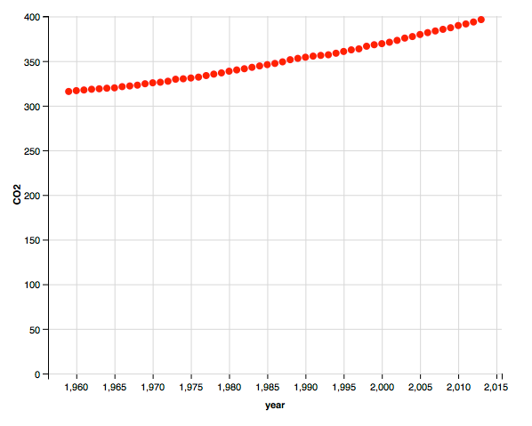

## Axes and legends

Axes and legends are both forms of guides, which help the reader to understand a graphic. Readability enhancers such as axes, title, and tick marks are generated automatically based on the parameters specified in the ggvis command. You can override the defaults.

Let’s redo the graphic with the relative change since the beginning of industrialization in the mid 18th century, when the level of CO2 was around 280 ppm. This time, we will create a line plot. We also add some titles for the axes and specify a format of four consecutive digits for displaying a year on the x-axis. We also move or offset the title for the y-axis a bit to the left to improve readability.

# compute a new column containing the relative change in CO2

carbon %>%

mutate(relCO2 = (CO2-280)/280) %>% # transformation

ggvis(~year,~relCO2) %>%

layer_lines(stroke:="blue") %>%

scale_numeric('y',zero=T) %>%

add_axis('y', title = "CO2 ppm of the atmosphere", title_offset=50) %>%

add_axis('x', title ='Year', format=‘####')

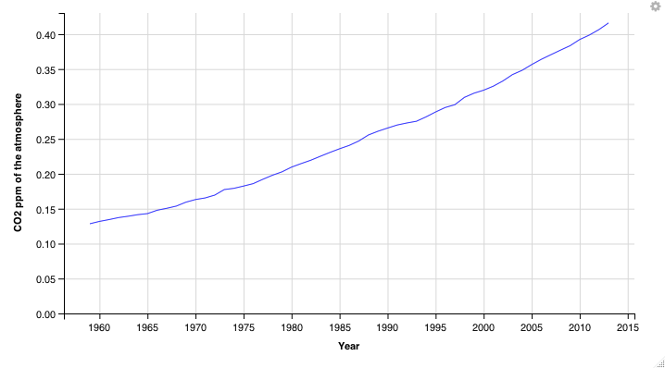

As the prior graphic shows, the present level of CO2 in the atmosphere is now above 40 percent higher than the pre-industrial period and is continuing to grow.

### Assignment function

You will have seen three types of assignment symbols in the preceding examples. The notion of scaling helps in understanding the difference between a value and a property. A property is fixed. So no matter how you resize the preceding graph, the stroke will always be blue. Whereas, a value, such as the title, is scalable. The difference between a value and a property can seem confusing, so don’t agonize over it.

| Symbol |  | Example |  |
| --- | --- | --- | --- |
| ~ | Data assignment | y ~ CO2 | y is CO2 column |
| = | Set a value | title = ‘year’ | Title is scaled |
| := | Set a property | stroke := ‘blue’ | Stroke is unscaled |

## Guides

Axes and legends are both forms of guides, which help the reader to understand a graphic. In ggvis, legends and axes are generated automatically based on the parameters specified in the ggvis command. You have the capability to override the defaults for axes, but the legend is quite fixed in its format.

In the following graphic, for each axis there is a label and there are tick marks with values so that you eyeball a point on the graphic for its x and y values. The legend enables you to determine which color, in this case, matches each year. A legend could also use shape (e.g., a diamond) and shape size to aid matching.

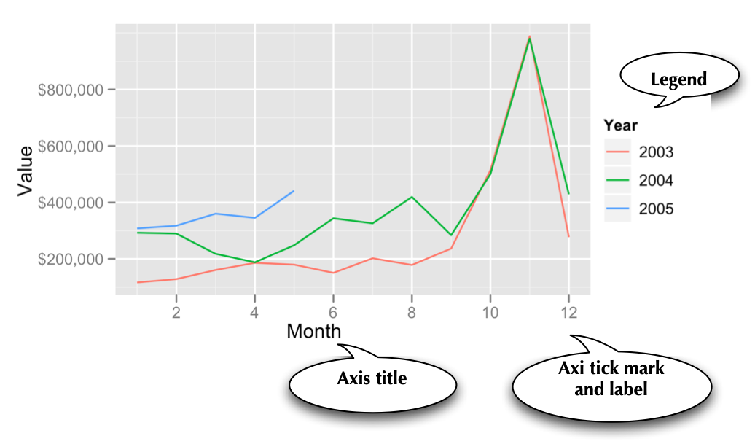

Skill builder

Create a line plot using the data in the following table.

|  |  |  |  |  |  |  |  |  |  |
| --- | --- | --- | --- | --- | --- | --- | --- | --- | --- |
| Year | 1804 | 1927 | 1960 | 1974 | 1987 | 1999 | 2012 | 2027 | 2046 |
| Population  (billions) | 1 | 2 | 3 | 4 | 5 | 6 | 7 | 8 | 9 |

# Some recipes

Learning the full power of ggvis is quite an undertaking, so here are a few recipes for visualizing data.

## Histogram

Histograms are useful for showing the distribution of values in a single column. A histogram has a vertical orientation. The number of occurrences of a particular value in a column are automatically counted by the ggvis function. In the following sample code, we show the distribution of temperatures in Celsius for the Central Park temperature data. Notice that the Celsius conversion is rounded to an integer for plotting. Width specifies the size of the bin, which is two in this case. This means that the bin above the tick mark 10 contains all values in the range 9 to 11. There is online a list of names of colors you can use in ggvis.[33]

library(ggvis)

library(readr)

library(measurements)

url <- 'http://www.richardtwatson.com/data/centralparktemps.txt'

t <- read_delim(url, delim=',')

t %>%

mutate(Celsius = conv_unit(t$temperature,'F','C')) %>%

ggvis(~Celsius) %>%

layer_histograms(width = 2, fill:='cornflowerblue') %>%

add_axis('x',title='Celsius') %>%

add_axis(‘y',title='Frequency')

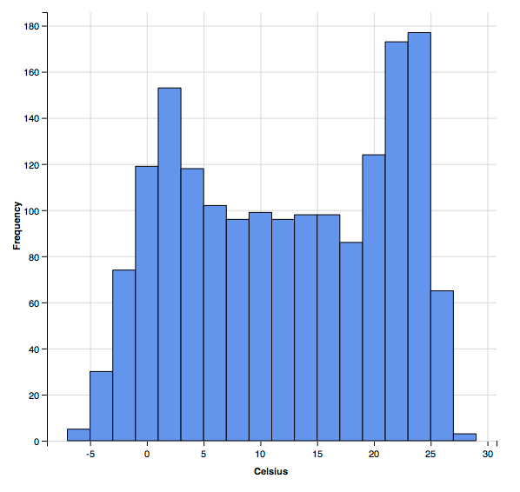

## Bar graph

In the following example, we query a database to get data for plotting. Because the column selected for graphing, productLine is categorical, we need to use a bar graph.

library(ggvis)

library(DBI)

conn <- dbConnect(RMySQL::MySQL(), "www.richardtwatson.com", dbname="ClassicModels", user="student", password="student")

# Query the database and create file for use with R

d <- dbGetQuery(conn,"SELECT * from Products;")

# Plot the number of product lines by specifying the appropriate column name

d %>%

ggvis(~productLine) %>%

layer_bars(fill:='chocolate') %>%

add_axis('x',title='Product line') %>%

add_axis(‘y',title='Count')

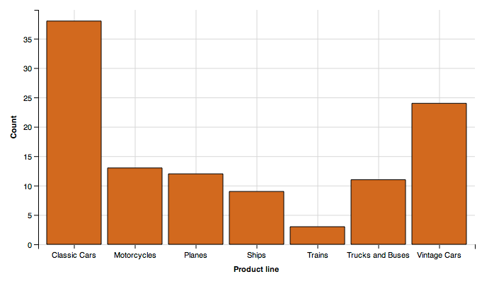

Skill builder

Create a bar graph using the data in the following table. Set population as the weight for each observation.

|  |  |  |  |  |  |  |  |  |  |
| --- | --- | --- | --- | --- | --- | --- | --- | --- | --- |
| Year | 1804 | 1927 | 1960 | 1974 | 1987 | 1999 | 2012 | 2027 | 2046 |
| Population  (billions) | 1 | 2 | 3 | 4 | 5 | 6 | 7 | 8 | 9 |

## Scatterplot

A scatterplot shows points on an x-y grid, which means you need to have an x and y with numeric values.

library(ggvis)

library(DBI)

library(dplyr)

library(lubridate)

conn <- dbConnect(RMySQL::MySQL(), "www.richardtwatson.com", dbname="ClassicModels", user="student", password="student")

o <- dbGetQuery(conn,"SELECT * FROM Orders")

od <- dbGetQuery(conn,"SELECT * FROM OrderDetails")

d <- inner_join(o,od)

# Get the monthly value of orders

d2 <- d %>%

mutate(month = month(orderDate)) %>%

group_by(month) %>% summarize(orderValue = sum(quantityOrdered*priceEach))

# Plot data orders by month

# Show the points and the line

d2 %>%

ggvis(~month, ~orderValue/1000000) %>%

layer_lines(stroke:='blue') %>%

layer_points(fill:='red') %>%

add_axis('x', title = 'Month') %>%

add_axis('y',title='Order value (millions)', title_offset=30)

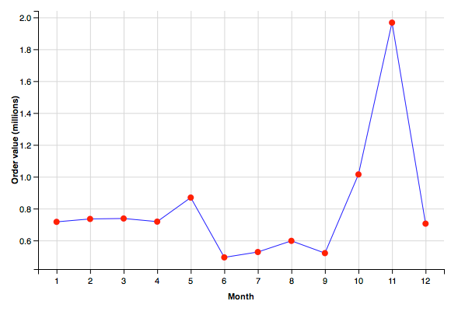

It is sometimes helpful to show multiple scatterplots on the one grid. In ggvis, you can create groups of points for plotting. Sometimes, you might find it convenient to recode data so you can use different colors or lines to distinguish values in set categories. Let’s examine grouping by year.

library(ggvis)

library(DBI)

library(dplyr)

library(lubridate)

conn <- dbConnect(RMySQL::MySQL(), "www.richardtwatson.com", dbname="ClassicModels", user="student", password="student")

o <- dbGetQuery(conn,"SELECT * FROM Orders")

od <- dbGetQuery(conn,"SELECT * FROM OrderDetails")

d <- inner_join(o,od)

d2 <- d %>%

mutate(month = month(orderDate)) %>%

mutate(year = year(orderDate)) %>%

group_by(year,month) %>% summarize(orderValue = sum(quantityOrdered*priceEach))

# Plot data orders by month and display by year

# ggvis expects grouping variables to be a factor

d2 %>%

ggvis(~month,~orderValue/1000, stroke = ~as.factor(year)) %>%

layer_lines() %>%

add_axis('x', title = 'Month') %>%

add_axis('y',title='Order value (thousands)', title_offset=50)

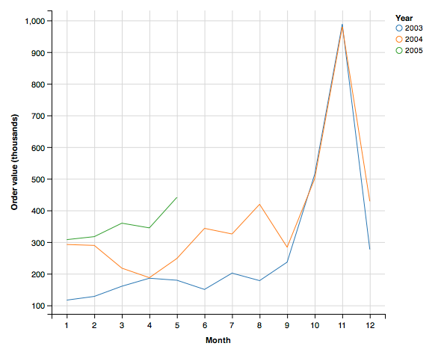

Because ggvis is based on a grammar of graphics, with a few changes, you can create a bar graph of the same data.

d2 %>%

ggvis( ~month, ~orderValue/100000, fill = ~as.factor(year)) %>%

layer_bars() %>%

add_axis('x', title = 'Month') %>%

add_axis('y',title='Order value (thousands)', title_offset=50)

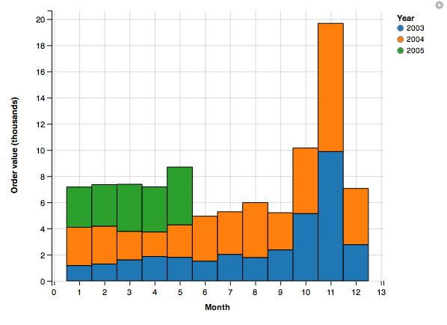

Sometimes the data that you want to graph will be in multiple files. Here is a case where we want to show ClassicCars orders and payments by month on the same plot.

library(ggvis)

library(DBI)

library(dplyr)

library(lubridate)

# Load the driver

conn <- dbConnect(RMySQL::MySQL(), "www.richardtwatson.com", dbname="ClassicModels", user="student", password="student")

o <- dbGetQuery(conn,"SELECT * FROM Orders")

od <- dbGetQuery(conn,"SELECT * FROM OrderDetails")

d <- inner_join(o,od)

d2 <-

d %>%

mutate(month = month(orderDate)) %>%

mutate(year = year(orderDate)) %>%

filter(year == 2004) %>%

group_by(month) %>%

summarize(value = sum(quantityOrdered*priceEach))

d2$category <- 'Orders'

p <- dbGetQuery(conn,"SELECT * from Payments;")

p2 <- p %>%

mutate(month = month(paymentDate)) %>%

mutate(year = year(paymentDate)) %>%

filter(year==2004) %>%

group_by(month) %>%

summarize(value = sum(amount))

p2$category <- 'Payments'

m <- rbind(d2,p2) # bind by rows

m %>%

group_by(category) %>%

ggvis(~month, ~value, stroke = ~ category) %>%

layer_lines() %>%

add_axis('x',title='Month') %>%

add_axis('y',title='Value',title_offset=70)

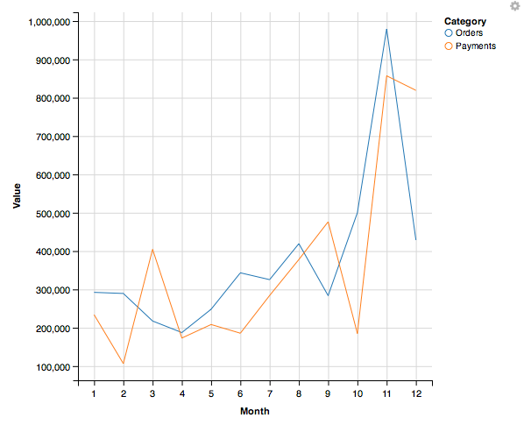

## Smoothing

Smoothing helps to detect a trend in a line plot. The following example shows the average mean temperatures for August for Central Park.

library(ggvis)

library(readr)

library(dplyr)

url <- "http://www.richardtwatson.com/data/centralparktemps.txt"

t <- read_delim(url, delim=',')

t %>%

filter(month == 8) %>%

ggvis(~year,~temperature) %>%

layer_lines(stroke:='red') %>%

layer_smooths(se=T, stroke:='blue') %>%

add_axis('x',title='Year',format = '####') %>%

add_axis('y',title='Temperature (F)', title_offset=30)

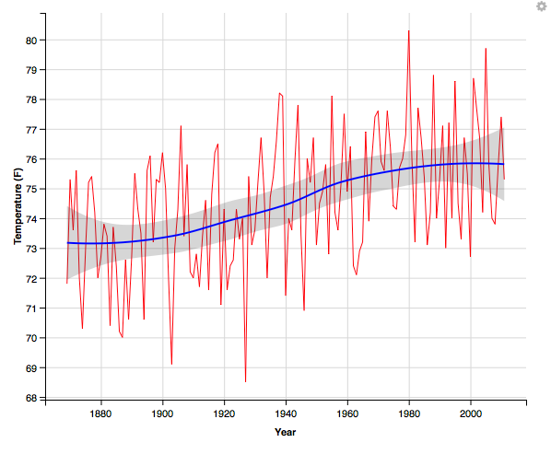

Skill builder

Using the Central Park data, plot the temperatures for February and fit a straight line to the points. Use layer_model_predictions(). What do you observe?

## Box Plot

A box plot is an effective means of displaying information about one or more variables. It shows minimum and maximum, range, lower quartile, median, and upper quartile for each variable. The following code creates a box plot for a single variable. Notice that we use factor(0) to indicate there is no grouping variable.

library(ggvis)

library(DBI)

conn <- dbConnect(RMySQL::MySQL(), "www.richardtwatson.com", dbname="ClassicModels", user="student", password="student")

d <- dbGetQuery(conn,"SELECT * from Payments;")

# Boxplot of amounts paid

d %>%

ggvis(~factor(0),~amount) %>%

layer_boxplots() %>%

add_axis('x',title='Checks') %>%

add_axis('y',title='')

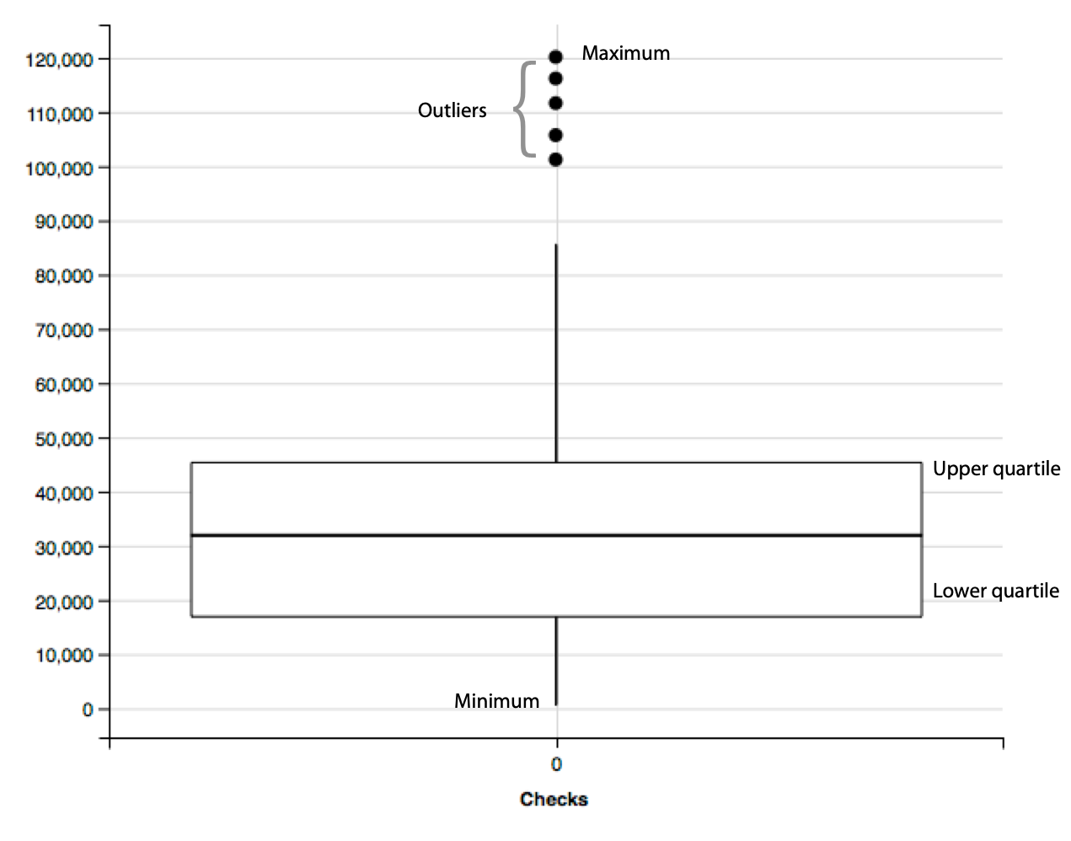

The following example shows a box plot for each month. Notice how to indicate the values for each of the ticks for the x-axis. Try running the code without the values specification.

library(ggvis)

library(DBI)

library(lubridate)

conn <- dbConnect(RMySQL::MySQL(), "www.richardtwatson.com", dbname="ClassicModels", user="student", password="student")

d <- dbGetQuery(conn,"SELECT * from Payments;")

# Boxplot of amounts paid

d %>%

mutate(month = month(paymentDate)) %>%

ggvis(~month,~amount) %>%

layer_boxplots() %>%

add_axis('x',title='Month', values=c(1:12)) %>%

add_axis('y',title='Amount', title_offset=70)

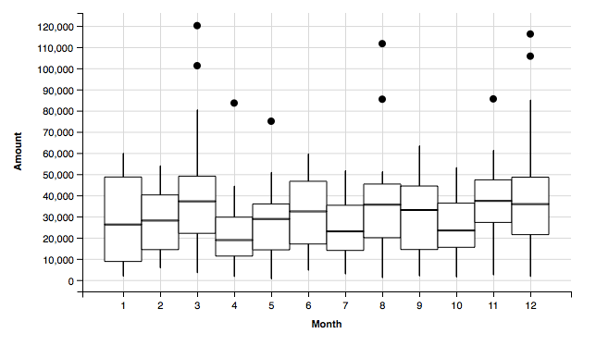

## Heat map

A heat map visualizes tabular data. It is useful when you have two categorical variables cross tabulated. Consider the case for the ClassicModels database where we want to get an idea of the different number of model scales in each product line. We can get a quick picture with the following code.

library(ggvis)

library(DBI)

library(dplyr)

# Load the driver

conn <- dbConnect(RMySQL::MySQL(), "www.richardtwatson.com", dbname="ClassicModels", user="student", password="student")

d <- dbGetQuery(conn,'SELECT * FROM Products;')

d2 <-

d %>%

group_by(productLine, productScale) %>%

summarize(frequency = n())

d2 %>%

ggvis( ~productScale, ~productLine, fill= ~frequency) %>%

layer_rects(width = band(), height = band()) %>%

add_axis('y',title='Product Line', title_offset=70) %>%

# add frequency to each cell

layer_text(text:=~frequency, stroke:='white', align:='left', baseline:='top')

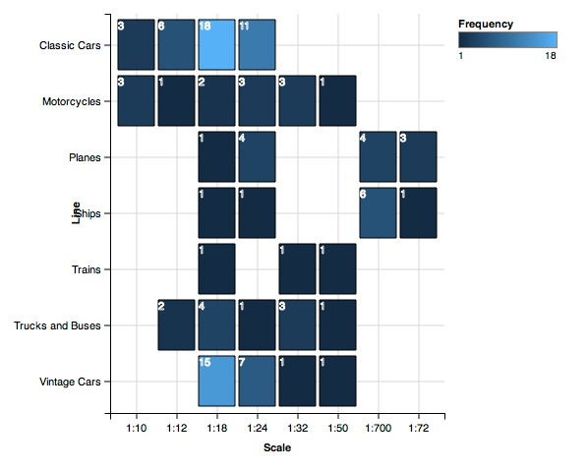

# Interactive graphics

The ggvis package incorporates features of shiny, an R package, that enable you to create interactive graphics. For example, you might want to let the viewer select the color and width of a line on a graphic. Many of the interactive controls, shown in the following table, should be familiar as the the various options are often used for web forms.

Interactive controls for ggvis

| Function | Purpose |
| --- | --- |
| input_checkbox() | Check one or more boxes |
| input_checkboxgroup() | A group of checkboxes |
| input_numeric() | A spin box |
| input_radiobuttons() | Pick one from a set of options |
| input_select() | Select from a drop-down text box |
| input_slider() | Select using a slider |
| input_text() | Input text |

## Selecting a property using a drop-down list

The following example uses the input_select function to present the viewer with an option of one of three colors (red, green, or blue) for the stroke of the graph. When you execute the code, you will see a selection list on the left bottom. Because the graph is interactive, you will need to click on the stop button (top right of the Viewer window) before running anymore R commands.

library(shiny)

library(ggvis)

library(dplyr)

carbon %>%

mutate(relCO2 = (CO2-280)/280) %>%

ggvis(~year,~relCO2) %>%

layer_lines(stroke:=input_select(c("red", "green", "blue"))) %>%

scale_numeric('y',zero=T) %>%

add_axis('y', title = "CO2 ppm of the atmosphere", title_offset=50) %>%

add_axis('x', title ='Year', format='####')

Skill builder

Create a point plot using the data in the following table. Give the viewer a choice of three colors and three shapes (square, cross, or diamond) for the points.

| Year | 1804 | 1927 | 1960 | 1974 | 1987 | 1999 | 2012 | 2027 | 2046 |
| --- | --- | --- | --- | --- | --- | --- | --- | --- | --- |
| Population  (billions) | 1 | 2 | 3 | 4 | 5 | 6 | 7 | 8 | 9 |

## Selecting a numeric value with a slider

A slider enables the viewer to select a numeric value in a range. In the following code, a slider is set up for values between 1 to 5, inclusively. Note in this case, the stroke width slider and color selector are defined outside the ggvis code. This is a useful technique for writing code that makes it possible for some chunks to be easily reused

slider <- input_slider(1, 5, label = "Width")

select_color <- input_select(label='Color',c("red", "green", "blue"))

carbon %>%

mutate(relCO2 = (CO2-280)/280) %>%

ggvis(~year,~relCO2) %>%

layer_lines(stroke:=select_color, strokeWidth:=slider) %>%

scale_numeric('y',zero=T) %>%

add_axis('y', title = "CO2 ppm of the atmosphere", title_offset=50) %>%

add_axis('x', title ='Year', format='####')

Skill builder

Using the Central Park data, plot the temperatures for a selected year using a slider.

# Geographic data

The ggmap package supports a variety of mapping systems, including Google maps. As you might expect, it offers many features, and we just touch on the basics in this example.

The Offices table in the Classic Models database includes the latitude and longitude of each office in officeLocation, which has a datatype of POINT. The following R code can be used to mark each office on a Google map. After loading the required packages, a database query is executed to return the longitude and latitude for each office. Then, a Google map of the United States is displayed. The marker parameter specifies the name of the table containing the values for longitude and latitude. Offices that are not in the U.S. (e.g., Sydney) are ignored. Adjust zoom, an integer, to get a suitably sized map. Zoom can range from 3 (a continent) to 20 (a building).

library(ggplot)

library(ggmap)

library(mapproj)

library(DBI)

conn <- dbConnect(RMySQL::MySQL(), "www.richardtwatson.com", dbname="ClassicModels", user="student", password="student")

# Google maps requires lon and lat, in that order, to create markers

d <- dbGetQuery(conn,"SELECT ST_Y(officeLocation) AS lon, ST_X(officeLocation) AS lat FROM Offices;")

# show offices in the United States

# vary zoom to change the size of the map

map <- get_googlemap('united states',marker=d,zoom=4)

ggmap(map) + labs(x = 'Longitude', y = 'Latitude') + ggtitle('US offices')

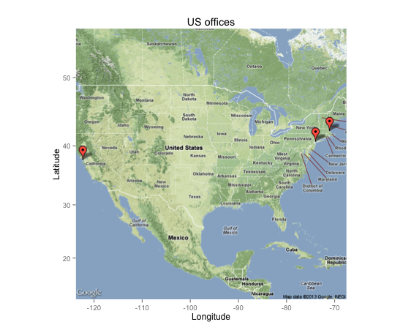

Skill builder

Create the following maps.

1. Offices in Europe
2. Office location in Paris
3. Customers in the US
4. Customers in Sydney

# R resources

The developer of ggvis, Hadley Wickham, maintains a [web site](http://ggvis.rstudio.com). Another useful web site for data visualization is [FlowingData](http://flowingdata.com), which has an associated book, titled Visualize This. If you become heavily involved in visualization, we suggest you read some of the works of Edward Tufte. One of his books is listed in the references.

## Summary

Because of evolutionary pressure, humans became strong visual processors. Consequently, graphics can be very effective for presenting information. The grammar of graphics provides a logical foundation for the construction of a graphic by adding successive layers of information. ggvis is a package implementing the grammar of graphics in R, the open source statistics platform. Data can be extracted from an MySQL database for processing and graphical presentation in R. Spatial data can be selected from a database and displayed on a Google map.

## Key terms and concepts

Bar chart

Box plot

dplyr

ggvis

Grammar of graphics

Graph

Graphic

Heat map

Histogram

Scatterplot

Smooth

## References

Kabacoff, R. I. (2009). R in action: data analysis and graphics with R. Greenwich, CT: Manning Publications.

Kahle, D., & Wickham, H. (2013). ggmap : Spatial Visualization with ggplot. The R Journal.

Tufte, E. (1983). The visual display of quantitative information. Cheshire, CT: Graphics Press.

Yau, N. (2011). Visualize this: the flowing data guide to design, visualization, and statistics. Indianapolis, IN: Wiley.

Wilkinson, L. (2005). The grammar of graphics (2nd ed.). New York: Springer.

## Exercises

1. Given the following data on the world’s cargo carrying capacity in millions of dead weight tons (dwt)[34] for the given years, graph the relationship as a point plot. Add a linear prediction model to the graph. What is the approximate increase in the world capacity each year?

dwt <- c(2566, 3704, 4008, 5984, 7700, 8034, 8229, 7858, 8408, 8939)

year <- c(1970, 1980, 1990, 2000, 2006, 2007, 2008, 2009, 2010, 2011)

1. Create a bar graph showing the relative ocean shipping cost as a percentage of total cost for some common household items using the following data.

unitCost <- c(700, 200, 150, 50, 15, 3, 1)

shipCost <- c(10.00, 1.50, 1.00, 0.15, 0.15, 0.05, 0.01)

item <- c('TV set', 'DVD player', 'Vacuum cleaner', 'Scotch whisky', 'Coffee', 'Biscuits', 'Beer')

### SQL input

1. Visualize in blue the number of items for each product scale.
2. Prepare a line plot with appropriate labels for total payments for each month in 2004.
3. Create a histogram with appropriate labels for the value of orders received from the Nordic countries (Denmark, Finland, Norway, Sweden).
4. Create a heatmap for product lines and Norwegian cities.
5. Show on a Google map the customers in Japan.
6. Show on a Google map the European customers who have never placed an order.

### File input

1. Access [http://www.richardtwatson.com/data/manheim.txt](http://people.terry.uga.edu/rwatson/data/manheim.txt), which contains details of the sales of three car models: X, Y, and Z.
   1. Create a bar chart for sales of each model (X, Y , or Z)
   2. Create bar chart for sales by each form of sale (online or auction).
2. Use the 'Import Dataset' feature of RStudio to read [http://www.richardtwatson.com/data/electricityprices.csv](http://people.terry.uga.edu/rwatson/data/electricityprices.csv), which contains details of electricity prices for a major city.[35] Do a Box plot of cost. What do you conclude about cost?
3. Read the table [http://www.richardtwatson.com/data/wealth.csv](http://people.terry.uga.edu/rwatson/data/wealth.csv) containing details of the wealth of various countries. Create histograms for each of the wealth measures. Consult the ggvis color chart[36] for a choice of colors.
4. Merge the data for weather <[http://www.richardtwatson.com/data/weather.csv](http://people.terry.uga.edu/rwatson/data/weather.csv)> and electricity prices <[http://www.richardtwatson.com/data/electricityprices.csv](http://people.terry.uga.edu/rwatson/data/electricityprices.csv)> for a major city. The merged file should contain air temperature and electricity cost. Also, you need to convert air temperature from a factor to a numeric (hint: first convert to a character). As readr does not currently handle date and time stamps, use the following code to read the files.

wurl <- 'http://www.richardtwatson.com/data/weather.csv'

w <- read.csv(wurl,sep=',',header=T)

eurl <- 'http://www.richardtwatson.com/data/electricityprices.csv'

e <- read.csv(eurl,sep=',',header=T)

* 1. Compute the correlation between temperature and electricity price. What do you conclude?
  2. Graph the relationship between temperature and electricity price.
  3. Graph the relationship between temperature and electricity price when the temperature is 95ºF and above.
  4. Create a single graph showing the relationship between temperature and electricity price differentiating by color when the temperature is above or below 90ºF. (Hint: Trying recoding temperature).

17. Text mining & natural language processing

From now on I will consider a language to be a set (finite or infinite) of sentences, each finite in length and constructed out of a finite set of elements. All natural languages in their spoken or written form are languages in this sense.

Noam Chomsky, *Syntactic Structures*

## Learning objectives

Students completing this chapter will:

* Have a realistic understanding of the capabilities of current text mining and NLP software;
* Be able to use R and associated packages for text mining and NLP.

# The nature of language

Language enables humans to cooperate through information exchange. We typically associate language with sound and writing, but gesturing, which is older than speech, is also a means of collaboration. The various dialects of sign languages are effective tools for visual communication. Some species, such as ants and bees, exchange information using chemical substances known as pheromones. Of all the species, humans have developed the most complex system for cooperation, starting with gestures and progressing to digital technology, with language being the core of our ability to work collectively.

Natural language processing (NLP) focuses on developing and implementing software that enables computers to handle large scale processing of language in a variety of forms, such as written and spoken. While it is a relatively easy task for computers to process numeric information, language is far more difficult because of the flexibility with which it is used, even when grammar and syntax are precisely obeyed. There is an inherent ambiguity of written and spoken speech. For example, the word “set” can be a noun, verb, or adjective, and the *Oxford English Dictionary* defines over 40 different meanings. Irregularities in language, both in its structure and use, and ambiguities in meaning make NLP a challenging task. Be forewarned. Don’t expect NLP to provide the same level of exactness and starkness as numeric processing. NLP output can be messy, imprecise, and confusing – just like the language that goes into an NLP program. One of the well-known maxims of information processing is “garbage-in, garbage-out.” While language is not garbage, we can certainly observe that “language-in, language-out” is a truism. You can’t start with something that is marginally ambiguous and expect a computer to turn it into a precise statement. Legal and religious scholars can spend years learning how to interpret a text and still reach different conclusions as to meaning.

NLP, despite its limitations, enables humans to process large volumes of language data (e.g., text) quickly and to identify patterns and features that might be useful. A well-educated human with domain knowledge specific to the same data might make more sense of these data, but it might take months or years. For example, a firm might receive over a 1,000 tweets, 500 Facebook mentions, and 20 blog references in a day. It needs NLP to identify within minutes or hours which of these many messages might need human action.

Text mining and NLP overlap in their capabilities and goals. The ultimate objective is to extract useful and valuable information from text using analytical methods and NLP. Simply counting words in a document is a an example of text mining because it requires minimal NLP technology, other than separating text into words. Whereas, recognizing entities in a document requires prior extensive machine learning and more intensive NLP knowledge. Whether you call it text mining or NLP, you are processing natural language. We will use the terms somewhat interchangeably in this chapter.

The human brain has a special capability for learning and processing languages and reconciling ambiguities,[37] and it is a skill we have yet to transfer to computers. NLP can be a good servant, but enter its realm with realistic expectations of what is achievable with the current state-of-the-art.

# Levels of processing

There are three levels to consider when processing language.

## Semantics

Semantics focuses on the meaning of words and the interactions between words to form larger units of meaning (such as sentences). Words in isolation often provide little information. We normally need to read or hear a sentence to understand the sender’s intent. One word can change the meaning of a sentence (e.g., “Help needed versus Help not needed”). It is typically an entire sentence that conveys meaning. Of course, elaborate ideas or commands can require many sentences.

## Discourse

Building on semantic analysis, discourse analysis aims to determine the relationships between sentences in a communication, such as a conversation, consisting of multiple sentences in a particular order. Most human communications are a series of connected sentences that collectively disclose the sender’s goals. Typically, interspersed in a conversation are one or more sentences from one or more receivers as they try to understand the sender’s purpose and maybe interject their thoughts and goals into the discussion. The points and counterpoints of a blog are an example of such a discourse. As you might imagine, making sense of discourse is frequently more difficult, for both humans and machines, than comprehending a single sentence. However, the braiding of question and answer in a discourse, can sometimes help to reduce ambiguity.

## Pragmatics

Finally, pragmatics studies how context, world knowledge, language conventions, and other abstract properties contribute to the meaning of human conversation. Our shared experiences and knowledge often help us to make sense of situations. We derive meaning from the manner of the discourse, where it takes place, its time and length, who else is involved, and so forth. Thus, we usually find it much easier to communicate with those with whom we share a common culture, history, and socioeconomic status because the great collection of knowledge we jointly share assists in overcoming ambiguity.

# Tokenization

Tokenization is the process of breaking a document into chunks (e.g., words), which are called tokens. Whitespaces (e.g., spaces and tabs) are used to determine where a break occurs. Tokenization typically creates a bag of words for subsequent processing. Many text mining functions use words as the foundation for analysis.

## Counting words

To count the number of words in a string, simply count the number of times there are one or more consecutive spaces using the pattern “ [[:space:]]+“ and then add one, because the last word is not followed by a space.

library(stringr)

str_count("The dead batteries were given out free of charge", "[[:space:]]+") + 1

# Sentiment analysis

Sentiment analysis is a popular and simple method of measuring aggregate feeling. In its simplest form, it is computed by giving a score of +1 to each “positive” word and -1 to each “negative” word and summing the total to get a sentiment score. A text is decomposed into words. Each word is then checked against a list to find its score (i.e., +1 or -1), and if the word is not in the list, it doesn’t score.

A major shortcoming of sentiment analysis is that irony (e.g., “The name of Britain’s biggest dog (until it died) was Tiny”) and sarcasm (e.g., “I started out with nothing and still have most of it left”) are usually misclassified. Also, a phrase such as “not happy” might be scored as +1 by a sentiment analysis program that simply examines each word and not those around it.

The sentimentr package offers an advanced implementation of sentiment analysis. It is based on a polarity table, in which a word and its polarity score (e.g., -1 for a negative word) are recorded. The default polarity table is provided by the syuzhet package. You can create a polarity table suitable for your context, and you are not restricted to 1 or -1 for a word’s polarity score. Here are the first few rows of the default polarity table.

> library(sentimentr)

> library(syuzhet)

> head(get_sentiment_dictionary())

word value

1 abandon -0.75

2 abandoned -0.50

3 abandoner -0.25

4 abandonment -0.25

5 abandons -1.00

6 abducted -1.00

In addition, sentimentr supports valence shifters, which are words that alter or intensify the meaning of a polarizing word (i.e., a word appearing in the polarity table) appearing in the text or document under examination. Each word has a value to indicate how to interpret its effect (negators (1), amplifiers(2), de-amplifiers (3), and conjunction (4).

Now, let’s see how we use the sentiment function. We’ll start with an example that does not use valence shifters, in which case we specify that the sentiment function should not look for valence words before or after any polarizing word. We indicate this by setting n.before and n.after to 0. Our sample text consists of several sentences, as shown in the following code, where polarizing words are shown in green (positive) and red (negative).

library(sentimentr)

sample = c("You're awesome and I love you", "I hate and hate and hate. So angry. Die!", "Impressed and amazed: you are peerless in your achievement of unparalleled mediocrity.")

sentiment(sample, n.before=0, n.after=0, amplifier.weight=0)

The results are:

element_id sentence_id word_count sentiment

1: 1 1 6 0.5511352

2: 2 1 6 -0.9185587

3: 2 2 2 -0.5303301

4: 2 3 1 -0.7500000

5: 3 1 12 0.3608439

Notice that the sentiment function breaks each element (the text between quotes in this case) into sentences, identifies each sentence in an element, and computes the word count for each of these sentences. The sentiment score is the sum of the polarity scores divided by the square root of the number of words in the associated sentence..

To get the overall sentiment for the sample text, -0.26 in this case, we can use:

y <- sentiment(sample, n.before=0, n.after=0)

mean(y$sentiment)

When a valence shift is detected before or after a polarizing word, its effect is incorporated in the sentiment calculation. The size of the effect is indicated by the amplifier.weight, a sentiment function parameter with a value between 0 and 1. The weight amplifies or de-amplifies by multiplying the polarized terms by 1 + the amplifier weight. A negator flips the sign of a polarizing word. A conjunction amplifies the current clause and down weights the prior clause. Some examples in the following table illustrate the results of applying the function

sentiment(text, n.before=2, n.after=2, amplifier.weight=.8, but.weight = .9)

to a variety of input text. The polarities are -1 (crazy) and 1 (love). There is a negator (not), two amplifiers (very and much), and a conjunction (but). Contractions are treated as amplifiers and so get weights based on the contraction (.9 in this case) and amplification (.8) in this case.

|  |  |  |  |
| --- | --- | --- | --- |
| **Type** | **Code** | **Text** | **Sentiment** |
|  |  | You're crazy, and I love you. | 0 |
| Negator | 1 | You're not crazy, and I love you. | 0.57 |
| Amplifier | 2 | You're crazy, and I love you very much. | 0.21 |
| De-amplifier | 3 | You're slightly crazy, and I love you. | 0.23 |
| Conjunction | 4 | You're crazy, but I love you. | 0.45 |

Skill builder

Run the following R code and comment on how sensitive sentiment analysis is to the n.before and n.after parameters.

sample = c("You're not crazy and I love you very much.")

sentiment(sample, n.before = 4, n.after=3, amplifier.weight=1)

sentiment(sample, n.before = Inf, n.after=Inf, amplifier.weight=1)

What are the correct polarities for each word, and weights for negators, amplifiers and so on? It is a judgment call and one that is difficult to justify.

Sentiment analysis has given you an idea of some of the issues surrounding text mining. Let’s now look at the topic in more depth and explore some of the tools available in **tm**, a general purpose text mining package for R. We will also use a few other R packages which support text mining and displaying the results.

## Corpus

A collection of text is called a corpus. It is common to use N for the corpus size, the number of tokens, and V for the vocabulary, the number of distinct tokens.

In the following examples, our corpus consists of Warren Buffett’s annual letters to the shareholders of Berkshire Hathaway[38] for the period 1998-2012.[39] The letters, available in html or pdf, were converted to separate text files using Abbyy Fine Reader. Tables, page numbers, and graphics were removed during the conversion.

The following R code sets up a loop to read each of the letters and add it to a data frame. When all the letters have been read, they are turned into a corpus.

require(stringr)

require(tm)

#set up a data frame to hold up to 100 letters

df <- data.frame(num=100)

begin <- 1998 # date of first letter

i <- begin

# read the letters

while (i < 2013) {

y <- as.character(i)

# create the file name

f <- str_c('<http://www.richardtwatson.com/BuffettLetters/',y>, 'ltr.txt',delim='')

# read the letter as on large string

d <- readChar(f,nchars=1e6)

# add letter to the data frame

df[i-begin+1,] <- d

i <- i + 1

}

# create the corpus

letters <- Corpus(DataframeSource(as.data.frame(df), encoding = "UTF-8"))

## Readability

There are several approaches to estimating the readability of a selection of text. They are usually based on counting the words in each sentence and the number of syllables in each word. For example, the Flesch-Kincaid method uses the formula:

(11.8 * syllables_per_word) + (0.39 * words_per_sentence) - 15.59

It estimates the grade-level or years of education required of the reader. The bands are:

13-16 Undergraduate

16-18 Masters

19- PhD

The R package koRpus has a number of methods for calculating readability scores. You first need to tokenize the text using the package’s tokenize function. Then complete the calculation.

library(koRpus)

#tokenize the first letter in the corpus after converting to character vector

txt <- letters[[1]][1] # first element in the list

tagged.text <- tokenize(as.character(txt),format="obj",lang="en")

# score

readability(tagged.text, hyphen=NULL,index="FORCAST")

## Preprocessing

Before commencing analysis, a text file typically needs to be prepared for processing. Several steps are usually taken.

### Case conversion

For comparison purposes, all text should be of the same case. Conventionally, the choice is to convert to all lower case.

clean.letters <- tm_map(letters,tolower)

### Punctuation removal

Punctuation is usually removed when the focus is just on the words in a text and not on higher level elements such as sentences and paragraphs.

clean.letters <- tm_map(clean.letters,removePunctuation)

### Number removal

You might also want to remove all numbers.

clean.letters <- tm_map(clean.letters,removeNumbers)

### Stripping extra white spaces

Removing extra spaces, tabs, and such is another common preprocessing action.

clean.letters <- tm_map(clean.letters,stripWhitespace)

Skill builder

Redo the readability calculation after executing the preprocessing steps described in the previous section. What do you observe?

### Stop word filtering

Stop words are short common words that can be removed from a text without affecting the results of an analysis. Though there is no commonly agreed upon list of stop works, typically included are the, is, be, and, but, to, and on. Stop word lists are typically all lowercase, thus you should convert to lowercase before removing stop words. Each language has a set of stop words. In the following sample code, we use the SMART list of English stop words. [40]

clean.letters <- tm_map(clean.letters,removeWords,stopwords("SMART"))

### Specific word removal

There can also specify particular words to be removed via a character vector. For instance, you might not be interested in tracking references to Berkshire Hathaway in Buffett’s letters. You can set up a dictionary with words to be removed from the corpus.

dictionary <- c("berkshire","hathaway", "million", "billion", "dollar")

clean.letters <- tm_map(clean.letters,removeWords,dictionary)

### Word length filtering

You can also apply a filter to remove all words less than or greater than a specified lengths. The tm package provides this option when generating a term frequency matrix, something you will read about shortly.

### Parts of speech (POS) filtering

Another option is to remove particular types of words. For example, you might scrub all adverbs and adjectives.

### Stemming

Stemming reduces inflected or derived words to their stem or root form. For example, cats and catty stem to cat. Fishlike and fishy stem to fish. As a stemmer generally works by suffix stripping, so catfish should stem to cat. As you would expect, stemmers are available for different languages, and thus the language must be specified.

# stem the document -- might take a while to run

stem.letters <- tm_map(clean.letters,stemDocument, language = "english")

Following stemming, you can apply stem completion to return stems to their original form to make the text more readable. The original document that was stemmed, in this case, is used as the dictionary to search for possible completions. Stem completion can apply several different rules for converting a stem to a word, including “prevalent” for the most frequent match, “first” for the first found completion, and “longest” and “shortest” for the longest and shortest, respectively, completion in terms of characters

# stem completion -- might take a while to run

stem.letters <- tm_map(stem.letters,stemCompletion, dictionary=clean.letters, type=c("prevalent"))

### Regex filtering

The power of regex (regular expressions) can also be used for filtering text or searching and replacing text. You might recall that we covered regex when learning SQL.

## Word frequency analysis

Word frequency analysis is a simple technique that can also be the foundation for other analyses. The method is based on creating a matrix in one of two forms.

* A term-document matrix contains one row for each term and one column for each document.

tdm <- TermDocumentMatrix(stem.letters,control = list(minWordLength=3))

dim(tdm)

# report those words occurring more than 100 times

findFreqTerms(tdm, lowfreq = 100, highfreq = Inf)

* A document-term matrix contains one row for each document and one column for each term.

dtm <- DocumentTermMatrix(stem.letters,control = list(minWordLength=3))

dim(dtm)

The function dtm() reports the number of distinct terms, the vocabulary, and the number of documents in the corpus.

### Term frequency

Words that occur frequently within a document are usually a good indicator of the document’s content. Term frequency (tf) measures word frequency.

tftd = number of times term t occurs in document d.

Here is the R code for determining the frequency of words in a corpus.

tdm <- TermDocumentMatrix(stem.letters,control = list(minWordLength=3))

# convert term document matrix to a regular matrix to get frequencies of words

m <- as.matrix(tdm)

# sort on frequency of terms

v <- sort(rowSums(m), decreasing=TRUE)

# display the ten most frequent words

v[1:10]

A probability density plot shows the distribution of words in a document visually. As you can see, there is a very long and thin tail because a very small number of words occur frequently. Note that this plot shows the distribution of words after the removal of stop words.

require(ggplot2)

# get the names corresponding to the words

names <- names(v)

# create a data frame for plotting

d <- data.frame(word=names, freq=v)

ggplot(d,aes(freq)) + geom_density(fill="salmon") + xlab("Frequency")

Probability density plot of word frequency

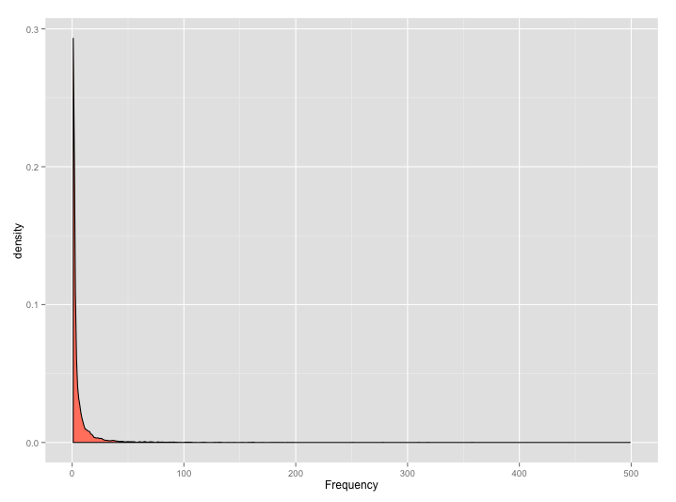

A word cloud is way of visualizing the most frequent words.

require(wordcloud)

# select the color palette

pal = brewer.pal(5,"Accent")

# generate the cloud based on the 30 most frequent words

wordcloud(d$word, d$freq, min.freq=d$freq[30],colors=pal)

A word cloud

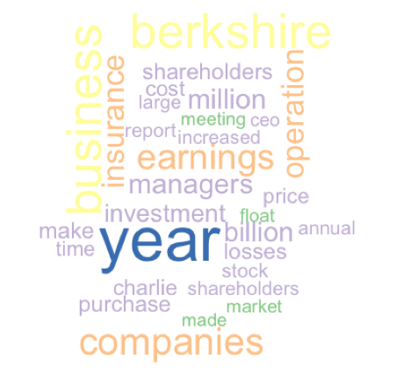

Skill builder

Start with the original letters corpus (i.e., prior to preprocessing) and identify the 20 most common words and create a word cloud for these words.

## Co-occurrence and association

Co-occurrence measures the frequency with which two words appear together. In the case of document level association, if the two words both appear or neither appears, then the correlation or association is 1. If two words never appear together in the same document, their association is -1.

A simple example illustrates the concept. The following code sets up a corpus of five elementary documents.

data <- c("word1", "word1 word2","word1 word2 word3","word1 word2 word3 word4","word1 word2 word3 word4 word5")

frame <- data.frame(data)

test <- Corpus(DataframeSource(frame, encoding = "UTF-8"))

tdm <- TermDocumentMatrix(test)

as.matrix(tdm)

Docs

Terms 1 2 3 4 5

word1 1 1 1 1 1

word2 0 1 1 1 1

word3 0 0 1 1 1

word4 0 0 0 1 1

word5 0 0 0 0 1

We compute the correlation of rows to get a measure of association across documents.

# Correlation between word2 and word3, word4, and word5

cor(c(0,1,1,1,1),c(0,0,1,1,1))

cor(c(0,1,1,1,1),c(0,0,0,1,1))

cor(c(0,1,1,1,1),c(0,0,0,0,1))

> cor(c(0,1,1,1,1),c(0,0,1,1,1))

[1] 0.6123724

> cor(c(0,1,1,1,1),c(0,0,0,1,1))

[1] 0.4082483

> cor(c(0,1,1,1,1),c(0,0,0,0,1))

[1] 0.25

Alternatively, use the findAssocs function, which computes all correlations between a given term and all terms in the term-document matrix and reports those higher than the correlation threshold.

# find associations greater than 0.1

findAssocs(tdm,"word2",0.1)

word3 word4 word5

0.61 0.41 0.25

Now that you have an understanding of how association works across documents, here is an example for the corpus of Buffett letters.

# Select the first ten letters

tdm <-  TermDocumentMatrix(stem.letters[1:10])

# compute the associations

findAssocs(tdm, "invest",0.80)

shooting cigarettes eyesight feed moneymarket pinpoint

0.83 0.82 0.82 0.82 0.82 0.82

ringmaster suffice tunnels unnoted

0.82 0.82 0.82 0.82

## Cluster analysis

Cluster analysis is a statistical technique for grouping together sets of observations that share common characteristics. Objects assigned to the same group are more similar in some way than those allocated to another cluster. In the case of a corpus, cluster analysis groups documents based on their similarity. Google, for instance, uses clustering for its news site.

The general principle of cluster analysis is to map a set of observations in multidimensional space. For example, if you have seven measures for each observation, each will be mapped into seven-dimensional space. Observations that are close together in this space will be grouped together. In the case of a corpus, cluster analysis is based on mapping frequently occurring words into a multidimensional space. The frequency with which each word appears in a document is used as a weight, so that frequently occurring words have more influence than others.

There are multiple statistical techniques for clustering, and multiple methods for calculating the distance between points. Furthermore, the analyst has to decide how many clusters to create. Thus, cluster analysis requires some judgment and experimentation to develop a meaningful set of groups.

The following code computes all possible clusters using the Ward method of cluster analysis. A term-document matrix is sparse, which means it consists mainly of zeroes. In other words, many terms occur in only one or two documents, and the cell entries for the remaining documents are zero. In order to reduce the computations required, sparse terms are removed from the matrix. You can vary the sparse parameter to see how the clusters vary.

# Cluster analysis

# name the columns for the letter's year

colnames(tdm) <- 1998:2012

# Remove sparse terms

tdm1 <- removeSparseTerms(tdm, 0.5)

# transpose the matrix

tdmtranspose <- t(tdm1)

cluster = hclust(dist(tdmtranspose))

# plot the tree

plot(cluster)

The cluster analysis is shown in the following figure as a dendrogram, a tree diagram, with a leaf for each year. Clusters seem to from around consecutive years. Can you think of an explanation?

Dendrogram for Buffett letters from 1998-2012



## Topic modeling

Topic modeling is a set of statistical techniques for identifying the themes that occur in a document set. The key assumption is that a document on a particular topic will contain words that identify that topic. For example, a report on gold mining will likely contain words such as “gold” and “ore.” Whereas, a document on France, would likely contain the terms “France,” “French,” and “Paris.”

The package topicmodels implements topic modeling techniques within the R framework. It extends tm to provide support for topic modeling. It implements two methods: latent Dirichlet allocation (LDA), which assumes topics are uncorrelated; and correlated topic models (CTM), an extension of LDA that permits correlation between topics.[41] Both LDA and CTM require that the number of topics to be extracted is determined a priori. For example, you might decide in advance that five topics gives a reasonable spread and is sufficiently small for the diversity to be understood.[42]

Words that occur frequently in many documents are not good at distinguishing among documents. The weighted term frequency inverse document frequency (tf-idf) is a measure designed for determining which terms discriminate among documents. It is based on the term frequency (tf), defined earlier, and the inverse document frequency.

### Inverse document frequency

The inverse document frequency (idf) measures the frequency of a term across documents.

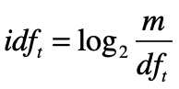

Where

m = number of documents (i.e., rows in the case of a term-document matrix);

dft = number of documents containing term t.

If a term occurs in every document, then its idf = 0, whereas if a term occurs in only one document out of 15, its idf = 3.91.

To calculate and display the idf for the letters corpus, we can use the following R script.

# calculate idf for each term

idf <- log2(nDocs(dtm)/col_sums(dtm > 0))

# create dataframe for graphing

df.idf <- data.frame(idf)

ggplot(df.idf,aes(idf)) + geom_histogram(fill="chocolate") + xlab("Inverse document frequency")

Inverse document frequency (corpus has 15 documents)

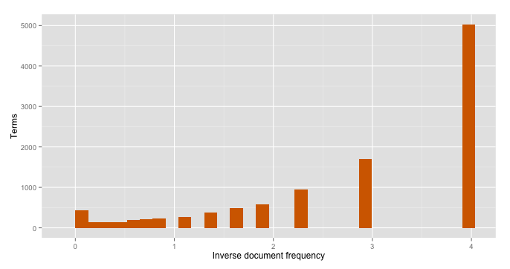

The preceding graphic shows that about 5,000 terms occur in only one document (i.e., the idf = 3.91) and less than 500 terms occur in every document. The terms with an idf in the range 1 to 2 are likely to be the most useful in determining the topic of each document.

### Term frequency inverse document frequency (tf-idf)

The weighted term frequency inverse document frequency (tf-idf or ωtd) is calculated by multiplying a term’s frequency (tf) by its inverse document frequency (idf).

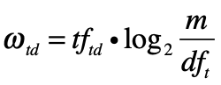

Where

tftd = frequency of term t in document d.

### Topic modeling with R

Prior to topic modeling, pre-process a text file in the usual fashion (e.g., convert to lower case, remove punctuation, and so forth). Then, create a document-term matrix.

The mean term frequency-inverse document frequency (tf-idf) is used to select the vocabulary for topic modeling. We use the median value of tf-idf for all terms as a threshold.

require(topicmodels)

require(slam)

# calculate tf-idf for each term

tfidf <- tapply(dtm$v/row_sums(dtm)[dtm$i], dtm$j, mean) * log2(nDocs(dtm)/col_sums(dtm > 0))

# report dimensions (terms)

dim(tfidf)

# report median to use as cut-off point

median(tfidf)

The goal of topic modeling is to find those terms that distinguish a document set. Thus, terms with low frequency should be omitted because they don’t occur often enough to define a topic. Similarly, those terms occurring in many documents don’t differentiate between documents.

A common heuristic is to select those terms with a tf-idf > median(tf-idf). As a result, we reduce the document-term matrix by keeping only those terms above the threshold and eliminating rows that have zero terms. Because the median is a measure of central tendency, this approach reduces the number of columns by roughly half.

# select columns with tf-idf > median

dtm <- dtm[,tfidf >= median(tfidf)]

#select rows with rowsum > 0

dtm <- dtm[row_sums(dtm) > 0,]

# report reduced dimension

dim(dtm)

As mentioned earlier, the topic modeling method assumes a set number of topics, and it is the responsibility of the analyst to estimate the correct number of topics to extract. It is common practice to fit models with a varying number of topics, and use the various results to establish a good choice for the number of topics. The analyst will typically review the output of several models and make a judgment on which model appears to provide a realistic set of distinct topics. Here is some code that starts with five topics.

# set number of topics to extract

k <- 5 # number of topics

SEED <- 2010 # seed for initializing the model rather than the default random

# try multiple methods – takes a while for a big corpus

TM <- list(VEM = LDA(dtm, k = k, control = list(seed = SEED)),

VEM_fixed = LDA(dtm, k = k, control = list(estimate.alpha = FALSE, seed = SEED)),

Gibbs = LDA(dtm, k = k, method = "Gibbs", control = list(seed = SEED, burnin = 1000, thin = 100, iter = 1000)), CTM = CTM(dtm, k = k,control = list(seed = SEED, var = list(tol = 10^-3), em = list(tol = 10^-3))))

topics(TM[["VEM"]], 1)

terms(TM[["VEM"]], 5)

> topics(TM[["VEM"]], 1)

1 2 3 4 5 6 7 8 9 10 11 12 13 14 15

4 4 4 2 2 5 4 4 4 3 3 5 1 5 5

> terms(TM[["VEM"]], 5)

Topic 1 Topic 2 Topic 3 Topic 4 Topic 5

[1,] "thats" "independent" "borrowers" "clayton" "clayton"

[2,] "bnsf" "audit" "clayton" "eja" "bnsf"

[3,] "cant" "contributions" "housing" "contributions" "housing"

[4,] "blackscholes" "reserves" "bhac" "merger" "papers"

[5,] "railroad" "committee" "derivative" "reserves" "marmon"

The output indicates that the first three letter (1998-2000) are about topic 4, the fourth (2001) topic 2, and so on.

Topic 1 is defined by the following terms: thats, bnsf, cant, blacksholes, and railroad. As we have seen previously, some of these words (e.g., thats and cant, which we can infer as being that’s and can’t) are not useful differentiators, and the dictionary could be extended to remove them from consideration and topic modeling repeated. For this particular case, it might be that Buffett’s letters don’t vary much from year to year, and he returns to the same topics in each annual report.

Skill builder

Experiment with the topicmodels package to identify the topics in Buffett’s letters. You might need to use the dictionary feature of text mining to remove selected words from the corpus to develop a meaningful distinction between topics.

# Named-entity recognition (NER)

Named-entity recognition (NER) places terms in a corpus into predefined categories such as the names of persons, organizations, locations, expressions of times, quantities, monetary values, and percentages. It identifies some or all mentions of these categories, as shown in the following figure, where an organization, place, and date are recognized.

Named-entity recognition example

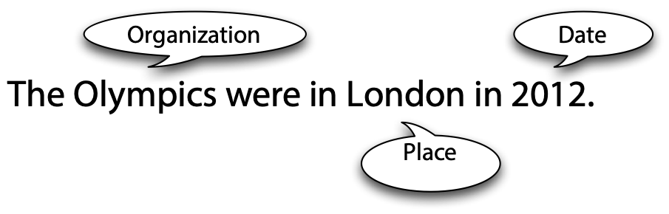

Tags are added to the corpus to denote the category of the terms identified.

The <organization>Olympics</organization> were in <place>London</place> in <date>2012</date>.

There are two approaches to developing an NER capability. A rules-based approach works well for a well-understood domain, but it requires maintenance and is language dependent. Statistical classifiers, based on machine learning, look at each word in a sentence to decide whether it is the start of a named-entity, a continuation of an already identified named-entity, or not part of a named-entity. Once a named-entity is distinguished, its category (e.g., place) must be identified and surrounding tags inserted.

Statistical classifiers need to be trained on a large collection of human-annotated text that can be used as input to machine learning software. Human-annotation, while time-consuming, does not require a high level of skill. It is the sort of task that is easily parallelized and distributed to a large number of human coders who have a reasonable understanding of the corpus’s context (e.g., able to recognize that London is a place and that the Olympics is an organization). The software classifier need to be trained on approximately 30,000 words.

The accuracy of NER is dependent on the corpus used for training and the domain of the documents to be classified. For example, NER is based on a collection of news stories and is unlikely to be very accurate for recognizing entities in medical or scientific literature. Thus, for some domains, you will likely need to annotate a set of sample documents to create a relevant model. Of course, as times change, it might be necessary to add new annotated text to the learning script to accommodate new organizations, place, people and so forth. A well-trained statistical classifier applied appropriately is usually capable of correctly recognizing entities with 90 percent accuracy.

### NER software

OpenNLP[43] is an Apache Java-based machine learning based toolkit for the processing of natural language in text format. It is a collection of natural language processing tools, including a sentence detector, tokenizer, parts-of-speech(POS)-tagger, syntactic parser, and named-entity detector. The NER tool can recognize people, locations, organizations, dates, times. percentages, and money. You will need to write a Java program to take advantage of the toolkit. The R package, openNLP, provides an interface to OpenNLP.

# Future developments

Text mining and natural language processing are developing areas and you can expect new tools to emerge. Document summarization, relationship extraction, advanced sentiment analysis, and cross-language information retrieval (e.g., a Chinese speaker querying English documents and getting a Chinese translation of the search and selected documents) are all areas of research that will likely result in generally available software with possible R versions. If you work in this area, you will need to continually scan for new software that extends the power of existing methods and adds new text mining capabilities.

## Summary

Language enables cooperation through information exchange. Natural language processing (NLP) focuses on developing and implementing software that enables computers to handle large scale processing of language in a variety of forms, such as written and spoken. The inherent ambiguity in written and spoken speech makes NLP challenging. Don’t expect NLP to provide the same level of exactness and starkness as numeric processing. There are three levels to consider when processing language: semantics, discourse, and pragmatics.

Sentiment analysis is a popular and simple method of measuring aggregate feeling. Tokenization is the process of breaking a document into chunks. A collection of text is called a corpus. The Flesch-Kincaid formula is a common way of assessing readability. Preprocessing, which prepares a corpus for text mining, can include case conversion, punctuation removal, number removal, stripping extra white spaces, stop word filtering, specific word removal, word length filtering, parts of speech (POS) filtering, Stemming, and regex filtering.

Word frequency analysis is a simple technique that can also be the foundation for other analyses. A term-document matrix contains one row for each term and one column for each document. A document-term matrix contains one row for each document and one column for each term. Words that occur frequently within a document are usually a good indicator of the document’s content. A word cloud is way of visualizing the most frequent words. Co-occurrence measures the frequency with which two words appear together. Cluster analysis is a statistical technique for grouping together sets of observations that share common characteristics. Topic modeling is a set of statistical techniques for identifying the topics that occur in a document set. The inverse document frequency (idf) measures the frequency of a term across documents. Named-entity recognition (NER) places terms in a corpus into predefined categories such as the names of persons, organizations, locations, expressions of times, quantities, monetary values, and percentages. Statistical classification is used for NER. OpenNLP is an Apache Java-based machine learning-based toolkit for the processing of natural language in text format. Document summarization, relationship extraction, advanced sentiment analysis, and cross-language information retrieval are all areas of research.

## Key terms and concepts

Association

Cluster analysis

Co-occurrence

Corpus

Dendrogram

Document-term matrix

Flesch-Kincaid formula

Inverse document frequency

KNIME

Named-entity recognition (NER)

Natural language processing (NLP)

Number removal

OpenNLP

Parts of speech (POS) filtering

Preprocessing

Punctuation removal

Readability

Regex filtering

Sentiment analysis

Statistical classification

Stemming

Stop word filtering

Stripping extra white spaces

Term-document matrix

Term frequency

Term frequency inverse document frequency

Text mining

Tokenization

Topic modeling

Word cloud

Word frequency analysis

Word length filtering

## References

Feinerer, I. (2008). An introduction to text mining in R. R News, 8(2), 19-22.

Feinerer, I., Hornik, K., & Meyer, D. (2008). Text mining infrastructure in R. *Journal of Statistical Software*, 25(5), 1-54.

Grün, B., & Hornik, K. (2011). topicmodels: An R package for fitting topic models. Journal of Statistical Software, 40(13), 1-30.

Ingersoll, G., Morton, T., & Farris, L. (2012). Taming Text: How to find, organize and manipulate it. Greenwich, CT: Manning Publications.

## Exercises

1. Take the recent annual reports for UPS[44] and convert them to text using an online service, such as [http://www.fileformat.info/convert/doc/pdf2txt.htm](http://convertonlinefree.com/PDFToTXTEN.aspx). Complete the following tasks:
   1. Count the words in the most recent annual report.
   2. Compute the readability of the most recent annual report.
   3. Create a corpus.
   4. Preprocess the corpus.
   5. Create a term-document matrix and compute the frequency of words in the corpus.
   6. Construct a word cloud for the 25 most common words.
   7. Undertake a cluster analysis, identify which reports are similar in nature, and see if you can explain why some reports are in different clusters.
   8. Build a topic model for the annual reports.
2. Download KNIME and run the New York TimesRSS feed analyzer.[45] Note that you will need to add the community contributed plugin, Palladian, to run the analyzer. See Preferences > Install/Update > Available Software Sites and the community contribution page <<http://tech.knime.org/community>>.
3. Merge the annual reports for Berkshire Hathaway (i.e., Buffett’s letters) and UPS into a single corpus.
   1. Undertake a cluster analysis and identify which reports are similar in nature.
   2. Build a topic model for the combined annual reports.
   3. Do the cluster analysis and topic model suggest considerable differences in the two sets of reports?

18. Cluster computing

Let us change our traditional attitude to the construction of programs: Instead of imagining that our main task is to instruct a computer what to do, let us concentrate rather on explaining to humans what we want the computer to do

Donald E. Knuth, *Literate Programming*, 1984

## Learning objectives

Students completing this chapter will:

* Understand the paradigm shift in decision-oriented data processing;
* Understand the principles of cluster computing

# A paradigm shift

There is much talk of big data, and much of it is not very informative. Rather a lot of big talk but not much smart talk. Big data is not just about greater variety and volumes of data at higher velocity, which is certainly occurring. The more important issue is the paradigm shift in data processing so that large volumes of data can be handled in a timely manner to support decision making. The foundations of this new model is the shift to cluster computing, which means using large numbers of commodity processors for massively parallel computing.

We start by considering what is different between the old and new paradigms for decision data analysis. Note that we are not considering transaction processing, for which the relational model is a sound solution. Rather, we are interested in the processing of very large volumes of data at a time, and the relational model was not designed for this purpose. It is suited for handling transactions, which typically involve only a few records. The multidimensional database (MDDB) is the “old” approach for large datasets and cluster compute is the “new.”

Another difference is the way data are handled. The old approach is to store data on a high speed disk drive and load it into computer memory for processing. To speed up processing, the data might be moved to multiple computers to enable parallel processing and the results merged into a single file. Because data files are typically much larger than programs, moving data from disks to computers is time consuming. Also, high performance disk storage devices are expensive. The new method is to spread a large data file across multiple commodity computers, possibly using HDFS, and then send each computer a copy of the program to run in parallel. The results from the individual jobs are then merged. While data still need to be moved to be processed, they are moved across a high speed data channel within a computer rather than the lower speed cables of a storage network.

| Old | New |
| --- | --- |
| Data to the program | Program to the data |
| Mutable data | Immutable data |
| Special purpose hardware | Commodity hardware |

# The drivers

Exploring the drivers promoting the paradigm shift is a good starting point for understanding this important change in data management. First, you will recall that you learned in Chapter 1 that decision making is the central organizational activity. Furthermore, because data-driven decision making increases organizational performance, many executives are now demanding data analytics to support their decision making.

Second, as we also explained in Chapter 1, there is a societal shift in dominant logic as we collectively recognize that we need to focus on reducing environmental degradation and carbon emissions. Service and sustainability dominant logics are both data intensive. Customer service decisions are increasingly based on the analysis of large volumes of operational and social data. Sustainability oriented decisions also require large volumes of operational data, which are combined with environmental data collected by massive sensor networks to support decision making that reduces an organization’s environmental impact.

Third, the world is in the midst of a massive data generating digital transformation. Large volumes of data are collected about the operation on an aircraft’s jet engines, how gamers play massively online games, how people interact in social media space, and the operation of cell phone networks, for example. The digital transformation of life and work is creating a bits and bytes tsunami.

# The bottleneck and its solution

In a highly connected and competitive world, speedy high quality decisions can be a competitive advantage. However, large data sets can take some time and expense to process, and so as more data are collected, there is a the danger that decision making will gradually slow down and its quality lowered. Data analytics becomes a bottleneck when the conversion of data to information is too slow. Second, decision quality is lowered when there is a dearth of skills for determining what data should be converted to information and interpreting the resulting conversion. We capture these problems in the elaboration of a diagram that was introduced in Chapter 1, which now illustrates the causes of the conversion, request, and interpretation bottlenecks.

Data analytics bottleneck

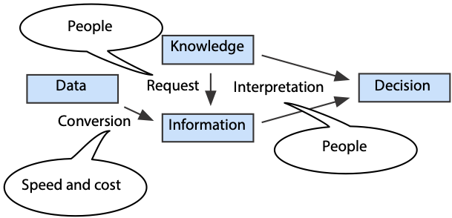

The people skills problem is being addressed by the many universities that have added graduate courses in data analytics. The Lambda Architecture[46] is a proposed general solution to the speed and cost problem.

# Lambda Architecture

We will now consider the three layers of the Lambda Architecture: batch, speed, and serving.

## The batch layer

Batch computing describes the situation where a computer works on one or more large tasks with minimal interruption. Because early computers were highly expensive and businesses operated at a different tempo, batch computing was common in the early days of information systems. The efficiency gains of batch computing mainly come from uninterrupted sequential file processing. The computer spends less time waiting for data to be retrieved from disks, particularly with HDFS where files are in 64Mb chunks. Batch computing is very efficient, though not timely, and the Lambda Architecture takes advantage of this efficiency.

The batch layer is used to precompute queries by running them with the most recent version of the dataset. The precomputed results are saved and can then be used as required. For example, a supermarket chain might want to know how often each pair of products appears in each shopper’s basket for each day for each store. These data might help it to set cross-promotional activities within a store (e.g., a joint special on steak and mashed potatoes). The batch program could precompute the count of joint sales for each pair of items for each day for each store in a given date range. This highly summarized data could then be used for queries about customers’ baskets (e.g., how many customers purchased both shrimp and grits in the last week in all Georgia stores?). The batch layer works with a dataset essentially consisting of every supermarket receipt because this is the record of a customer’s basket. This dataset is also stored by the batch layer. Hadoop is well-suited for handling the batch layer, as you will see later, but it is not the only option.

New data are appended to the master dataset to preserve is immutability, so that it remains a complete record of transactions for a particular domain (e.g., all receipts). These incremental data are processed the next time the batch process is restarted.

The batch layer can be processing several batches simultaneously. It typically keeps recomputing batch views using the latest dataset every few hours or maybe overnight.

## The serving layer

The serving layer processes views computed by the batch layer so they can be queried. Because the batch layer produces a flat file, the serving layer indexes it for random access. The serving layer also replaces the old batch output with the latest indexed batch view when it is received from the batch layer. In a typical Lambda Architecture system, there might be several or more hours between batch updates.

The combination of the batch and serving layers provides for efficient reporting, but it means that any queries on the files generated by the batch layer might be several or more hours old. We have efficiency but not timeliness, for which we need the speed layer.

## Speed layer

Once a batch recompute has started running, all newly collected data cannot be part of the resulting batch report. The purpose of the speed layer is to process incremental data as they arrive so they can be merged with the latest batch data report to give current results. Because the speed layer modifies the results as each chunk of data (e.g., a transaction) is received, the merge of the batch and speed layer computations can be used to create real-time reports.

Merging speed and serving layer results to create a report (source: (Marz and Warren 2012))

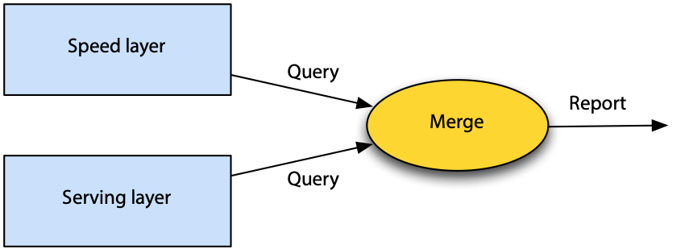

## Putting the layers together

We now examine the process in detail.

Assume batchn-1 has just been processed.

1. During the processing of batchn-1, incrementn-1 was created from the records received. The combination of these two data sets creates batchn.
2. As the data for incrementn-1 were received, speed layer (Sresultsn-1) were dynamically recomputed.
3. A current report can be created by combining speed layer and batch layer results (i.e., Sresultsn-1 and Bresultsn-1).

Now, assume batch computation resumes with batchn.

1. Sresultsn are computed from the data collected (incrementn) while batchn is being processing.
2. Current reports are based on Bresultsn-1, Sresultsn-1, and Sresultsn.
3. At the end of processing batchn, Sresultsn-1 can be discarded because Bresultsn includes all the data from batchn-1 and incrementn-1.

The preparation of a real-time report using batch and speed layer results when processing batchn

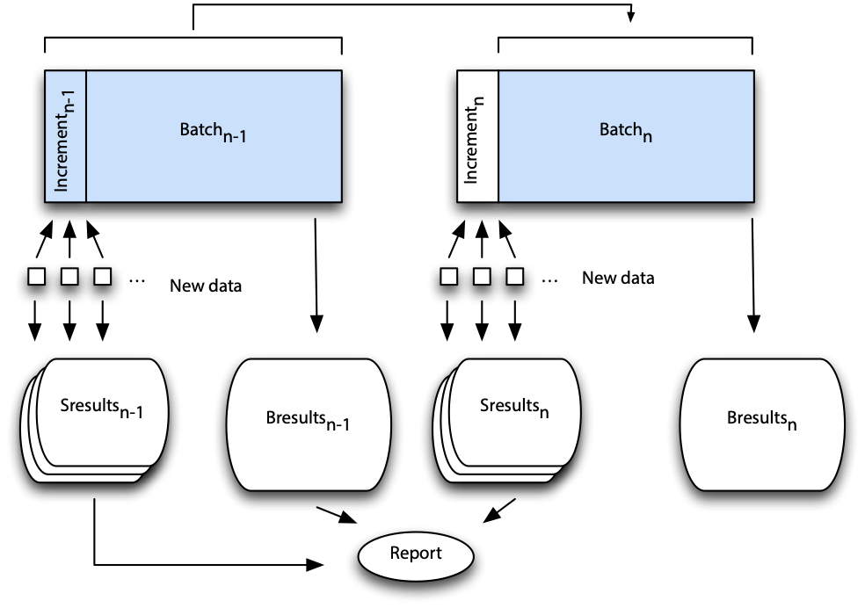

In summary, the batch layer pre-computes reports using all the currently available data. The serving layer indexes the results of the batch layers and creates views that are the foundation for rapid responses to queries. The speed layer does incremental updates as data are received. Queries are handled by merging data from the serving and speed layers.

Lambda Architecture (source: (Marz and Warren 2012))

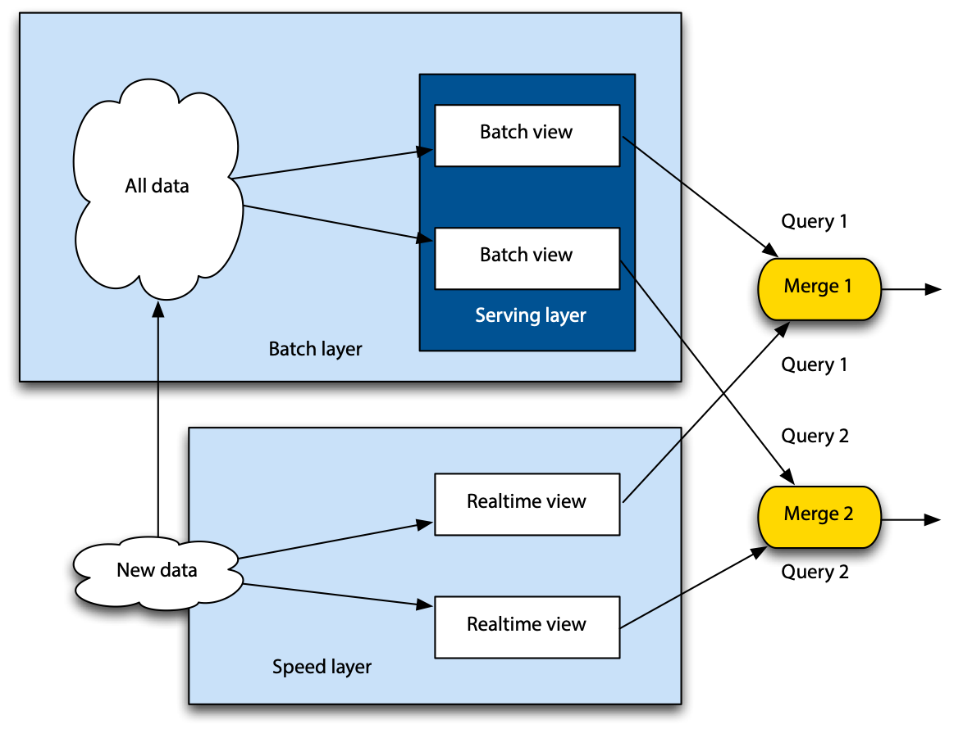

## Benefits of the Lambda Architecture

The Lambda Architecture provides some important advantages for processing large datasets, and these are now considered.

### Robust and fault-tolerant

Programming for batch processing is relatively simple and also it can easily be restarted if there is a problem. Replication of the batch layer dataset across computers increases fault tolerance. If a block is unreadable, the batch processor can shift to the identical block on another node in the cluster. Also, the redundancy intrinsic to a distributed file system and distributed processors provides fault-tolerance.

The speed layer is the complex component of the Lambda Architecture. Because complexity is isolated to this layer, it does not impact other layers. In addition, since the speed layer produced temporary results, these can be discarded in the event of an error. Eventually the system will right itself when the batch layer produces a new set of results, though intermediate reports might be a little out of date.

### Low latency reads and updates

The speed layer overcomes the long delays associated with batch processing. Real-time reporting is possible through the combination of batch and speed layer outputs.

### Scalable

Scalability is achieved using a distributed file system and distributed processors. To scale, new computers are added.

### Support a wide variety of applications

The general architecture can support reporting for a wide variety of situations.

### Extensible

New data types can be added to the master dataset or new master datasets created. Furthermore, new computations can be added to the batch and speed layers to create new views.

### Ad hoc queries

On the fly queries can be run on the output of the batch layer provided the required data are available in a view.

### Minimal maintenance

The batch and serving layers are relatively simple programs because they don’t deal with random updates or writes. Simple code requires less maintenance.

### Debuggable

Batch programs are easier to debug because you can have a clear link between the input and output. Data immutability means that debugging is easier because no records have been overwritten during batch processing.

## Relational and Lambda Architectures

Relational technology supports both transaction processing and data analytics. As a result, it needs to be more complex than the Lambda Architecture. Separating out data analytics from transaction processing simplifies the supporting technology and makes it suitable for handling large volumes of data efficiently. Relational systems can continue to support transaction processing and, as a byproduct, produce data that are fed to Lambda Architecture based business analytics.

# Hadoop

Hadoop, an Apache project,[47] supports distributed processing of large data sets across a cluster of computers. A Hadoop cluster consists of many standard processors, nodes, with associated main memory and disks. They are connected by Ethernet or switches so they can pass data from node to node. Hadoop is highly scalable and reliable. It is a suitable technology for the batch layer of the Lambda architecture. Hadoop is a foundation for data analytics, machine learning, search ranking, email anti-spam, ad optimization, and other areas of applications which are constantly emerging.

A market analysis projects that the Hadoop market is growing at 58% per year.[48] It also asserts that, “Hadoop is the only cost-sensible and scalable open source alternative to commercially available Big Data management packages. It also becomes an integral part of almost any commercially available Big Data solution and de-facto industry standard for business intelligence (BI).”

## Hadoop distributed file system (HDFS)

HDFS is a highly scalable, fault-toleration, distributed file system. When a file is uploaded to HDFS, it is split into fixed sized blocks of at least 64MB. Blocks are replicated across nodes to support parallel processing and provide fault tolerance. As the following diagram illustrates, an original file when written to HDFS is broken into multiple large blocks that are spread across multiple nodes. HDFS provides a set of functions for converting a file to and from HDFS format and handling HDFS.

Splitting of file across a HDFS cluster.

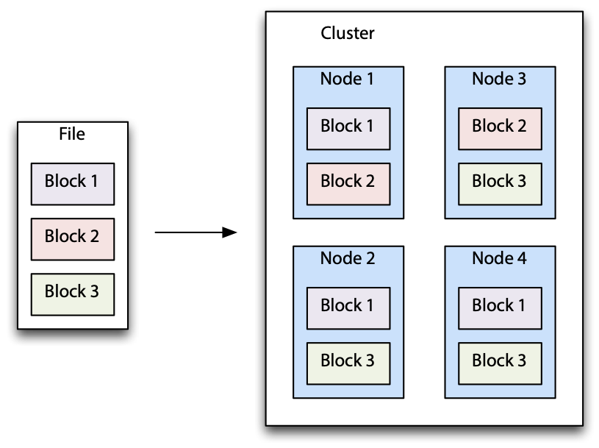

On each node, blocks are stored sequentially to minimize disk head movement. Blocks are grouped into files, and all files for a dataset are grouped into a single folder. As part of the simplification to support batch processing, there is no random access to records and new data are added as a new file.

Scalability is facilitated by the addition of new nodes, which means adding a few more pieces of inexpensive commodity hardware to the cluster. Appending new data as files on the cluster also supports scalability.

HDFS also supports partitioning of data into folders for processing at the folder level. For example, you might want all employment related data in a single folder.

# Spark

Spark is an Apache project[49] for cluster computing that was initiated at the University of California Berkeley and later transferred to Apache as an open source project. Spark’s distributed file system, resilient distributed dataset (RDD), has similar characteristics to HDFS. Spark can also interface with HDFS and other distributed file systems. For testing and development, Spark has a local mode, that can work with a local file system.

Spark includes several component, including Spark SQL for SQL-type queries, Spark streaming for real-time analysis of event data as it is received, and a machine learning (ML) library. This library is designed for in-memory processing and is approximately 10 times faster than disk-based equivalent approaches. Distributed graph processing is implemented using GraphX.

## Computation with Spark

Spark applications can be written in Java, Scala, Python, and R. In our case, we will use the sparklyr,[50] an R interface to Spark. This package provides a simple, easy to use set of commands for exposing the distributed processing power of Spark to those familiar with R. In particular, it supports dplyr for data manipulation of Spark datasets and access to Sparks ML library.

Before starting with sparklyr, you need to check that you have latest version of Java on your machine.[51] Use RStudio to install sparklyr. For developing and testing on your computer, install a local version of Spark.

library(sparklyr)

[spark_install](http://spark.rstudio.com/reference/spark_install.html)(version='2.4')

Use the spark_connect function to connect to Spark either locally or on a remote Spark cluster. The following code shows how to specify local Spark connection (sc).

library(sparklyr)

sc <- [spark_connect](http://spark.rstudio.com/reference/spark-connections.html)(master = "local")

## Tabulation

In this example, we have a list of average monthly temperatures for New York’s Central Park[52] and we want to determine how often each particular temperature occurred. R

Average monthly temperatures since 1869 are read, and the temperature rounded to an integer for the convenience of tabulation.

library(dplyr)

Library(readr)

url <- "http://www.richardtwatson.com/data/centralparktemps.txt"

t <- read_delim(url, delim=',')

# tabulate frequencies for temperature

t %>%

mutate(Fahrenheit = round(temperature,0)) %>%

group_by(Fahrenheit) %>%

summarize(Frequency = n())

# A tibble: 61 x 2

Fahrenheit Frequency

<dbl> <int>

1 20 1

2 22 2

3 23 3

4 24 5

5 25 15

6 26 10

7 27 8

8 28 19

9 29 24

10 30 32

# ... with 51 more rows

### Spark

By using dplyr in the prior R code, we can copy and paste and add a few commands for the Spark implementation. The major differences are the creation of a Spark connection (sc) and copying the R tibble to Spark with copy-to. Also, note that you need to sort the resulting tibble, which is not required in regular R.

library(dplyr)

Library(readr)

spark_install(version='2.4')

sc <- spark_connect(master = "local", spark_home=spark_home_dir(version = '2.4'))

url <- "http://www.richardtwatson.com/data/centralparktemps.txt"

t <- read_delim(url, delim=',')

t_tbl <- copy_to(sc,t)

t_tbl %>%

mutate(Fahrenheit = round(temperature,0)) %>%

group_by(Fahrenheit) %>%

summarize(Frequency = n()) %>%

arrange(Fahrenheit)

# A tibble: 61 x 2

Fahrenheit Frequency

<dbl> <dbl>

1 20 1

2 22 2

3 23 3

4 24 5

5 25 15

6 26 9

7 27 9

8 28 17

9 29 26

10 30 30

# ... with 51 more rows

It you observe the two sets of output carefully, you will note that the results are not identical. It is because rounding can vary across systems. The IEEE Standard for Floating-Point Arithmetic (IEEE 754)[53] states on rounding, “if the number falls midway it is rounded to the nearest value with an even (zero) least significant bit.” Compare the results for round(12.5,0) and round(13.5,0). R follows the IEEE standard, but Spark apparently does not.

Skill builder

Redo the tabulation example with temperatures in Celsius.

## Basic statistics with Spark

We now take the same temperature dataset and calculate mean, min, and max monthly average temperatures for each year and put the results in a single file.

### R

library(dplyr)

Library(readr)

url <- "http://www.richardtwatson.com/data/centralparktemps.txt"

t <- read_delim(url, delim=',')

# report minimum, mean, and maximum by year

t %>%

group_by(year) %>%

summarize(Min=min(temperature),

Mean = round(mean(temperature),1),

Max = max(temperature))

# A tibble: 148 x 4

year Min Mean Max

<int> <dbl> <dbl> <dbl>

1 1869 34.5 51.4 72.8

2 1870 31.3 53.6 76.6

3 1871 28.3 51.1 73.6

4 1872 26.7 51.0 77.5

5 1873 28.6 51.0 75.4

6 1874 31.3 51.3 73.9

7 1875 23.8 49.4 74.0

8 1876 24.9 51.9 79.4

9 1877 27.7 52.8 75.4

10 1878 30.3 53.5 77.8

# ... with 138 more rows

### Spark

Again, the use of dplyr makes the conversion to Spark simple.

library(sparklyr)

library(tidyverse)

spark_install(version='2.4')

sc <- spark_connect(master = "local", spark_home=spark_home_dir(version = '2.4'))

url <- "http://www.richardtwatson.com/data/centralparktemps.txt"

t <- read_delim(url, delim=',')

t_tbl <- copy_to(sc,t)

# report minimum, mean, and maximum by year

# note that sparkly gives a warning if you do not specify how to handle missing values

t_tbl %>%

group_by(year) %>%

summarize(Min=min(temperature, na.rm = T),

Mean = round(mean(temperature, na.rm = T),1),

Max = max(temperature, na.rm = T)) %>%

arrange(year)

# A tibble: 148 x 4

year Min Mean Max

<int> <dbl> <dbl> <dbl>

1 1869 34.5 51.4 72.8

2 1870 31.3 53.6 76.6

3 1871 28.3 51.1 73.6

4 1872 26.7 51.0 77.5

5 1873 28.6 51.0 75.4

6 1874 31.3 51.3 73.9

7 1875 23.8 49.4 74.0

8 1876 24.9 51.9 79.4

9 1877 27.7 52.8 75.4

10 1878 30.3 53.5 77.8

# ... with 138 more rows

Skill builder

A file[54] of electricity costs for a major city contains a timestamp and cost separated by a comma. Compute the minimum, mean, and maximum costs.

## Summary

Big data is a paradigm shift to new file structures, such as HDFS and RDD, and algorithms for the parallel processing of large volumes of data. The new file structure approach is to spread a large data file across multiple commodity computers and then send each computer a copy of the program to run in parallel. The drivers of the transformation are the need for high quality data-driven decisions, a societal shift in dominant logic, and digital transformation. The speed and cost of converting data to information is a critical bottleneck as is a dearth of skills for determining what data should be converted to information and interpreting the resulting conversion. The people skills problem is being addressed by universities’ graduate courses in data analytics. The Lambda Architecture, a solution for handling the speed and cost problem, consists of three layers: speed, serving, and batch. The batch layer is used to precompute queries by running them with the most recent version of the dataset. The serving layer processes views computed by the batch layer so they can be queried. The purpose of the speed layer is to process incremental data as they arrive so they can be merged with the latest batch data report to give current results. The Lambda Architecture provides some important advantages for processing large datasets. Relational systems can continue to support transaction processing and, as a byproduct, produce data that are fed to Lambda Architecture based business analytics.

Hadoop supports distributed processing of large data sets across a cluster of computers. A Hadoop cluster consists of many standard processors, nodes, with associated main memory and disks. HDFS is a highly scalable, fault-toleration, distributed file system. Spark is a distributed computing method for scalable and fault-tolerant cluster computation.

## Key terms and concepts

Batch layer

Bottleneck

Cluster computing

Hadoop

HDFS

Immutable data

Lambda Architecture

Parallelism

Serving layer

Spark

Speed layer

## References and additional readings

Lam, C. (2010). *Hadoop in action*: Manning Publications Co.

Marz, N., & Warren, J. (2012). Big Data: Manning Publications.

## Exercises

1. Write Spark code for the following situations.
   1. Compute the square and cube of the numbers in the range 1 to 25. Display the results in a data frame.
   2. Using the average monthly temperatures for New York’s Central Park, compute the maximum, mean, and average temperature in Celsius for each month.
   3. Using the average monthly temperatures for New York’s Central Park, compute the max, mean, and min for August. You will need to use subsetting, as discussed in this chapter.
   4. Using the electricity price data, compute the average hourly cost.
   5. Read the national GDP file,[55] which records GDP in millions, and count how many countries have a GDP greater than or less than 10,000 million.

19. Dashboards

I think, aesthetically, car design is so interesting - the dashboards, the steering wheels, and the beauty of the mechanics. I don't know how any of it works, I don't want to know, but it's inspirational.

Paloma Picasso, designer, 2013[56]

## Learning objectives

Students completing this chapter will:

* Understand the purpose of dashboards;
* Be able to use the R package shinydashboard to create a dashboard.

# The value of dashboards

A dashboard is a web page or mobile app screen designed to present important information, primarily visual format, that can be quickly and easily comprehended. Dashboards are often used to show the current status, such as the weather app you have on your smart phone. Sometimes, a dashboard can also show historical data as a means of trying to identify long term trends. Key economic indicators for the last decade or so might be shown graphically to help strategic planners identify major shifts in economic activity. In a world overflowing with data, dashboards are an information system for summarizing and presenting key data. They can be very useful for maintaining situation awareness, by providing information about key environmental measures of the current situation and possible future developments.

A dashboard typically has a header, sidebar and body

## Header

There is a header across the top of a page indicating the purpose of the dashboard, and additional facts about the content, such as the creator. A search engine is a common element of a header. A header can also contain tabs to various sources of information or reports (e.g., social media or Fortune 1000 companies).

## Sidebar

A sidebar usually contains features that enable the body of the report to be customized to the viewer’s needs. There might be filters to fine-tune what is displayed. Alternatively, there can be links to select information on a particular topic. In the following example, the sidebar contains some high level summary data, such as the number of documents in a category.

## Body

The body of a dashboard contains the information selected via a sidebar. It can contained multiple panes, as shown in the following example, that display information in a variety of ways. The body of the following dashboard contains four types of visuals (a multiple time series graph, a donut style pie chart, a map, and a relationship network). It also shows a list of documents satisfying the specified criteria and a word cloud of these documents.

I encourage you to visit the ecoresearch.net dashboard. It is an exemplar and will give you some idea of the diversity of ways in which information can be presented and the power of a dashboard to inform.

A dashboard <<http://www.ecoresearch.net/climate/>>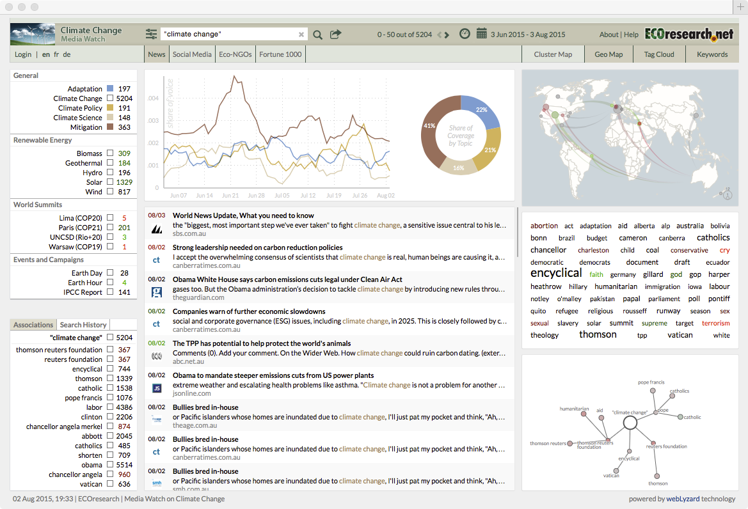

## Designing a dashboard

The purpose of a dashboard is to communicate, so the first step is to work with the client to determine the key performance indicators (KPIs), visuals, or text that should be on the dashboard. Your client will have some ideas as to what is required, and by asking good questions and prototyping, you can clarify needs.

You will need to establish that high quality data sources are available for conversion into the required information. If data are not available, you will have to work with other IS professionals to establish them, or you might conclude that it is infeasible to try to meet some requirements. You should keep the client informed as you work through the process of resolving data source issues. Importantly, you should make the client aware of any data quality problems. Sometimes your client might have to settle for less than desirable data quality in order to get some idea of directional swings.

Try several ways of visualizing data to learn what suits the client. The ggvis package works well with shinydashboard, the dashboard package we will learn. Also, other R packages, such as dygraphs, can be deployed for graphing time series, a frequent dashboard element for showing trends and turning points. Where possible, use interactivity to enable the client to customize as required (e.g., let the client select the period of a time series).

Design for ease of navigation and information retrieval. Simplicity should generally be preferred to complexity. Try to get chunks of information that should be viewed at the same time on the same page, and put other collections of cohesive information on separate tabs.

Use colors consistently and in accord with general practice. For example, red is the standard color for danger, so a red information box should contain only data that indicate a key problem (e.g., a machine not working or a major drop in a KPI). Consistency in color usage can support rapid scanning of a dashboard to identify the attention demanding situations.

Study dashboards that are considered as exhibiting leading business practices or are acknowledged as exemplars. Adopt or imitate the features that work well.

Build a prototype as soon as you have a reasonable idea of what you think is required and release it to your client. This will enable the client to learn what is possible and for you to get a deeper understanding of the needs. Learn from the response to the prototype, redesign, and release version 2. Continue this process for a couple of iterations until the dashboard is accepted.

## Dashboards with R

R requires two packages, shiny and shinydashboard, to create a dashboard. Also, you must use RStudio to run your R script. Shiny is a R package for building interactive web applications in R. It was contributed to the R project by RStudio. It does not require knowledge of traditional web development tools such as HTML, CSS, or JavaScript. Shinydashboard uses Shiny to create dashboards, but you you don’t need to learn Shiny. Some [examples](http://www.apple.com) of dashboards built with shinydashboard will give you an idea of what is feasible.

### The basics

In keeping with the style of this book, we will start by creating a minimalist dashboard without any content. There are three elements: header, sidebar, and body. It this case, they are all null. Together, these three elements create the UI (user interface) of a dashboard page. The dynamic side of the page, the server, is also null. A dashboard is a Shiny app, and the final line of code runs the application.

A UI script defines the layout and appearance of dashboard’s web page. The server script contains commands to run the dashboard app and to make a page dynamic.

library(shiny)

library(shinydashboard)

header <- dashboardHeader()

sidebar <- dashboardSidebar()

body <- dashboardBody()

ui <- dashboardPage(header,sidebar,body)

server <- function(input, output) {}

shinyApp(ui, server)

When you select all the code and run it, a new browser window will open and display a blank dashboard.

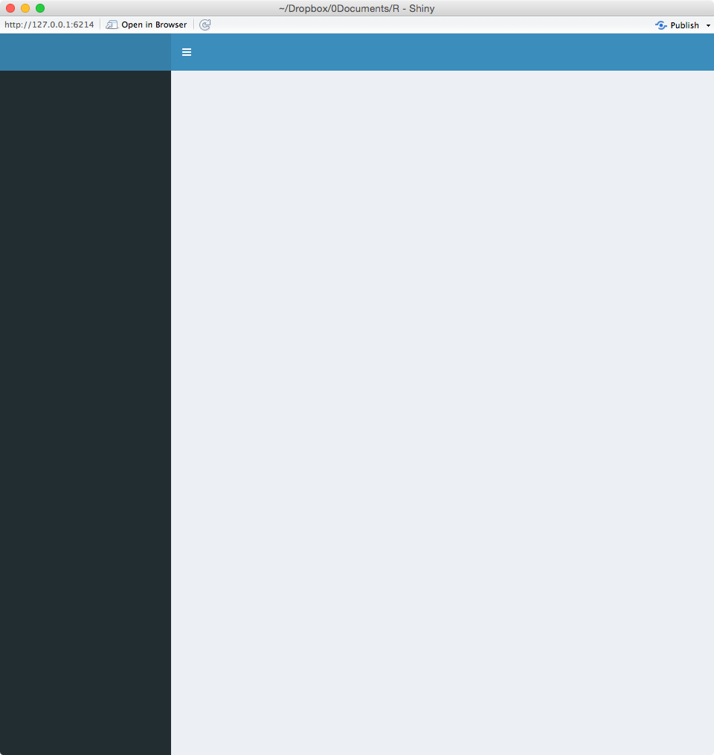

When you inspect some shinydashboard code, you will sometimes see a different format in which commands are deeply embedded in other commands. The following code illustrates this approach. I suggest you avoid it because it is harder to debug such code, especially when you are a novice.

library(shiny)

library(shinydashboard)

ui <- dashboardPage(

dashboardHeader(),

dashboardSidebar(),

dashboardBody()

)

server <- function(input, output) {}

shinyApp(ui, server)

### Terminating a dashboard

A dashboard is meant to be a dynamic web page that is updated when refreshed or when some element of the page is clicked on. It remains active until terminated. This means that when you want to test a new version of a dashboard or run another one, you must first stop the current one. You will need to click the stop icon on the console’s top left to terminate a dashboard and close its web page.

### A header and a body

We now add some content to a basic dashboard by giving it a header and a body. This page reports the share price of Apple, which has the stock exchange symbol of AAPL. The getQuote function[57] of the [quantmod](https://cran.r-project.org/web/packages/quantmod/index.html) package returns the latest price, with about a two hour delay, every time the page is opened or refreshed. Notice the use of paste to concatenate a title and value.

library(shiny)

library(shinydashboard)

library(quantmod)

header <- dashboardHeader(title = 'Apple stock watch')

sidebar <- dashboardSidebar()

body <- dashboardBody(paste('Latest price ',getQuote('AAPL')$Last))

ui <- dashboardPage(header,sidebar,body)

server <- function(input, output) {}

shinyApp(ui, server)

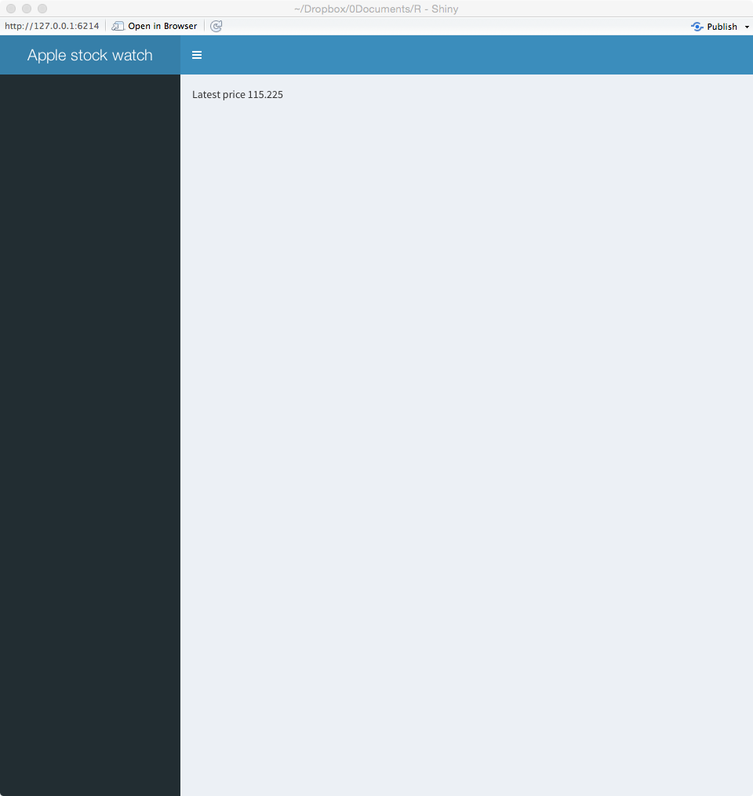

### Boxes and rows

Boxes are the building blocks of a dashboard, and they can be assembled into rows or columns. The fluidRow function is used to place boxes into rows and columns. The following code illustrates the use of fluidRow.

library(shiny)

library(shinydashboard)

library(quantmod)

header <- dashboardHeader(title = 'Apple stock watch')

sidebar <- dashboardSidebar()

boxLatest <- box(title = 'Latest price: ',getQuote('AAPL')$Last, background = 'blue' )

boxChange <- box(title = 'Change ',getQuote('AAPL')$Change, background = 'red' )

row <- fluidRow(boxLatest,boxChange)

body <- dashboardBody(row)

ui <- dashboardPage(header,sidebar,body)

server <- function(input, output) {}

shinyApp(ui, server)

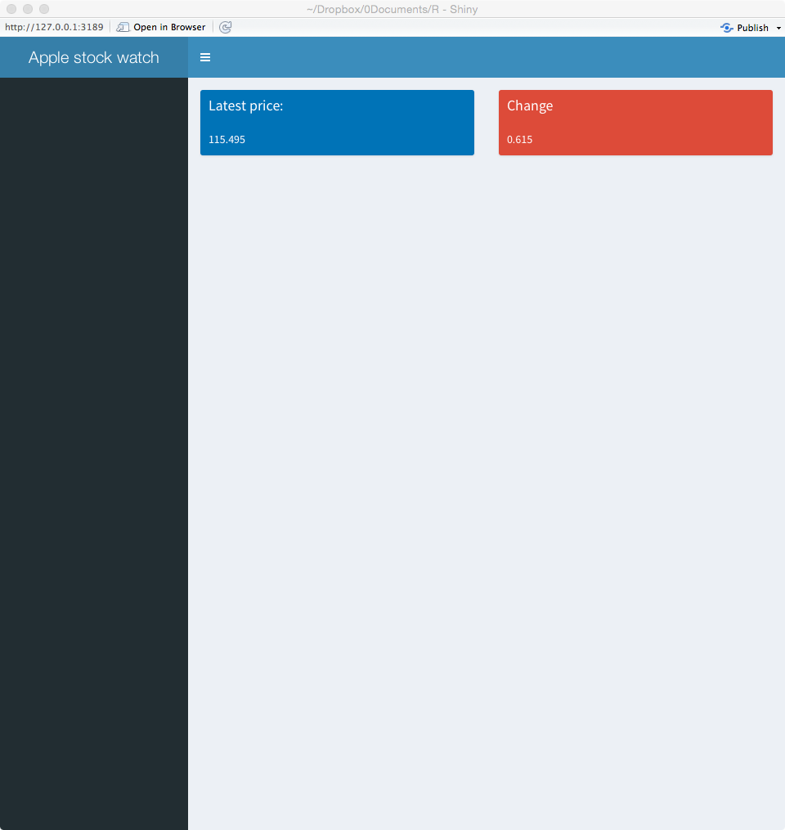

Skill builder

Add three more boxes (e.g., high price) to the dashboard just created.

### Multicolumn layout

Shinydashboard is based on dividing up the breadth of a web page into 12 units, assuming it is wide enough. Thus, a box with width = 6 will take up half a page. The tops of the boxes in each row will be aligned, but the bottoms may not be because of the volume of data they contain. The fluidRows function ensures that a row’s elements appear on the same line, if the browser has adequate width.

You can also specify that boxes are placed in columns. The column function defines how much horizontal space, within the 12-unit width grid, each element should occupy.

In the following code, note how:

* a background for a box is defined (e.g., background=‘navy’);
* five boxes are organized into two columns (rows <- fluidRow(col1,col2));
* volume of shares traded is formatted with commas (formatC(getQuote(‘AAPL')$Volume,big.mark=',').

library(shiny)

library(shinydashboard)

library(quantmod)

header <- dashboardHeader(title = 'Apple stock watch')

sidebar <- dashboardSidebar()

boxLast <- box(title = 'Latest', width=NULL, getQuote('AAPL')$Last, background='navy')

boxHigh <- box(title = 'High', width=NULL, getQuote('AAPL')$High , background='light-blue')

boxVolume <- box(title = 'Volume', width=NULL, formatC(getQuote('AAPL')$Volume,big.mark=','), background='aqua')

boxChange <- box(title = 'Change', width=NULL, getQuote('AAPL')$Change, background='light-blue')

boxLow <- box(title = 'Low', width=NULL, getQuote('AAPL')$Low, background='light-blue')

col1 <- column(width = 4,boxLast,boxHigh,boxVolume)

col2 <- column(width = 4,boxChange,boxLow)

rows <- fluidRow(col1,col2)

body <- dashboardBody(rows)

ui <- dashboardPage(header,sidebar,body)

server <- function(input, output) {}

shinyApp(ui, server)

#### 

### Sidebar

A sidebar is typically used to enable quick navigation of a dashboard’s features. It can contain layers of menus, and by clicking on a menu link or icon, the dashboard can display different content in the body area.

A library of icons is available ([Font-Awesome](http://fontawesome.io/icons/) and [Glyphicons](http://www.apple.com)) for use in the creation of a dashboard.

library(shiny)

library(shinydashboard)

library(quantmod)

header <- dashboardHeader(title = 'Stock watch')

menuApple <- menuItem("Apple", tabName = "Apple", icon = icon("dashboard"))

menuGoogle <- menuItem("Google", tabName = "Google", icon = icon("dashboard"))

sidebar <- dashboardSidebar(sidebarMenu(menuApple, menuGoogle))

tabApple <- tabItem(tabName = "Apple", getQuote('AAPL')$Last)

tabGoogle <- tabItem(tabName = "Google", getQuote('GOOG')$Last)

tabs <- tabItems(tabApple,tabGoogle)

body <- dashboardBody(tabs)

ui <- dashboardPage(header, sidebar, body)

server <- function(input, output) {}

shinyApp(ui, server)

For the following dashboard, by clicking on Apple, you get its latest share price, and similarly for Google.

#### 

### Infobox

An infobox is often used to display a single measure, such as a KPI.

library(shiny)

library(shinydashboard)

library(quantmod)

header <- dashboardHeader(title = 'Apple stock watch')

sidebar <- dashboardSidebar()

infoLatest <- infoBox(title = 'Latest', icon('dollar'), getQuote('AAPL')$Last, color='red')

infoChange <- infoBox(title = 'Web site', icon('apple'),href='http://investor.apple.com', color='purple')

row <- fluidRow(width=4,infoLatest,infoChange)

body <- dashboardBody(row)

ui <- dashboardPage(header,sidebar,body)

server <- function(input, output) {}

shinyApp(ui, server))

The following dashboard shows the latest price for Apple’s shares. By clicking on the purple infobox, you access Apple investors’ web site.

#### 

### Dynamic dashboards

Dashboards are more useful when they give managers access to determine what is presented. The server function supports dynamic dashboards and executes when a dashboard is opened or refreshed.

The following basic dashboard illustrates how a server function is specified and how it communicates with the user interface. Using the time series graphing package, dygraphs, it creates a dashboard showing the closing price for Apple. Key points to note:

* The ui function indicates that it wants to create a graph with the code dygraphOutput('apple').
* The server executes output$apple <- renderDygraph({dygraph(Cl(get(getSymbols(‘AAPL'))))}) to produce the graph.
* The linkage between the UI and the server functions is through the highlighted code, as shown in the preceding two bullets and the following code block.
* The text parameter of dynagraphOutput() in the UI function must match the text following output$ in the server function.
* The data to be graphed are retrieved with the Cl function of the quantmod package.[58]

library(shiny)

library(shinydashboard)

library(quantmod)

library(dygraphs) # graphic package for time series

header <- dashboardHeader(title = 'Apple stock watch')

sidebar <- dashboardSidebar(NULL)

boxPrice <- box(title='Closing share price', width = 12, height = NULL, dygraphOutput('apple'))

body <- dashboardBody(fluidRow(boxPrice))

ui <- dashboardPage(header, sidebar, body)

server <- function(input, output) {

# quantmod retrieves closing price as a time series

output$apple <- renderDygraph({dygraph(Cl(get(getSymbols('AAPL'))))})

}

shinyApp(ui, server)

When you create the dashboard, mouse over the points on the graph and observe the data that are reported.

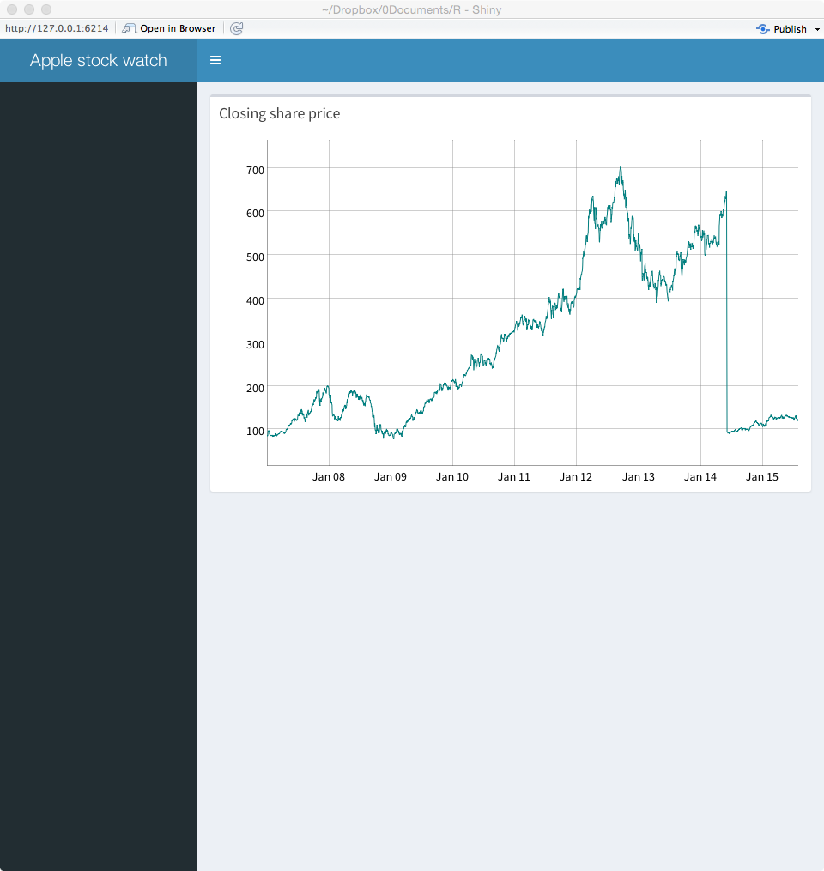

The following code illustrates how to create a dashboard that enables an analyst to graph the closing share price for Apple, Google, or Ford. Important variables in the code have been highlighted so you can easily see the correspondence between the UI and server functions. Note:

* The use of a selection list to pick one of three companies (selectInput("symbol", "Equity:", choices = c("Apple" = "AAPL", "Ford" = "F", "Google" = “GOOG").
* When an analyst selects one of the three firms, its stock exchange symbol (symbol) is passed to the server function.
* The value of symbol is used to retrieve the time series for the stock and to generate the graphic (chart ) for display with boxSymbol. The symbol is also inserted into a text string (text) for display with boxOutput.

library(shiny)

library(shinydashboard)

library(quantmod)

library(dygraphs)

header <- dashboardHeader(title = 'Stock watch')

sidebar <- dashboardSidebar(NULL)

boxSymbol <- box(selectInput("symbol", "Equity:", choices = c("Apple" = "AAPL", "Ford" = "F", "Google" = "GOOG"), selected = 'AAPL'))

boxPrice <- box(title='Closing price', width = 12, height = NULL, dygraphOutput("chart"))

boxOutput <- box(textOutput("text"))

body <- dashboardBody(fluidRow(boxSymbol, boxOutput, boxPrice))

ui <- dashboardPage(header, sidebar, body)

server <- function(input, output) {

output$text <- renderText({

paste("Symbol is:",input$symbol)

})

# Cl in quantmod retrieves closing price as a time series

output$chart <- renderDygraph({dygraph(Cl(get(input$symbol)))}) # graph time series

}

shinyApp(ui, server)

The following dashboard shows the pull down list in the top left for selecting an equity. The equity’s symbol is then displayed in the top right box, and a time series of its closing price appears in the box occupying the entire second row.

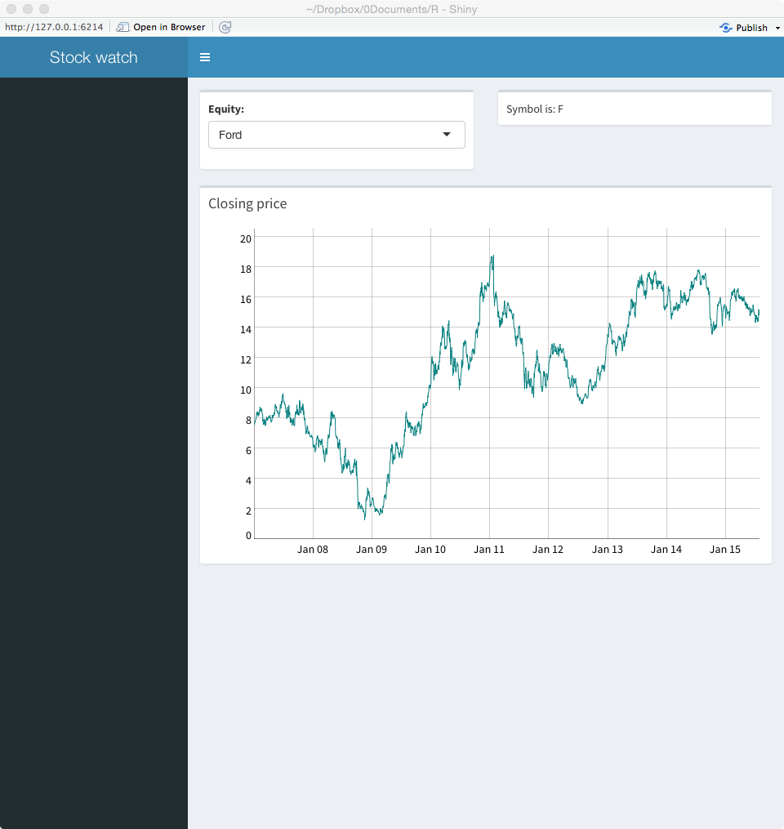

#### Input options

The preceding example illustrates the use of a selectInput function to select an equity from a list. There are other input options available, and these are listed in the following table.

| Function | Purpose |
| --- | --- |
| checkboxInput() | Check one or more boxes |
| checkboxGroupInput() | A group of checkboxes |
| numericInput() | A spin box for numeric input |
| radioButtons() | Pick one from a set of options |
| selectInput() | Select from a drop-down text box |
| selectSlider() | Select using a slider |
| textInput() | Input text |

Skill builder

Using ClassicModels, build a dashboard to report total orders by value and number for a given year and month.

.

# Conclusion

This chapter has introduced you to the basic structure and use of shinydashboard. It has many options, and you will need to consult the online [documentation](http://rpackages.ianhowson.com/cran/shinydashboard/) and examples to learn more about creating dashboards.

## Summary

A dashboard is a web page or mobile app screen that is designed to present important information in an easy to comprehend and primarily visual format. A dashboard consists of a header, sidebar, and body. Shinydashboard is an R package based on shiny that facilitates the creation of interactive real-time dashboards. It must be used in conjunction with RStudio.

## Key terms and concepts

Body

Header

Server function

Sidebar

UI function

User-interface (ui)

## References

Few, S. (2006). *Information dashboard design*: O'Reilly.

## Exercises

1. Create a dashboard to show the current conditions and temperatures in both Fahrenheit and Celsius at a location. Your will need the [rwunderground](https://cran.r-project.org/web/packages/rwunderground/index.html) package and [an API key](https://www.wunderground.com/weather/api/d/docs).
2. Revise the dashboard created in the prior exercise to allow someone to select from up to five cities to get the weather details for that city.
3. Extend the previous dashboard. If the temperature is about 30C (86F), code the server function to give both temperature boxes a red background, and if it is below 10C (50F) give both a blue background. Otherwise the color should be yellow.
4. Use the WDI package to access World Bank Data and create a dashboard for a country of your choosing. Show three or more of the most current measures of the state of the selected country as an information box.
5. Use the WDI package to access World Bank Data for China, India, and the US for three variables, (1) CO2 emissions (metric tons per capita), (2) Electric power consumption (kWh per capita), and (3) forest area (% of land area). The corresponding WDI codes are: EN.ATM.CO2E.PC, EG.USE.ELEC.KH.PC, and AG.LND.FRST.ZS. Set up a dashboard so that a person can select the country from a pull down list and then the data for that country are shown in three infoboxes.
6. Use the WDI package to access World Bank Data for China, India, and the US for three variables, (1) CO2 emissions (metric tons per capita), (2) Electric power consumption (kWh per capita), and (3) forest area (% of land area). The corresponding WDI codes are: EN.ATM.CO2E.PC, EG.USE.ELEC.KH.PC, and AG.LND.FRST.ZS. Set up a dashboard so that a person can select one of the three measures, and then the data for each country are shown in separate infoboxes.
7. Create a dashboard to:
8. Show the conversion rate between two currencies using the quantmod package to retrieve exchange rates. Let a person select from one of five currencies using a drop down box;
9. Show the value of input amount when converted one of the selected currencies to the other selected currency;
10. Show the exchange rate between the two selected currencies over the last 100 days

1. [http://www.garyryanblair.com](http://www.terry.uga.edu/people/rwatson/)
2. epsg.io/4326
3. Adapted from: Goralwalla, I. A., M. T. Özsu, and D. Szafron. 1998. An object-oriented framework for temporal data models. In Temporal databases: research and practice, edited by O. Etzion, S. Jajoda, and S. Sripada. Berlin: Springer-Verlag
4. [www.opencypher.org](https://www.opencypher.org)
5. [www.gqlstandards.org](https://www.gqlstandards.org)
6. https://neo4j.com/neo4j-graph-database/
7. https://neo4j.com/download/
8. [s3.amazonaws.com/artifacts.opencypher.org/openCypher9.pdf](https://s3.amazonaws.com/artifacts.opencypher.org/openCypher9.pdf)/
9. Needham, M., & Hodler, A. E. (2019). Graph Algorithms: Practical Examples in Apache Spark and Neo4j: O'Reilly Media. ISBN: 1492047651
10. [www.richardtwatson.com/dm6e/reader/northwind.cypher](https://www.richardtwatson.com/dm6e/reader/northwind.cypher)
11. Cowlishaw, M. F. (1987). Lexx—a programmable structured editor. *IBM Journal of Research and Development*, 31(1), 73-80.
12. [www.ofx.net](http://www.ofx.net)
13. You should use an XML editor for creating XML files. I have not found a good open source product. Among the commercial products, my preference is for [Oxygen](http://www.oxygenxml.com/), which you can get for a 30 days trial.
14. In this chapter, numbers in {} refer to line numbers in the corresponding XML code.
15. A namespace is a collection of valid names of attributes, types, and elements for a schema. Think of a namespace as a dictionary.
16. Overall, Firefox seems to do the best job of displaying xml files.
17. [www.softwareag.com/Corporate/products/wm/tamino/default.asp](http://www.softwareag.com/Corporate/products/wm/tamino/default.asp)
18. The lib_mysqludf_xql library is housed at [www.mysqludf.org](http://www.mysqludf.org). It might not be installed for the version of MySQL you are using.
19. [http://www.richardtwatson.com/xml/customerpayments.xml](http://richardtwatson.com/xml/customerpayments.xml)
20. RStudio provides a keyboard command, which is Alt+- (Windows & Linux) or Option+- (Mac)
21. <http://cran.r-project.org/web/packages/>
22. <http://cran.rstudio.com/web/packages/dplyr/vignettes/introduction.html>
23. Short cuts is Ctrl+Shift+M (Windows & Linux) and Cmd+Shift+M (Mac)
24. This is the R notation for indicating the package (dplyr) to which a method (inner_join) belongs.
25. As I continually revise data files to include the latest observations, your answer might differ for this and other analyses.
26. You will likely get a warning message of the form “unrecognized MySQL field type 7 in column 0 imported as character,” because R does does recognize the first column as a timestamp. You can ignore it, but later you might need to convert the column to R’s timestamp format.
27. See <http://www.r-project.org/doc/bib/R-books.html>
28. <http://chartsgraphs.wordpress.com/category/r-climate-data-analysis-tool/>
29. Note these prices have been transformed from the original values, but are still representative of the changes over time.
30. [http://www.statmethods.net/management/functions.html](http://www.terry.uga.edu/people/rwatson/)
31. Wilkinson, L. (2005). *The grammar of graphics* (2nd ed.). New York: Springer.
32. <http://trifacta.github.io/vega/>
33. [www.w3schools.com/cssref/css_colornames.asp](http://www.w3schools.com/cssref/css_colornames.asp)
34. Dead weight tonnage is a measure of how much weight, in tonnes, a ship can safely carry.
35. Note these prices have been transformed from the original values, but are still representative of the changes over time.
36. [www.w3schools.com/cssref/css_colornames.asp](http://www.w3schools.com/cssref/css_colornames.asp)
37. Ambiguities are often the inspiration for puns. “You can tune a guitar, but you can't tuna fish. Unless of course, you play bass," by Douglas Adams
38. <http://www.berkshirehathaway.com/letters/letters.html>
39. The converted letters are available at [http://www.richardtwatson.com/BuffettLetters/](http://www.terry.uga.edu/people/rwatson/) and will be extended to include earlier and more recent letters. The folder also contains the original letter in pdf.
40. See <http://jmlr.csail.mit.edu/papers/volume5/lewis04a/a11-smart-stop-list/english.stop>
41. The mathematics of LDA and CTM are beyond the scope of this text. For details, see Grün, B., & Hornik, K. (2011). Topicmodels: An R package for fitting topic models. Journal of Statistical Software, 40(13), 1-30.
42. Humans have a capacity to handle about 7±2 concepts at a time. Miller, G. A. (1956). The magical number seven, plus or minus two: some limits on our capacity for processing information. The Psychological Review, 63(2), 81-97.
43. <http://opennlp.apache.org>
44. <http://www.investors.ups.com/phoenix.zhtml?c=62900&p=irol-reportsannual>
45. <http://tech.knime.org/named-entity-recognizer-and-tag-cloud-example>
46. Marz, N., & Warren, J. (2012). Big Data: Manning Publications.
47. <http://hadoop.apache.org>
48. <https://www.marketanalysis.com/?p=279> (Hadoop Market Forecast 2017-2022, May 2017)
49. <https://spark.apache.org>
50. <http://spark.rstudio.com>
51. <https://www.java.com/en/download/help/version_manual.xml>
52. <http://www.erh.noaa.gov/okx/climate/records/monthannualtemp.html>
53. <https://en.wikipedia.org/wiki/IEEE_floating_point>
54. [http://www.richardtwatson.com/data/electricityprices.csv](http://people.terry.uga.edu/rwatson/data/electricityprices2010_14.csv)
55. [http://www.richardtwatson.com/data/GDP.csv](http://people.terry.uga.edu/rwatson/data/GDP.csv)
56. <http://articles.latimes.com/2013/apr/18/news/la-paloma-picasso-discusses-new-olive-leaf-collection-for-tiffany-co-20130418>
57. getQuote returns a dataframe, containing eight values :Trade Time, Last, Change, % Change, Open, High, Low, Volume. For example, getQuote('AAPL')$`% Change` returns the percentage change in price since the daily opening price.
58. The quantmod function getSymbols('X') returns an time series object named X. The get function retrieves the name of the object and passes it to the Cl function and then the time series is graphed by dygraph. The code is a bit complicated, but necessary to generalize it for use with an interactive dashboard.